GEF-6 REQUEST FOR PROJECT ENDORSEMENT/APPROVAL
Project Type:
Type of Trust Fund:
For more information about GEF, visit TheGEF.org


part i: project information
Project Title: Environmentally Sound Management and Disposal of Polychlorinated Biphenyls (PCBs) in the Republic of South Africa
Country(ies): | Republic of South Africa | GEF Project ID: |  | 9576
GEF Agency(ies): |  | GEF Agency Project ID:
Other Executing Partner(s): | Government (DEA), Others (AI) | Submission Date: |  | November 2019
GEF Focal Area (s): |  | Project Duration (Months) |  | 60
Integrated Approach Pilot | IAP-Cities IAP-Commodities IAP-Food Security |  | Corporate Program: SGP
Name of Parent Program | [if applicable] | Agency Fee ($) |  | 741,825
- Focal Area Strategy Framework and Other Program Strategies
Focal Area Objectives/Programs | Focal Area Outcomes | Trust Fund | (in $)
Focal Area Objectives/Programs | Focal Area Outcomes | Trust Fund | GEF Project Financing | Co-financing
 | Reduction and elimination of POPs |  | 8,242,500 | 56,432,558
Total project costs |  |  | 8,242,500 | 56,432,558
- Project description summary

Project Objective: To reduce and eliminate the use and releases of PCBs to the environment through development and implementation of the environmentally sound management (ESM) and disposal of PCBs and PCB-contaminated oil, equipment, and wastes in South Africa.
Project Components/  Programs | Financing Type | Project Outcomes | Project Outputs | Trust Fund | (in $)
 |  |  |  |  | GEF Project Financing | Confirmed Co-financing
1. Institutional capacity building and awareness raising |  | Key institutions are enabled to manage PCBs in an environmentally sound manner, and awareness raised on the adverse effects of PCBs | 1.1 Institutional capacity for the ESM of PCBs and PCB-contaminated oil, equipment, and wastes evaluated  1.2 Training materials developed and workshops for representatives of key stakeholders undertaken on PCB management  1.3 A National PCBs and PCB-contaminated oil, equipment, and waste tracking and record keeping system upgraded  1.4 Sampling, analysis, and monitoring capacity evaluated and strengthened  1.5 PCB owner phase-out plans and national PCB management plan developed  1.6 Information, Education, and Communication (IEC) Strategy developed and implemented  1.7 Environmental and social risk assessments and contaminated site management plans prepared for at least three sites |  | 2,561,144 | 17,296,642
2. Final treatment and disposal of PCBs and PCB-contaminated oil, equipment, and wastes |  | Collection and final treatment and disposal of PCBs and PCB-contaminated oil, equipment, and wastes | 2.1 Detailed assessment of available technology in South Africa undertaken  2.2 Technology transfer for PCB treatment and destruction through open international tender process, local authorizations and permits, and public-private-partnership (PPP) model implemented  2.3 Final treatment of 2,640 metric tons of PCBs and PCB-contaminated oil, equipment, and wastes undertaken  2.4 Occupational safety and health issues incorporated and complied with |  | 5,090,781 | 36,900,916
3. Monitoring and evaluation and replication |  | Project results sustained and replicated  Lessons learned and best practices captured, published, and disseminated at national, regional, and global level | 3.1 Gender assessment conducted, M&E and adaptive management applied to the project in response to needs, and evaluation findings and lessons learned extracted  3.2 Project website established for stakeholder engagement and sharing good practices, guidance/tools, and experiences  3.3 Yearly lessons-learned reports/ publications prepared and disseminated  3.4 End of project publication prepared and disseminated  3.5 Mid-term and Terminal Evaluation Reports |  | 198,075 | 1,235,000
Subtotal |  |  |  |  | 7,850,000 | 55,432,558
Project Management Cost (PMC) |  |  |  |  | 392,500 | 1,000,000
Total project costs |  |  |  |  | 8,242,500 | 56,432,558
- confirmed sources of Co-financing for the project by name and by type
Please include evidence for co-financing for the project with this form.
Sources of Co-financing | Name of Co-financier | Type of Cofinancing | Amount ($)
 | DEA and municipalities |  | 8,000,000
 | Eskom |  | 15,639,142
 | A-Thermal |  | 12,383,416
 | DBSA |  | 19,210,000
 | Africa Institute |  | 1,200,000
Total Co-financing |  |  | 56,432,558
- Trust Fund Resources Requested by Agency(ies), Country(ies) and the Programming of Funds
GEF Agency | Trust Fund | Country  Name/Global | Focal Area | Programming of Funds | (in $)
 |  |  |  |  | GEF Project Financing (a) | Agency Fee ^{a)} (b)² | Total  (c)=a+b
 |  | Republic of South Africa |  |  | 8,242,500 | 741,825 | 8,984,325
Total Grant Resources |  |  |  |  | 8,242,500 | 741,825 | 8,984,325

a ) Refer to the Fee Policy for GEF Partner Agencies

- Project’s Target Contributions to GEF 6 Core Indicators
Update the relevant sub-indicator values for this project using the methodologies indicated in the Core Indicator Worksheet (as used in GEF 7 Endorsement template – Annex E) and aggregating them in the table below. Progress in programming against these targets is updated at mid-term evaluation and at terminal evaluation. Achieved targets will be aggregated and reported any time during the replenishment period. There is no need to complete this table for climate adaptation projects financed solely through LDCF and SCCCF.
Project Core Indicators |  | Expected at CEO Endorsement
1 | Terrestrial protected areas created or under improved management for conservation and sustainable use (Hectares)
2 | Marine protected areas created or under improved management for conservation and sustainable use (Hectares)
3 | Area of land restored (Hectares)
4 | Area of landscapes under improved practices (excluding protected areas)(Hectares)
5 | Area of marine habitat under improved practices (excluding protected areas) (Hectares)
 | Total area under improved management (Hectares)
6 | Greenhouse Gas Emissions Mitigated (metric tons of CO2e)
7 | Number of shared water ecosystems (fresh or marine) under new or improved cooperative management
8 | Globally over-exploited marine fisheries moved to more sustainable levels (metric tons)
9 | Reduction, disposal/destruction, phase out, elimination and avoidance of chemicals of global concern and their waste in the environment and in processes, materials and products (metric tons of toxic chemicals reduced) | 2,640 metric tons of PCBs
10 | Reduction, avoidance of emissions of POPs to air from point and non-point sources (grams of toxic equivalent gTEQ)
11 | Number of direct beneficiaries disaggregated by gender as co-benefit of GEF investment
Provide additional explanation on targets, other methodologies used, and other focal area specifics (i.e., Aichi targets in BD) including justification where core indicator targets are not provided.
- Project Taxonomy
Please update the table below for the taxonomic information provided at PIF stage. Use the GEF Taxonomy Worksheet provided in Annex F to find the most relevant keywords/topics/themes that best describe the project.
Level 1 | Level 2 | Level 3 | Level 4
Influencing Models | Strengthen institutional capacity and decision-making
Stakeholders | Beneficiaries
Capacity, Knowledge and Research | Capacity Development
Gender Equality | Gender results areas | Awareness raising
Focal Area/Theme | Chemicals and Waste | Persistent Organic Pollutants
Rio Markers

part ii: project justification

A. describe any changes in alignment with the project design with the original pif
A.1. Project Description. Elaborate on: 1) the global environmental and/or adaptation problems, root causes and barriers that need to be addressed; 2) the baseline scenario or any associated baseline projects, 3) the proposed alternative scenario, GEF focal area strategies, with a brief description of expected outcomes and components of the project, 4) incremental/additional cost reasoning and expected contributions from the baseline, the GEFTF, LDCF, SCCF, and co-financing; 5) global environmental benefits (GEFTF) and/or adaptation benefits (LDCF/SCCF); and 6) innovativeness, sustainability and potential for scaling up.

The following table outlines the key changes from the original PIF.

Table 1: Summary of key deviations from PIF
Issue | PIF | CEO Endorsement Approval Template
PCB inventory data | The PCB inventory data was limited to the findings of the NIP, which did not include the NERSA-licenced municipalities. | The PCB inventory data has been updated to include the NERSA-licenced municipalities and more concrete data provided to DEA in the form of phase-out plans from 161 companies (including Eskom).
Possible PPP framework | The PIF mentions “The existing treatment facilities of Hazardous Wastes in the country will be evaluated and possibly upgraded through a technology transfer process based on a Public Private Partnership (PPP) initiative which will be implemented in a transparent manner.” | The PPP framework has been elaborated to outline the possible roles of the public and private sector partners, preliminary identification of the required technology and skills transfer under the PPP, and disposal price guarantees.
Use of combustion technology | The PIF states that “As a means of achieving this goal, a non-combustion technology transfer to South Africa will be obtained through an open international tender process, local authorizations and permits and PPP model.” | Based on the identified PCB treatment facilities in South Africa and their current capacity (including the amount of waste that can be treated per year), it is more efficient to undertake technology transfer for high temperature incineration. This will also produce greater added value in the future for the environmentally sound treatment of other hazardous waste as well as possible PCB waste identified after completion of the project.
Technical specifications of PCB treatment and disposal facilities in South Africa | The PIF states that “no PCB decontamination facility has been established yet, and the absence of national PCB disposal options continues to pose a major challenge for South Africa to accelerate its efforts to meet the obligation of the Stockholm Convention” and “the existing treatment facilities of Hazardous Wastes in the country will be evaluated and possibly upgraded. | Two potential PCB treatment facilities have been identified in South Africa: A-Thermal and Enviroil. Since the PIF was written, treatment technology in South Africa, including the thermal desorption technology available at A-Thermal, has improved significantly. An initial assessment of A-Thermal capacity and required technology and skills transfer was conducted. It was not possible to assess the technology at Enviroil during the PPG phase. If Enviroil confirms its interest to participate in the project, it will be subject to a third-party assessment of its services regarding PCB treatment, and the appropriateness of its technology will be assessed against the findings of the comprehensive inventory in the early stage of project implementation.

1.1 Global environmental and/or adaptation problems, root causes and barriers that need to be addressed

PCBs are a class of synthetic organic chemicals that have a low electrical conductivity and high resistance to thermal breakdown, oxidants, and other chemicals. They are widely used as dielectric fluids in electrical transformers and capacitors. PCBs are among the most toxic and persistent POPs listed in the Stockholm Convention. PCBs are characterized by a toxicity and environmental persistence, which is very similar to that of dioxins. Some of the adverse effects associated with the exposure to PCBs include damage to the immune system, liver, skin, reproductive system, gastrointestinal tract and thyroid gland. Based on the re-assessment of scientific evidence, PCBs have recently been re-classified as class 1 carcinogens from the International Agency for Research of Cancer (IARC-WHO).
The Stockholm Convention banned the production of PCBs, but gives Parties to the Convention until 2025 to take action to phase-out the use of PCB oils and equipment contaminated with PCBs. Recovered PCBs must be treated and eliminated by 2028. Although PCBs were never produced in South Africa, PCBs and PCB-contaminated oil and equipment were imported for the power generation and distribution sector. PCBs have been listed as a Group II hazardous substance in South Africa by the Hazardous Substances Act, 1973 (Act No.15 of 1973) and have been allocated a unique code in South Africa’s Tariff Book. This allows them to be identified specifically in cases of import. They have also been placed on the Customs and Excise list of “Prohibited and Restricted” imports and exports, and therefore any PCBs and PCB-contaminated oil and equipment entering the country are to be retained by the Customs Division, except for the purposes of environmentally sound treatment and disposal.
On 10 July 2014, the Department of Environmental Affairs (DEA) also published the “Regulations to phase-out the use of PCB materials and PCB contaminated materials” (hereafter referred to as the “South Africa PCB Regulations”) under section 44(1) (aA) and (aB) of the National Environmental Management Act, 1998 (Act No. 107 of 1998). The main objective of the regulations is to phase-out the use of PCBs in electrical equipment by 2023 and dispose of the resulting wastes by 2026. Despite the requirement in the South Africa PCB Regulations that “Any PCB holder must develop a phase-out Plan and submit it to the DG within a year (12 months) of the coming into effect of these Regulations”, a significant number of potential PCB owners did not provide data on their PCB inventories nor submit phase-out plans.
The key stakeholders in South Africa that own electricity generating and transmission equipment which could contain PCBs and PCB-contaminated oil are: Eskom (the country’s only utility company, which is responsible for bulk supply of electricity); 174 municipalities licensed by the National Energy Regulator of South Africa (NERSA); and other energy intensive industries such as mining, cement, steel, aluminium, chemical, and petrochemical manufacturing, and transportation. Eskom is the largest producer of electricity in Africa and is among the top seven utilities in the world in terms of generation capacity and among the top nine in terms of sales. Eskom generates approximately 95% of electricity used in South Africa, and also oversees the management of electrical equipment for 106 municipalities.
Of the 280 municipalities (metro, district, and local) in South Africa, Eskom is responsible for maintenance and repair of equipment, such as transformers and capacitors, in 106 municipalities. The remaining 174 municipalities are directly licensed by NERSA and ESKOM is only responsible for bulk supply of electricity. These municipalities oversee their own transmission and distribution including the procurement and maintenance of their equipment.
These 174 NERSA-licensed municipalities in particular face significant financial and technical challenges with undertaking comprehensive PCB inventories and disposing of PCBs and PCB-contaminated oil, equipment, and waste. In many cases, there is a lack of awareness and capacity regarding PCB management. This has resulted in only five of the NERSA-licensed municipalities submitting their phase-out plans. Many municipalities are also unaware of the South Africa PCB Regulations and the South African National Standard on “Mineral insulating oils – Management of polychlorinated biphenyls (PCBs)” (SANS 290). The lack of specific schemes or administrative mechanisms governing PCB oils in these municipalities means that some of them may still procure PCB-contaminated transformers. It has also been noted in consultations related to the implementation of the South Africa PCB Regulations that community members have used PCB-contaminated oils for improper purposes, e.g. traditional healers have prescribed PCB-contaminated transformer oil for medicinal purposes, and some individuals believe that the oil has a healing effect on diseases such as arthritis.
While comprehensive PCB inventories have been undertaken by Eskom and most industries, in accordance with the South Africa PCB Regulations, a comprehensive inventory will need to be conducted for all potential PCBs and PCB-contaminated oil and electrical equipment in the 174 NERSA-licensed municipalities. This need has been confirmed by the results of the preliminary PCB inventories developed for the 2012 NIP, initial work undertaken as part of updating the NIP, and research undertaken during the PPG phase of this project. Due to a lack of capacity and funding, PCB concentrations in the NERSA-licensed municipalities have not been determined or characterized. Therefore, the lack of adequate national data on PCBs, the potential for significant PCB releases from their use, stockpiles and wastes, and the need to phase-out and dispose of PCBs and PCB-contaminated oil, equipment, and wastes are major problems that have been prioritized for action.
South Africa is Party to the key chemicals and waste-related international agreements, among others, which together provide an international framework governing the environmentally sound management of hazardous chemicals and wastes throughout their life cycle. These include the Stockholm Convention, Basel Convention, Rotterdam Convention, and Montreal Protocol. South Africa also supports the Strategic Approach to International Chemicals Management (SAICM).
The following are the barriers that need to be addressed by this project to ensure the ESM of PCBs and PCB-contaminated oil, equipment, and wastes and to avoid PCBs being released into the environment as a consequence of improper disposal:
- Most of the NERSA-licensed municipalities across the country do not have specific schemes or administrative mechanisms governing PCBs and PCB-contaminated oil, equipment, and wastes
- Many of the potential owners of PCBs and PCB-contaminated oil, equipment, and wastes, particularly the NERSA-licensed municipalities, currently lack the means to identify such oil, equipment, and wastes or apply ESM practices to PCBs or PCB-contaminated equipment in service, in storage, or out-of-service
- The preliminary national PCB inventory that is available as a result of the 2012 (updating the NIP is underway) is not sufficiently detailed for the purposes of phase-out and disposal planning; a comprehensive, detailed inventory and assessment of the PCB situation in South Africa will be need to be undertaken at the early stages of the project, with a particular focus on the NERSA-licensed municipalities
- Despite awareness raising efforts undertaken regarding implementation of the South Africa PCB Regulations, many owners of PCBs and PCB-contaminated oil, equipment, and wastes are unaware of the threats that PCBs pose to human health and the environment, and hence electrical equipment is often not managed in an environmentally sound manner
- There are no systematic investment mechanisms to support the ESM of PCBs and PCB-contaminated oil, equipment, and wastes within the country
- There are at least four PCB-contaminated sites that have been identified, but environmental and social risk assessments or contaminated sites management plans have not been developed
- PCB treatment facilities in South Africa are relatively new and require detailed assessments and related accreditation processes to ensure that they can treat PCBs in an environmentally sound manner in accordance with national laws and regulations, Stockholm and Basel Convention provisions, and related guidance

1.2 Baseline Scenario and Associated Baseline Projects

As Party to the Stockholm Convention, South Africa has made strides in putting in place and implementing mechanisms to enable its compliance to this treaty. Such initiatives include development of related policies, regulations, and standards, including the South Africa PCB Regulations and SANS 290 mentioned above, and formulation and updating of the NIP through intensive stakeholder consultation processes.
Although PCBs were never produced in South Africa, PCB oil and related equipment were imported for use mainly in the energy sector. PCBs have been listed as a Group II hazardous substance in South Africa and have been allocated a unique tariff code in the South African tariff book to enable them to be identified on import. PCBs have also been placed on the Customs and Excise list of “Prohibited and Restricted” imports and exports. The Customs Division is therefore expected to retain any PCBs and PCB-contaminated oil, equipment, and wastes entering the country and no further imports of PCBs are expected to be received into the country, except for the purposes of environmentally sound treatment and disposal.
In order to enable better management of existing PCBs and PCB-contaminated oil, equipment, and wastes, the South African National Standard on “Mineral insulating oils – Management of polychlorinated biphenyls (PCBs)” (SANS 290) was developed. (The standard was developed in 2007 and updated in 2016, and is currently undergoing a national review of certain elements.) SANS 290 prescribes health and safety, identification, inspection, labelling, retrofilling, and management measures to mitigate the risks associated with PCB oils.
- Inventories, phase-out plans, and asset registries
As part of the 2012 NIP, a national preliminary inventory on PCB-containing electrical equipment was conducted, which estimated the presence of more than 10,000 transformers with dielectric fluid contaminated by PCBs at a level >50 ppm. The estimated total weight of these transformers was 8,000 metric tons (hereafter referred to as tons), along with an additional 2,000 tons of contaminated soils.
The 2012 NIP also provides details of a separate 2010 inventory conducted by Eskom for the large equipment that it owns, which revealed that 17,086 pieces of equipment (transformers, capacitors, and auxiliary equipment) contain PCBs with content > 50 ppm. However, these findings seem to be inaccurate, probably due to incorrect use of field test kits. Data from the 174 NERSA-licensed municipalities was not made available for the 2012 NIP. The above provides further justification for undertaking a comprehensive national PCB inventory including training on sampling and analysis under the project.
The 2012 NIP also reported the destruction of 1,027 tons of PCB-contaminated oil and equipment (149 and 876 respectively) in South Africa between 2005 and 2010, initiated mainly by the industrial sectors. Prior to the 2014 South Africa PCB Regulations, approximately 8,900 tons were reportedly treated at A-Thermal in South Africa between 2006 and 2013 (see section on “PCB treatment facilities” below). This figure includes PCB waste from South Africa and other countries in the region.
An updated preliminary inventory has been undertaken as input to the second (2019) NIP and this project, building on PCB inventories and phase-out plans received by DEA in order to comply with the 2014 South Africa PCB Regulations. Updated data was collected from Eskom and most industries in South Africa. A limited amount of data has also been gathered from the NERSA-licensed municipalities through asset registries submitted to the government. The key findings from these sources and from personal communications undertaken during the PPG phase are as follows.
According to the inventories and phase-out plans submitted to DEA by 161 companies (including Eskom), 17,423 transformers have been tested for PCBs (with GC analysis) and 1,808 transformers have been identified as containing PCBs (>500 ppm) or PCB-contaminated (50-500 ppm). This includes approximately 932 tons of PCB-contaminated oil (932,775 litres); 463 tons of equipment contaminated with pure PCBs; and approximately 228 tons (228,239 litres) of oil and articles with PCB concentration > 500 ppm. Since the 2014 South Africa PCB Regulations came into effect, an additional 103 tons (or 103,000 litres) of oil and materials have been treated (at A-Thermal).
Regarding the 174 NERSA-licensed municipalities, only 39 provided asset registries and data during the PPG phase. These 39 municipalities listed a total of 43,546 transformers. (Extrapolating the data provided by these municipalities, there is an estimated total of 194,000 transformers in the 174 NERSA-licensed municipalities.) Of the data obtained, only 13 municipalities included details on the status of PCB contamination, which includes 15 transformers that have been identified as PCB-contaminated (50-500 ppm). Many of the NERSA-licensed municipalities are in financial distress and therefore face significant financial and capacity-related challenges to performing regular transformer maintenance and sampling. Most municipalities only test the oil when there is a maintenance problem and this typically does not include PCB testing.
While there is currently a lack of clear information regarding PCBs in the 174 NERSA-licensed municipalities, extrapolating the data provided by Eskom and industry (in the phase-out plans submitted to DEA) – and assuming a total stock of approximately 194,000 transformers in the NERSA-licensed municipalities with an average weight of 0.5 tons/transformer (including oil and carcass) – there may be approximately 584 tons of PCB-contaminated oil; 290 tons of equipment contaminated with pure PCBs; and 143 tons of oil and articles with PCB concentration > 500 ppm. Taking into that 8,900 tons were already treated at A-Thermal between 2006 and 2013, the figures for the NERSA-licensed municipalities could be significantly higher.
According to the above-mentioned sources of data and personal communications with the PCB owners, there are approximately 503,000 transformers in operation (300,000 in Eskom; 10,000 in industry; and 193,000 in the NERSA-licensed municipalities). The current total estimate of PCBs and PCB-contaminated oil, equipment, and wastes in South Africa is 2,640 tons, as follows: 1,516 tons of PCB-contaminated oil; 753 tons of equipment contaminated with pure PCBs; and 371 tons of oil and articles with PCB concentration > 500 ppm. The precise amounts will be confirmed after undertaking the comprehensive PCB inventory.
- PCB management capacity and level of awareness
Although the South Africa PCB Regulations are now in force along with SANS 290, in some cases, cross-contamination has continued to occur. For example, since Eskom’s first phase-out plan was submitted to DEA in 2016, seven transformers were added to the updated 2018 phase-out plan due to cross-contamination. Cross-contamination has also likely taken place in many of the NERSA-licensed municipalities, which have more limited technical capacity and compliance measures. While some NERSA-licensed municipalities have reported that they have regular transformer maintenance schedules (e.g. every five years), most only undertake transformer maintenance when a problem is identified.
Despite a number of efforts to raise awareness on PCB management (e.g. during the NIP development/updating processes, SANS 290 and South Africa PCB Regulations development, updating, and implementation, and a series of provincial and national meetings organised by DEA on PCB inventories and phase-out plans in 2014 and on the national PCB Stakeholder Forum in 2015 and 2016), current levels of awareness remains low with some stakeholders. Many municipal-level workers, DEA provincial staff, and the general public are generally not aware of the health and environmental adverse effects of PCBs. Low levels of awareness lead to continued mismanagement of PCBs and PCB-contaminated oil, equipment, and wastes. A lack of specific schemes or administrative mechanisms governing PCB oils and equipment in many of the municipalities also means that some of the municipalities may still procure PCB-contaminated transformers. Furthermore, there have been reported cases of PCB or PCB-contaminated oil being improperly used as medicinal remedies. Therefore, there is a need to develop a comprehensive awareness raising strategy by sector and by stakeholder groups, including interested and affected parties, and especially women and children.
In addition, most of the NERSA-licensed municipalities also do not have training facilities that have the capacity to strengthen skills for PCB management. This is another gap that will need to be addressed under the project, in coordination with existing national and local training institutions and departments, such as Eskom’s Training School, Sector Education and Training Authority (SETA; https://www.vocational.co.za), and Local Government Sector Education and Training Authority (LGSETA; http://www.lgseta.co.za). All municipalities that were consulted during the PPG phase expressed strong interest in participating in training and introducing best practices regarding PCB management.
- Contaminated sites
Article 6 of the Stockholm Convention states that Parties shall “endeavour to develop appropriate strategies for identifying sites contaminated by chemicals listed in Annex A, B or C; if remediation of those sites is undertaken it shall be performed in an environmentally sound manner”. Some NERSA-licensed municipalities reported that they have runoff contamination at most substations and that records of leakage of transformers are not typically kept. Instead the leaks are simply dealt with as part of the maintenance practices. Some municipalities have also reported that they have transformers that are not situated in proper pans to catch oil leakage. Therefore, there is a need to conduct environmental and social risk assessments for the potentially contaminated sites and develop corresponding contaminated sites management plans.
- PCB treatment facilities
There are currently two potential PCB treatment facilities in South Africa: A-Thermal and Enviroil. A-Thermal uses thermal desorption technology, with a capacity to treat approximately 1,000 tons/month of PCB waste. This includes transformer oil and transformer carcasses, capacitors, PCB-contaminated soil, and PCB-contaminated materials such as personal protective equipment (PPE) and metal barrels. According to A-Thermal, it uses USEPA 761 PCB destruction air quality standards and has reported PCB destruction efficiency of 99.9999%. In addition to annual audits and periodic air quality monitoring conducted by the national responsible authorities, A-Thermal undertakes continuous monitoring of CO, CO₂, HCL, PM, Hg, TOCs, Benzene, HF, NOx, SOx, and NH₃ emissions using uses infrared and UV sensor technology, and residues are analysed by ISO 17025 accredited labs. Its rotating kiln operates at 650ºC, with thermal oxidation at 11,000ºC for a minimum residence time of 2 seconds followed by a quenching process from 1,100 to 80ºC in <0.5 seconds to reduce the chances of breaking down into dioxins and furans. Destruction and removal efficiency (DRE) tests are also undertaken including stack emissions and solid outputs, and external risk assessments are conducted. It has a number of certifications including ISO 9001 (Feb 2016); ISO 14001 (Nov 2009); and OSHAS 18001 (Feb 2016). Finally, briquettes can be produced from carbon residue, which serve as an alternative fuel resource to industrial boilers and kilns.
A-Thermal has the capacity to collect waste directly from its source of origin or receive waste at its premises delivered by other waste management companies/transporters. The A-Thermal campus appears to have ample security including more than 100 CCTV cameras on site; thermal imaging; security stands at feeding platforms; high schedule pharmaceuticals stored in locked cages; and barcoded waste. It also appears to have considerable measures in place regarding health and safety issues including segregation of stored waste; advanced firefighting capacity; hazchem training; and specialized vacuum facilities and PPEs. Internal training is provided, and medical tests are performed for its staff every six months. The cost of PCB destruction is approximately 14 ZAR/kg (1 USD) for <500 ppm and 23 ZAR/kg (1.60 USD) for >500 ppm. If A-Thermal is selected as a service provider for PCB treatment/disposal, a negotiated rate for PCB treatment/disposal will be agreed based on the PPP arrangements and taking into account the cost of required technology transfer. A-Thermal is willing to participate in assessment and accreditation processes to ensure that its technology and practices adhere to the required international standards for PCB treatment. A-Thermal may also contribute to job creation, e.g. through labour required to prepare transformers and PCB waste for treatment, as a result of the project. (The unemployment rate in South Africa is currently 26.6%.) The participation of A-Thermal in the project would be subject to a transparent national selection process in accordance with South African law and DBSA policy.
According to Enviroil, it is a leading supplier of new and regenerated transformer oil in Southern Africa and also provides transformer oil related services. It undertakes PCB decontamination using a proprietary reagent that operates at controlled temperatures starting from 60˚C. This process is unique to Enviroil and is capable of detoxifying and dehalogenating PCBs present in transformer oil with an efficiency of 99.9%. The PCB level of transformer oil received for decontamination is verified by gas chromatograph (GC) prior to decontamination. After decontamination the PCB level is again verified by GC. A certificate is provided as evidence that the transformer oil has been decontaminated by Enviroil and contains unique information to identify the volume, date, etc. of the transformer oil decontaminated. All of the work indicated above is performed in-house. In 2011, Enviroil obtained ISO 9001:2008 management system certification in 2011 and was also certified according to SANS 290:2011 for the handling of PCBs. Enviroil was the first company to be certified to this PCB management standard.
- Laboratory capacity
Eskom has an in-house accredited laboratory, which performs gas chromatography (GC) analysis and participates in Institute for Interlaboratory Studies (IIS) and South African National Accreditation System (SANAS) schemes. It has capacity to analyse about 50 samples/day. The results of the tests are typically included in the maintenance certificate for each piece of equipment and recorded on a label that is affixed to the equipment in accordance with SANS 290. There are five other laboratories in South Africa that can analyse for PCBs using GC, but they are not accredited. GC analysis of oil samples costs 700 ZAR (50 USD) at Eskom’s laboratory and 300 ZAR (21.40 USD) from other non-accredited laboratories. The costs of field and laboratory testing of oil samples is cost-prohibitive for most of the NERSA-licensed municipalities.
- Interim storage facilities
Most of the transformer owners in South Africa do not have or use interim storage facilities or facilities specifically set up for interim PCB storage. In the case of Eskom, PCB waste or failed equipment is transported from the site directly to treatment facilities; there is no interim storage for PCBs. Regarding the NERSA-licensed municipalities, some use open spaces or more specialised storage or workshops for damaged equipment; some sell failed equipment at auction each year while others sell such equipment immediately, which is then collected by the new owners (typically for scrap metal). In some cases, equipment is stolen from the storage sites. Clear and environmentally sound practices for PCBs and PCB-contaminated waste needs to be developed, in accordance with SANS 290, and interim storage facilities may also need to be established.
- Vandalism
In some municipalities, vandalism occurs whereby the transformers and other electrical equipment is taken in whole or dismantled on site to obtain copper, entire transformers, steel doors, etc. Often the pole-mounted transformers are targeted. Oil is not targeted by the vandals. Some municipalities have reported losing 5-10 transformers/year; others have reported no cases of vandalism. One municipality reported one incidence of vandalism and a related oil spill in a sugarcane field.
- Field testing
Upon further discussions on the merits of including the 50 Chlor-N-Oil tests during the PPG phase, particularly for the 174 NERSA-licensed municipalities, it was agreed that: 50 Chlor-N-Oil tests are not confirmatory tests and therefore will just provide an indication of potential PCBs and PCB-contaminated transformers; and since the PPG phase funding is limited, a comprehensive sampling and analysis of all transformers was not possible as only a limited sample could be conducted. Therefore, there is no formula to guarantee that the selection of the sample population would be representative enough to establish the national PCB-contamination trends; and in case the selected sample population for sampling and analysis is an outlier, i.e. is all positive or negative, this can result in distortions and would not be useful to the project preparation. Therefore, it was agreed that the PPG phase should focus on gathering and verifying existing inventories, phase-out plans, and asset registries; total number of transformers; details on contaminated sites; other unconfirmed information from the PIF; and developments and updates since the PIF was submitted.
1.3 Proposed Alternative Scenario

The proposed alternative scenario will support South Africa with the necessary technical and financial assistance to ensure that at least 2,640 tons of PCBs and PCB-contaminated oil, equipment, and wastes are identified, properly managed, and treated. The project will also ensure that adequate capacity for the sound management of PCBs is built for addressing any further PCBs identified after the project’s closure. The project will be implemented in partnership with the relevant institutional and utility stakeholders, i.e. DEA, Eskom, NERSA-licensed municipalities, industry, and other confirmed or potential holders of PCBs and PCB-contaminated oil, equipment, and wastes.
The project consists of the following three components:
- Component 1: Institutional capacity building and awareness raising
- Component 2: Final treatment and disposal of PCBs and PCB-contaminated oil, equipment, and wastes
- Component 3: Monitoring, evaluation, and replication

Component 1: Institutional capacity building and awareness raising

Under this project component, a national project secretariat, headed by the national project manager (and hosted by DEA) will be established. A Project Steering Committee (PSC) will also be established making full use of existing structures dealing with chemicals management (such as national coordination groups for POPs and SAICM) to coordinate and guide project implementation. The PSC will comprise a group of experts from different sectors (e.g. government, private sector, NGOs, and academia) whose roles will be coordination, oversight, and advisory regarding project activities. The PSC will seek synergies and joint activities with existing and relevant planned chemicals-related activities.
This component will also support South Africa to conduct a comprehensive assessment of the institutional capacity in the country related to the sound management of PCBs, including institutional arrangements, administrative processes, and technical preparedness. This assessment will identify strengths and gaps including a prioritization of needs, and support the development of a comprehensive PCB training programme, covering PCB inventories, sampling, and analysis, development of PCB management plans, and all steps of the ESM of PCBs.
Appropriate tools will also be developed to address the key gaps identified in the NIP and the comprehensive institutional capacity assessment. For example, technical guidance documents will serve as the reference documents for project staff, NERSA-licensed municipalities, industry, and others, and will cover the following aspects: national and international regulations concerning PCBs (including Stockholm and Basel Conventions and associated guidance); sampling of electrical equipment; use of screening and analytical tools and devices for PCBs; PCB labelling criteria and standards; collection; safe packaging; transportation; storage procedures and technical specifications for storage facilities; international shipment procedures, where applicable; and rationale for the selection of disposal and treatment technologies.
In this component, South Africa will also be assisted to establish a comprehensive and functional PCB management institutional setup that will address needs at the national and municipal level. Hands-on training workshops for key stakeholders will be undertaken on the various aspects outlined above. Practical training will be provided that will build the technical capacity of those that will be physically engaged in PCB management such as handling PCB-contaminated transformers on how to perform sampling and testing of dielectric oil to ensure that proper methodologies are adopted, risks are minimised, and environmentally sound management is applied. This will also be complemented with demonstration and fieldwork activities, in coordination with project partners, covering the various steps of PCB management. For example, pilot studies will be undertaken in NERSA-licensed municipalities, and documentation, including lessons learned and best practices, will be made available to all stakeholders for adoption. DEA will also be capacitated to monitor the PCB phase-out plans, through spot sampling and analysis. Customs officials and other relevant stakeholders will also be trained on national and international regulations concerning PCBs and related safe inspection practices to ensure appropriate action is taking at the borders. This will also address procurement issues to ensure that PCB-contaminated transformers are not purchased and that mechanisms are in place to prevent sales of contaminated equipment within the country.
Some of the training workshops may include participants from other countries, particularly from the 12 countries participating in the GEF-funded project “Disposal of PCB Oils Contained in Transformers and Disposal of Capacitors Containing PCB in Southern Africa” (https://www.thegef.org/project/disposal-pcb-oils-contained-transformers-and-disposal-capacitors-containing-pcb-southern) and other PCB projects in the region, to ensure regional collaboration that will benefit both South Africa and the region.
National training institutions and departments will be heavily involved in the development and delivery of the training. For example, Eskom’s Training School has expertise in raising awareness and providing training on oil handling procedures and hazardous chemicals, including a six-hour module on PCB-specific training. The Sector Education and Training Authority (SETA; https://www.vocational.co.za) and the Local Government Sector Education and Training Authority (LGSETA; http://www.lgseta.co.za) will also be closely consulted. A train-the-trainers approach will also be incorporated in all training activities to facilitate access to a large number of training recipients and to make the best use of financial and human resources.
The national PCB equipment tracking and record keeping system to support the ESM of PCBs and prevent illegal use and importation of equipment likely to contain PCBs will be upgraded in coordination with all PCB owners. The upgrading, which will enable the recording, mapping, and tracking of all PCBs and PCB-contaminated oil, equipment, and waste throughout the country, will involve representatives of government, private sector, customs officers, academia, and NGOs, and will also support the appropriate personnel, such as DEA, to undertake periodic monitoring visits to PCB holders. This activity will support South Africa to strengthen its data collection and management capacity regarding PCBs, which will include assessing its data needs and developing protocols and procedures for data collection, processing, and storage and sampling and analysis.
A comprehensive PCB inventory will be conducted and will include the sampling and analysis of phased-out and in-use equipment (approximately 50,000 pieces). The national PCB equipment tracking and record keeping system will also provide a platform for characterisation of PCB waste streams, such as the concentration and volume of PCBs and condition of the equipment. This will feed into the assessment of the available treatment technology required to ensure ESM and disposal of PCBs. For example, the treatment or disposal of contaminated transformers that are relatively new and in good working order might only require a dechlorination approach (e.g. at Enviroil). On the other hand, old, defective, and highly contaminated transformers will be considered for dismantling at a licensed facility (e.g. at A-Thermal), where PCBs and PCB-contaminated oil, equipment, and waste will be thermally treated, as appropriate. In some cases, the valuable scrap metal may be decontaminated and sold. The final decisions for treatment or disposal options (including domestic and international options) will be based on a detailed third-party assessment (see Component 2 below), which will carefully consider risks, cost estimates, financial feasibility, and viability considerations, and a transparent national selection process in accordance with South African law and DBSA policy.
The findings of the comprehensive PCB inventory (and detailed third-party assessment of the treatment options; see Component 2 below) will form the basis for the development of PCB owner phase-out plans and a national PCB management plan. This activity is particularly important for enabling the 174 NERSA-licensed municipalities to develop their phase-out plans in accordance with the South Africa PCB Regulations. The purpose of the phase-out plans and national PCB management plan is to establish a roadmap for the disposal/decontamination of PCBs and PCB-contaminated oil, transformers, and waste while ensuring rational use of the economic resources and minimum impact and disruption of the production activities (i.e. electricity production) through integration with normal maintenance operations. The management plan in particular will set environmental objectives and criteria, and occupational safety rules. The following criteria will be adopted in drafting the management plan: prioritization (PCB concentration, risk assessment, transformer residual life); selection of the proper technologies (based on PCB concentration and trade-off between transformers residual life and clean-up vs. disposal cost); economic sustainability; accountability; and sound and feasible time planning.
This component will also include the development and implementation of an Information, Education, and Communication (IEC) Strategy addressing PCB management. This will also involve the development of related materials such as multimedia educational tools, posters, and brochures. The IEC Strategy will bring about a better understanding and appreciation by all stakeholders including the public of the health and environmental impacts and importance of ensuring the ESM of PCBs. This will also contribute to guiding all PCB owners in their policy and decision-making functions. Moreover, the IEC activities will help ensure a better understanding of the South Africa PCB Regulations by all relevant stakeholders, which in turn will promote better cooperation towards achieving compliance and address issues such as a lack of regulatory coordination at the various levels of government, especially at the municipal level.
The IEC Strategy will include briefing events for mid-level managers (e.g. facility managers), high-level officials (ministers, members of parliament, and chief executives), and the media. Local communities will have access to awareness raising materials in their own local languages and training at the community level will be organized. The IEC Strategy will promote an integrated approach to identifying, capturing, evaluating, and sharing information through the design and establishment of a knowledge management framework. Through the knowledge management network, DEA will be able to report to each PCB holder on their progress regarding their phase-out plans as a peer report back mechanism. This will be undertaken in coordination with the establishment and management of the national project website.
Regarding PCB-contaminated sites, such as facilities or areas where PCB-containing transformers have leaked or hazardous waste sites as listed above, environmental and social risk assessments and contaminated site management plans will be prepared. This will be undertaken for at least three such sites, one of which could be for an interim PCB storage site, if appropriate. Remediation of such sites will take place with resources outside of this GEF project.

Component 2: Final treatment and disposal of PCB contaminated oils and wastes

This component will comprise the collection and treatment/disposal of at least 2,640 tons of PCBs and PCB-contaminated oil, equipment, and waste in an environmentally sound manner. The equipment will be labelled, packaged, transported, temporarily stored where necessary, and finally treated/disposed.
Regarding final treatment/disposal, two potential options exist in South Africa at A-Thermal and Enviroil. A detailed third-party assessment of interested facilities will be conducted in the early part of this project to ensure that they can treat PCBs in an environmentally sound manner in accordance with national laws and regulations, Stockholm and Basel Convention provisions, and related guidance including:
- General technical guidelines on the environmentally sound management of wastes consisting of, containing or contaminated with persistent organic pollutants (UNEP/CHW.13/6/Add.1/Rev.1)
- Technical guidelines on the environmentally sound management of wastes consisting of, containing or contaminated with polychlorinated biphenyls, polychlorinated terphenyls, polychlorinated naphthalenes or polybrominated biphenyls including hexabromobiphenyl (UNEP/CHW.13/6/Add.4/Rev.1)
- Draft updated technical guidelines on incineration on land (D10) (UNEP/CHW/OEWG.11/INF/18)
- Destruction technologies for polychlorinated biphenyls (PCBs), Rahuman et al., 2000
- Technology alternatives for the remediation of PCB contaminated soils and sediments, US EPA
The assessment will review the following criteria, among others:
- Site location
- Design of the facility
- Capacity and training of operators of the facility
- Environmental assessment
- Socio-economic assessment
- Operation/discharge standards
- Monitoring and control
- Measurements and management systems
- Health and safety
- Emergency preparedness and response and contingency plans
- Records and record-keeping
- Treatment of slag and dust from the incineration/treatment plant
- Decommissioning plans
An assessment of the related regulatory framework and capacity of the national oversight institutions to monitor and regulate the facilities will also be undertaken. The outcomes of these assessments will be used as a basis to define existing gaps and how these can be addressed to upgrade potential PCB treatment and disposal facilities in South Africa to ensure that the necessary PCB treatment standards are met, where applicable. This will include detailed recommendations on required technology and skills transfer to be supported by the project and a public-private-partnership (PPP). A preliminary technical assessment of available PCB treatment capacity in South Africa, including analysis of A-Thermal’s capacity and required upgrades, has been undertaken as part of the PPG activities (see Annex L).
A-Thermal has been identified as a potential treatment and disposal facility for PCB waste collected under the project and it has expressed its firm commitment to serve in this capacity. The participation of A-Thermal in the project would be subject to a transparent national selection process in accordance with South African law and DBSA policy. Preliminary discussions have also taken place between DEA and A-Thermal to assess the level of interest regarding the establishment of a PPP. The PPP, to be confirmed during project implementation, would be a long-term agreement between the Government of South Africa and a treatment and disposal facility that facilitates the delivery of PCB treatment services using the private sector counterpart’s capital assets and sharing the associated risks. The private sector counterpart would be required to guarantee the price of treatment services and meet the national and international standards. DEA, as the public sector counterpart, would provide an enabling framework and facilitate the upgrading of the treatment facility based on the outcome of the detailed third-party assessment, and guarantee the amount of PCB waste that will be treated under the PPP. The technology transfer required under the project will depend on the outcome of the detailed assessment and the available resources under the project. If A-Thermal is selected as a service provider for PCB treatment/disposal, a negotiated rate for PCB treatment/disposal will be agreed based on the PPP arrangements and taking into account the cost of required technology transfer. The precise requirements will be identified in the early stages of project implementation and the PPP’s scope and related details will be defined followed by formal establishment of the PPP.
The proposed PPP framework for the treatment and disposal of PCBs in South Africa will establish a clear, predictable, and legitimate institutional framework supported by structured and predictable resources. The agreed modalities will utilise available resources in a transparent manner in order to minimise fiscal risks and ensure the integrity of the procurement process. It will leverage resources and expertise and provide a win-win situation for both the public and private sector in South Africa.
This approach will also make a significant contribution to developing sustainable and internationally approved capacity in South Africa, and more broadly in the region, to ensure the ESM of PCBs, particularly at the end of its lifecycle. This will also result in economic and job creation benefits to South Africa and the region. For example, funds for PCB treatment will be spent in South Africa rather than abroad, and the costs of PCB treatment per ton are significantly less expensive compared to shipping PCBs and PCB-contaminated waste abroad, typically to the Europe. These activities also contribute to job creation, e.g. through labour required to prepare transformers and PCB waste for treatment as a result of this project and other current and future PCB projects and disposal needs in the region.
Following the identification, labelling, collection, packaging, transportation, and interim storage of PCBs and PCB-contaminated oil, equipment, and wastes, as part of the PCB management system established in South Africa under the project, at least 2,640 tons of PCBs and PCB-contaminated oil, equipment, and wastes will be treated in an environmentally sound manner in South Africa (to be confirmed by the detailed third-party assessment outlined above). In accordance with the comprehensive PCB inventory, phase-out plans, and national PCB management plan, high-concentration PCB waste will be prepared as necessary, packaged, and transported for destruction through high temperature incineration (HTI) in compliance with the Basel Convention rules, while the treatment of PCB-contaminated transformers with low concentrations that are relatively new and in good working order might only require a dechlorination approach.
Occupational safety and health issues will also be incorporated into the project activities. The national PCB management plan in particular will set occupational safety rules, which are also supported by SANS 290. This will address occupational exposure, for example, as a result of inhalation of airborne PCBs as well as skin contact or absorption of PCBs. As part of the national efforts to remove all PCB materials, all necessary equipment and procedures to control worker exposures to PCBs will be deployed. This will include the development and implementation of engineering and administrative controls, guidance, and training on PPE, respiratory protective equipment (RPE), and personal hygiene and sanitation procedures. All operations involving the draining of oil from transformers will be done under vacuum conditions. PPE/RPE will be provided to prevent skin and eye contact as well as to control respiratory exposure. Non-porous gloves, gauntlets, boots or shoe protection, and aprons or heavy overalls will used to avoid skin exposure. For major spill clean-up operations, a full suit of non-porous clothing will be used. Goggles and/or face shields will also be provided and required to be worn at all times when working to prevent the possibility of splashing PCBs into the eyes.
Work areas will be appropriately demarcated and labelled with big signposts according to risk categories. Work areas will also be equipped with emergency response systems such as firefighting equipment including water jets in case of accidents. In case of accidents such as PCB spills or splashing on a worker, contaminated clothing will be removed immediately, and the skin washed thoroughly with soap and water for at least 15 minutes. An emergency telephone will be also be on standby.

Component 3: Monitoring, evaluation, and replication

Under this component, an internal project monitoring and evaluation (M&E) team will be established and an M&E framework will be designed and implemented in accordance with DBSA and GEF requirements. The M&E team will produce monthly activity reports, quarterly progress reports, and annual Project Implementation Reviews (PIRs), which will be submitted to DBSA. These will address project performance, stakeholders’ views on project impacts, and recommendations for improvements. Outputs of this component will also include mid-term and terminal evaluation reports, and an audit undertaken by an independent consultant and commissioned by the DBSA as the Implementing Agency.
Lessons learned and case study reports will also be prepared for project milestones (e.g. upgrading the national PCB equipment tracking and record keeping system, strengthening sampling and analysis capacity), endorsed by national stakeholders, and shared internally as well as externally with other project countries addressing PCB management. Best practices for the introduction of ESM will be identified, documented, and disseminated to stakeholders and other Parties of the Stockholm Convention. In coordination with the IEC strategy, a national project website will be developed for engagement, sharing good practices, guidance, tools, and experience. End-of-project publications will be prepared and disseminated. All of these activities will be undertaken in coordination with the IEC Strategy (See Component 1 above).
This component will also involve the implementation and tracking of the Gender Action Plan prepared under the PPG phase for this project (see Annex H). Further details are provided in the Gender Equality and Women’s Empowerment section below.

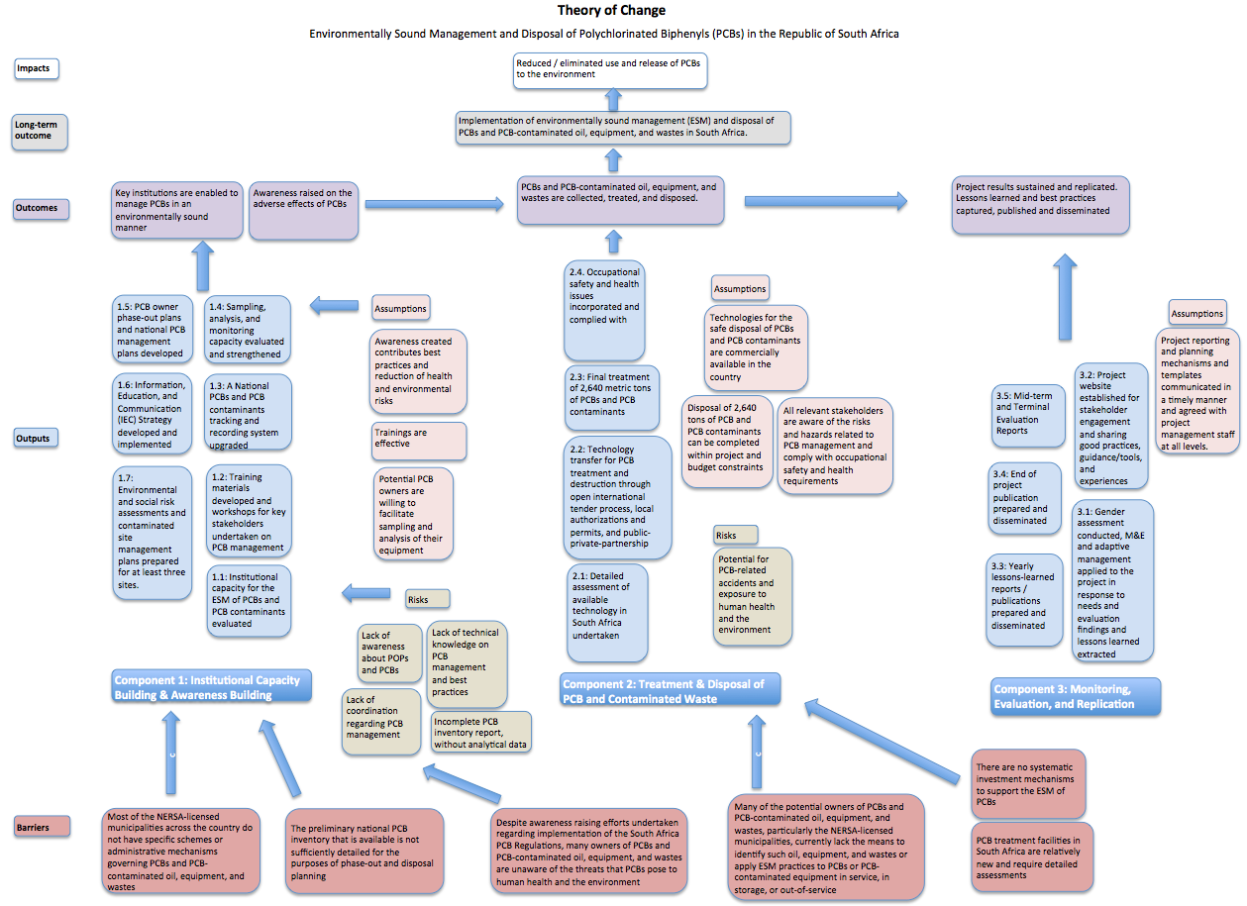
A Theory of Change for the project is presented below.
1.4 Incremental/additional cost reasoning and expected contributions from the baseline, the GEFTF, LDCF, SCCF, and co-financing

As indicated above, developing countries and countries with economies in transition, including South Africa, face several challenges concerning the environmentally sound management of PCB oils and PCB-containing oil, equipment, and waste due to issues such as a lack of capacity, poor inventories, and limited resources. Despite its limited financial and technical capability, South Africa has made significant progress in managing its own PCBs in an environmentally sound manner including those coming from other countries. For example, prior to development of the PIF, audit findings had revealed that one of the local plants (Thermal Power; now called A-Thermal), which was intended to treat PCB-contaminated fluids up to 200 ppm, was not functioning in line with international best practices and standards. Since then, A-Thermal has made significant upgrades to its facility. A-Thermal uses USEPA 761 PCB destruction air quality standards and has reported PCB destruction efficiency of 99.9999%. In addition, Enviroil, which uses detoxifying and dehalogenating technology for PCB transformer oil treatment has reported efficiency of 99.9%.
A detailed third-party assessment of these facilities will be conducted in the early part of this project to ensure that they can treat PCBs in an environmentally sound manner in accordance with national laws and regulations, Stockholm and Basel Convention provisions, and related guidance. Where needed, this project will support international technology transfer to South Africa through a PPP model to ensure that the country is technically capable to manage PCBs in an environmentally sound manner. It is only through this proposed project and GEF funding that this can be achieved.
The GEF grant will also be used to ensure the ESM of PCBs at the earlier stages of the lifecycle among the NERSA-licensed municipalities, Eskom, and other stakeholders. For example, the funds will also be used for establishing procedures for continuous updating of the national PCB equipment tracking and record keeping system, including sampling and analysis. This will support the Government of South Africa and the private sector to improve energy service delivery beyond the project lifespan. This will contribute directly to South Africa’s social and economic development.
The project will also provide technical and financial assistance to speed up the effort related to the enforcement of the South Africa PCB Regulations, and to help prevent further imports of equipment such as transformers and capacitors that contain PCBs. Export of suspected PCB-contaminated transformers and capacitors will also be prevented.
It is also worth noting that Eskom, the country’s only utility (and other PCB owners in South Africa, such as the NERSA-licensed municipalities), is not participating in the GEF-funded Southern Africa regional PCB project due to it being much larger (in term of assets and likely impact due to PCBs) than other regional utilities. This South Africa GEF project will therefore provide an opportunity for comprehensive ESM of PCBs in Eskom. Without the GEF resources, the utility would be left out.
The project will secure the ESM disposal of at least 2,640 tons of PCBs and PCB-contaminated oil, equipment, and wastes. It will explore the option of decontamination in addition to incineration, particularly using domestic facilities, thereby contributing to the capacity building of the country to dispose of future stockpiles in compliance with SC requirements.
Lastly, the project will provide a platform for exchange of information with other countries on PCB management techniques and approaches.
1.5 Global Environmental Benefits

The project is expected to achieve effective management of PCBs and PCB-contaminated oil, equipment, and waste and eliminate known stocks in South Africa. This is essential to minimize and eliminate exposure to POPs of stakeholders directly involved in the management of PCBs and PCB-contaminated oil, equipment, and waste; those who may be exposed due to a lack of awareness of related risks; others in close proximity to PCB-contaminated sites; and those who may be inappropriately using PCB-contaminated oils. Successful implementation of the project components will contribute significantly to global environmental benefits by reducing PCB-related risks to human health and the environment. Improper use and disposal of PCBs and PCB-contaminated oils and equipment, e.g. to landfill sites, as well as mismanagement of PCBs will be eliminated through implementation of the project, thereby avoiding pollution of groundwater, surfacewater, and soil, and subsequently reducing emissions to the atmosphere. As such, human health, ecosystems, and biodiversity will be preserved. The project will ensure the long-term sustainability of actions aimed at reducing the release of PCBs into the environment through strengthening capacity to enforce the South Africa PCB Regulations. It will also deliver the necessary management tools for achieving the disposal of PCBs, thereby eliminating the risks of PCB releases and contributing to the overall reduction of the global PCB aggregate load in the environment.
It is expected that through the project 2,640 tons of PCBs materials (oil, equipment, and wastes) in the country will be disposed of in an environmentally sound manner. Moreover, through the project, the region will be technologically and institutionally capacitated to provide solutions to South Africa and other countries to meet their PCB-related Stockholm Convention targets and obligations. For example, the project will collaborate with the GEF-funded Southern Africa regional PCB project, possibly through countries in the region shipping their PCBs and PCB-contaminated oil, equipment, and waste for treatment and destruction in South Africa. In addition, ESM practices will be identified, documented, and disseminated to national stakeholders and other countries in the region where similar projects are being undertaken.
1.6 Innovativeness, sustainability, and potential for scaling up

Strong sustainability of the project outputs will be ensured by: (i) strengthening implementation of policies, laws, and regulations related to PCB management; (ii) mobilization of stakeholders to become self-sustaining given the critical mass of the project activities; (iii) collaboration with other national and local government structures; (iv) design and establishment of a knowledge management framework; and (v) financial sustainability through the PPP model with companies dedicated to supporting the sound management of PCBs (which can also concurrently address e-waste and other hazardous waste). It is also expected that the facilities that will be upgraded through this project (where necessary) will also accept PCBs from other countries for treatment and destruction, ensuring economic viability and sustenance of the project.
The project will establish a National Expert Group, including experts from the government, private sector, academia, and NGOs. This multi-disciplinary working group will provide sound expert advice to the project team and will cover all topics related to the lifecycle of PCBs (administrative processes for PCB disposal, inventory taking, response to emergencies, maintenance and storage of equipment, and disposal). The project will also ensure a sound regulatory framework for PCB management in South Africa through capacity building and an emphasis on enforcement. For example, the project will include the use of on-site monitoring and inspections addressing the upgrading/construction of interim PCB storage sites, where required, and PCB-contaminated sites in the country. Training will be conducted for the local communities within localities impacted by PCBs.
The project will also assess possible technologies that may be adopted to address PCB management with less negative environmental impacts. This will involve undertaking a detailed third-party assessment of existing PCB treatment companies using both thermal and non-thermal solutions that are available locally. Through a strong PPP process, pollution prevention and sustainability will be achieved. If required, technology will be transferred through this project for the treatment and disposal of at least 2,640 tons of PCBs and PCB-contaminated oil, equipment, and waste will be the first of its kind in South Africa and the region.
The project will make use of consolidated technologies for the disposal of PCBs. High-concentration PCB waste and soil contaminated by PCBs will be pre-treated as necessary, packaged, and transported for destruction through high temperature incineration (HTI) or co-incineration in BAT/BEP compliant plants in compliance with the Basel Convention rules. However, based on waste characterization outcomes, management and disposal options will be evaluated. The evaluation of disposal options will take into account the levels of PCB concentrations and the condition of the equipment. For example, the treatment or disposal of contaminated transformers which are relatively new and in good working order might only require a dechlorination approach, whereas old, defective, and highly contaminated transformers in low- or high-risk areas might require dismantling at licensed facilities and incineration with PCB oil at an incineration facility meeting international standards as defined by the Stockholm and Basel Conventions. The process for evaluating these options will be robust and will include considerations such as: condition of the equipment, convention requirements, PCB concentrations in the waste streams, and local conditions. If the treatment facilities in South Africa are not viable, service providers regarding waste pre-treatment, packaging, transportation, and disposal will be selected through competitive bidding in compliance with UN and South African rules.
The experience gained through this project in the development, communication, and enforcement of guidelines and standards can be scaled up to countries with similar situations and to other areas of chemicals management in the country or beyond.
Management of PCB including transport, storage, and disposal will also be sustained and replicated in the following ways:
- An improved national regulatory framework for PCB management along with strengthened enforcement capacity will contribute to sustaining the project’s results beyond the project’s duration.
- The development of guidance and provision of training on the management of PCBs and contaminated sites will also strengthen capacity on processes that can be replicated and applied to other POPs and chemicals management. This applies to various stages of the life cycle such as transportation, storage, and disposal, as well as contaminated site identification and management regarding other contaminants.
- Strengthening the national PCB equipment tracking and record keeping system as well as capacity to prevent importation and illegal use of equipment likely to contain PCBs, with the participation of representatives of government, private sector, customs officers, academia, and NGOs, will also contribute to sustainability and prevent further imports of PCBs.
- Prioritizing as much work as possible with local operators while providing the necessary training and ensuring international standards are met, as per the obligations of the Stockholm and Basel Conventions. This will provide the co-benefits of capacity development and employment returns in the country, favouring sustainable long-term engagement of the national stakeholders. Collaboration with local businesses will be two-fold. First, through the promotion of local services for the environmentally sound collection, transport, and treatment of PCBs and PCB-contaminated oil, equipment, and waste and second, by promoting the recovery of decontaminated, and therefore higher value, metal scrap by local businesses, following all safety measures required by the Stockholm and Basel Conventions. Valorising reclaimable materials generated during treatment can help to offset treatment costs. These activities will be undertaken in coordination with firms specializing in PCB management and disposal, and related training will be provided.
- Exchange of experiences with other countries in the region will be explored, within the limits of the proposed budget, in order to promote through South-South cooperation the replication and/or adoption of best practices from and in neighbouring countries. The approach and related lessons learned from the project can serve as a basis for scale-up and replication in other countries, particularly in the region. The project will document these in the annual lessons learned and key experiences reports, which can assist other countries to replicate the most suitable approaches. The capacity strengthened in South Africa through the project can also be applied to other areas of chemicals management in the future.
- All guidance and training materials will continue to be accessible on the project websites beyond the project’s duration.
- Awareness raising activities will be targeted to all those involved in and/or impacted by PCBs and PCB-contaminated sites. The raised awareness will facilitate understanding of the associated risks and the modification of related practices to be applied for years to come.
The project will adopt a collaborative approach to implement all PCB management activities including identification, collection, storage, and disposal. This will have the following advantages: developing, promoting, and enhancing collaborative processes among the key project stakeholders; facilitating access to the sites for conducting sampling and analysis of equipment and waste, as well as for storage and packaging of PCBs and PCB-contaminated oil, equipment, and waste before treatment; and ensuring that the culture and views of the public and private partners will be properly integrated with an increased mutual understanding.

A.2. Child Project? If this is a child project under a program, describe how the components contribute to the overall program impact.

N/A
A.3. Stakeholders. Please provide the Stakeholder Engagement Plan or equivalent assessment. (Type response here; if available, upload document or provide link) In addition, provide a summary on how stakeholders will be consulted in project execution, the means and timing of engagement, how information will be disseminated, and an explanation of any resource requirements throughout the project/program cycle to ensure proper and meaningful stakeholder engagement.
Select what role civil society will play in the project:
Consulted only;
Member of Advisory Body; contractor;
Co-financier;
Member of project steering committee or equivalent decision-making body;
Executor or co-executor;
Other (Please explain) Support implementation of the IEC Strategy.

In South Africa, the Stockholm Convention is implemented by the South African Government through DEA as the focal point. DEA works collaboratively with various other Departments including Agriculture, Forestry and Fisheries (DAFF), Water and Sanitation (DWS), Trade and Industry (DTI), Science and Technology (DST), Transport (DoT), and Health (DoH). In addition, several non-governmental organizations, industry bodies, and para-statal organizations are consulted on the implementation of the Convention through the Multi-stakeholder Committee on Chemicals Management (MCCM).
The MCCM was established jointly by DEA and DTI in 2008. MCCM meets quarterly and consists of representatives from the key national organs of state that are responsible for chemicals (listed above). The major industry and NGO stakeholders are also invited to attend its meetings. The MCCM’s Terms of Reference cover all of the MEAs associated with chemicals and waste management including SAICM. The MCCM is responsible for preparing for international meetings; reporting back to the key national organs of state and stakeholders on decisions taken at international meetings; communicating the implications of such decisions and the actions needed to implement these decisions to organs of state and stakeholders; and coordinating national implementation.
A National Project Steering Committee for the development of the NIP (the PSC) was also established in 2011 to oversee the development of the first generation POPs Profile and NIP. The PSC, chaired by DEA, is a multi-stakeholder forum and comprises fifteen permanent member institutions and some five temporary member institutions, which represent government, industry, agricultural sector, and civil society. NIP updating is coordinated by DEA with oversight provided by the PSC.
A PPG Project Steering Committee was also formed for the PPG phase of this PCB project, involving DEA, DBSA, and AI.
Thus the steering committee of this project will draw from the above mechanisms and work with them throughout the implementation. The project will be implemented in partnership with the relevant institutional and industrial partners, i.e. DEA, Eskom, NERSA-licensed municipalities, industry, other potential holders of PCB equipment, and other interested and affected stakeholders. Each one of these partners will play a specific role in ensuring that the changes needed for the project implementation are achieved.
Collaboration with civil society organizations will also take place, especially regarding awareness raising activities in the communities and informal sectors, and in particular regarding the impacts of inappropriate use of PCB-contaminated oil. Civil society and the public at large will be kept informed of project objectives, activities, achievements, and best practices through the IEC strategy. In addition, the project will give the community and other stakeholders opportunities to provide comments on and participate in project activities, including: participation of civil society, NGOs, and others in meetings, fora, seminars, etc. related to decision-making on the project’s implementation plans; participation of civil society, NGOs, and others in training workshops, where appropriate; and through establishment of moderated discussion forums on the project’s website.
The above will also address some of the identified risks of the project, such as: excluding any potentially affected stakeholders, in particular marginalized groups, from fully participating in decisions that may affect them; generating adverse social and environmental effects from the project; or generating safety risks to local communities from project construction, operation, or decommissioning.
The key stakeholders and their roles in the project is summarized in the table below.

Table 2: List of the key stakeholders and relative roles
NAME | TYPE | SPECIALIZATION | ROLE IN THE PROJECT
Department of Environmental Affairs (DEA) | Government | Custodian of environmental policy and a key regulator in in environmental issues including chemicals and wastes. This Department is the designated national authority and the focal point for the implementation of the MEAs that relate to chemicals ad waste management including the Basel, Rotterdam, and Stockholm Conventions. With respect to the environment, DEA is, among others, responsible for setting national policies, norms, and standards. | - Coordinates the project  - Chairs the PSC  - Hosts the Project Secretariat  - Ensures execution of the national comprehensive PCB inventory exercise  - Supports national training conducted under the project  - Supports the regulatory aspects of the project  - Supports PCB analysis (with appropriate technical support from the project)
Development Bank of Southern Africa (DBSA) | GEF agency (government entity) | Plays a pivotal role in delivering developmental infrastructure in South Africa and the rest of the African continent. | - Serves as the project’s Implementing Agency as an accredited entity of the GEF  - Member of the PSC
Africa Institute for the environmentally sound management of hazardous and other wastes (AI) | Integovernmental organisation | Regional centre for both Stockholm and Basel Conventions. AI has executed several projects in the region and is the strongest partner of GEF Agencies in the region. It is currently executing the GEF-UNEP Southern Africa regional PCB project that covers 12 of the SADC member states, and the South Africa NIP updating project. | - Serves as the project’s Executing Agency  - Member of the PSC
Eskom | Government | The state-owned electricity company generates approximately 95% of the electricity used in South Africa and approximately 45% of the electricity used in Africa. Eskom generates, transmits, and distributes electricity to industrial, mining, commercial, agricultural, and residential customers and redistributors. | - Member of the PSC  - Provides a dedicated officer to support the national comprehensive PCB inventory  - Provides logistical supports for project-related project activities  - Provides training support through its Training School  - Supports PCB analysis (with appropriate financial support from the project)
South African Local Government Association (SALGA) | Government | Represent, promotes, and protects the interests of local governments and raises the profile of local government. | - Member of the PSC  - Support training, awareness raising, and outreach activities
Department of Cooperative Governance and Traditional Affairs (COGTA) | Government | Ensures that all municipalities perform their basic responsibilities and functions consistently by: putting people and their concerns first; supporting the delivery of municipal services to the right quality and standard; promoting good governance, transparency and accountability; ensuring sound financial management and accounting; and building institutional resilience and administrative capability. | - Member of the PSC  - Support training, awareness raising, and outreach activities
Department of Energy (DoE) | Government | Has oversight responsibilities over five State Owned Entities (SOE) and their subsidiaries which are either classified as Schedule 2 or 3 in the PFMA; these include the National Energy Regulator of South Africa (NERSA) that directly regulates Eskom and 174 NERSA-licensed municipalities. | - Member of the PSC  - Supports the regulatory aspects of the project  - Participates in the comprehensive PCB inventory
Department of Trade & Industry (DTI) | Government | The driver of industrial development and trade in South Africa. | - Supports the regulatory aspects of the project  - Participates in the comprehensive PCB inventory
Department of Health (DoH) | Government | Administers the Hazardous Substances Act of 1973 and its regulations. Some of the chemicals listed by the Rotterdam and Stockholm Conventions are controlled by the same Act. | - Provides specialized knowledge on the effects of PCBs on human health  - Participates in national awareness raising activities
Department of Labour (DoL) | Government | The custodian department for occupational safety and health programmes, which include fostering a safe and healthy work environment. DoL is also the focal point for the implementation of the Globally Harmonised System of Classification and Labelling of Chemicals (GHS). | - Provides specialized knowledge on the occupational safety and health aspects of the project  - Participates in national awareness raising activities
Department of Mineral Resources (DoMR) | Government | Responsible for mining industry; many of the mining houses own electrical equipment such as transformers and capacitors that may contain PCBs and are thus important to project execution. | - Supports the PSC to liaise with mining stakeholders
Chamber of Mines | Government | Acts as a principal advocate for mining in South Africa to government, communicating major policies endorsed by its members. | - Supports the PSC to liaise with mining stakeholders
Department of Corporate Governance and Traditional Affairs | Government | Oversees local government structures, namely municipalities and traditional rulers. Its mission is to ensure that all municipalities perform their basic responsibilities and functions consistently by, among other things, supporting the delivery of municipal services to the right quality and standard. | - Supports the PSC to liaise with the NERSA-licensed municipalities  - Participates in national awareness raising activities
NERSA | Government | Regulates the electricity, piped-gas, and petroleum pipelines industries in terms of the Electricity Regulation Act, 2006 (Act No. 4 of 2006), Gas Act, 2001 (Act No. 48 of 2001) and Petroleum Pipelines Act, 2003 (Act No. 60 of 2003). | - Facilitates coordination with the NERSA-licensed municipalities
NERSA-licensed Municipalities | Government | Distributes electricity and own transformers, capacitors, and other electrical equipment that could contain or be contaminated with PCBs. There are 174 NERSA-licensed municipalities. | - Provides dedicated officers to support the PCB inventory and other PCB management activities  - Provide logistical supports for project-related project activities  - Participates in training
Council for Scientific and Industrial Research (CSIR) | Government | Undertakes directed and multidisciplinary research, technological innovation, and industrial and scientific development to improve the quality of life of the country’s people. | - Provides support for technology-related matters of the project
A-Thermal (to be confirmed pending the national selection process) | Private sector | Specializes in the thermal treatment and management of hazardous and toxic waste, primarily servicing the pharmaceutical and chemical manufacturing industries. | - Provides support to undertaking a detailed third-party assessment of its services regarding PCB treatment  - Participates in technology transfer and PPP in accordance with the findings of the assessment  - Participates in a transparent bid process to become a preferred PCB treatment and destruction partner
Enviroil (to be confirmed pending expression of interest and the national selection process) | Private sector | Conducts a verifiable process that breaks down the PCB structure in transformer oil, removing the chlorine from the PCB molecule, and leaving the biphenyl in the transformer oil. | - Provides support to undertaking a detailed third-party assessment of its services regarding PCB treatment  - Participates in technology transfer and PPP in accordance with the findings of the assessment  - Participates in a transparent bid process to become a preferred PCB treatment partner
Scrap metal dealers | Private sector | Processes equipment manufactured with metal, which may be PCB-contaminated. | - Will be targeted for awareness raising to build knowledge and capacity regarding PCB-contaminated materials
Sector Education and Training Authority (SETA) | Government | Helps implement the National Skills Development Strategy, contributing to the raising of skills. | - Supports development and implementation of training materials and activities
Local Government Sector Education and Training Authority (LGSETA) | Government | Provides an environment to facilitate the training and up skilling of various employees and people involved in local government structures, as well as unemployed South Africans. This entails creating and implementing a variety of skills development interventions such as, the Sector Skills Plan (SSP) and learning programmes aimed at local government employees and others working within the sphere such as traditional leaders and ward councillors. | - Supports development and implementation of training materials and activities
Groundwork | Non-governmental organization |  | - Member of the PSC (NGOs will be proposed to designate one of their entities to represent them on the PSC; this should be determined on the occasion of the Inception Workshop for the project)  - Coordinates with partners regarding community input and awareness raising activities
Local communities | Civil society | Knowledge of needs and interests of local communities | - Participates in awareness raising activities; training workshops, where appropriate; and moderated discussion forums on the project’s website

A.4. Gender Equality and Women's Empowerment. Provide the gender analysis or equivalent socio-economic assessment. (Type response here; if available, upload document or provide link)
Does the project expect to include any gender-responsive measures to address gender gaps or promote gender equality and women’s empowerment? (yes /no) If yes, please upload gender action plan or equivalent here.
If possible, indicate in which results area(s) the project is expected to contribute to gender equality:
closing gender gaps in access to and control over natural resources;
improving women’s participation and decision making; and or
generating socio-economic benefits or services for women.
Does the project's results framework or logical framework include gender-sensitive indicators? (yes /no)

Women are generally at higher risks regarding POPs being distributed in the broader environment, specifically related to their bioaccumulation and transfer through breast milk. Due to their physiological features, women and children are more exposed to risks associated to POPs compared to adult men given the same doses of exposure. The risks associated to POPs exposure for pregnant women and children are also comparatively higher. Gender mainstreaming considerations in line with the DBSA and GEF safeguards are therefore an integral part of the project strategy.
Specific activities will be developed to encourage women to access the information related to the project implementation and POPs. Awareness raising materials specially designed for facilitating women's involvement and knowledge will be prepared, which will introduce the gender-differentiated impact of POPs exposure on human health, particularly reproductive health, with the overall aim of reducing the risk of exposure of women and infants given their specific sensitivity. For example, in order to raise public awareness, the project will target media such as radio and TV stations and programmes that are mainly addressed to women. Gender aspects will also be taken into consideration when implementing specific project activities related, for example, to adoption of risk-reduction counter-measures.
In addition, in the course of project implementation, compliance with DBSA and UN policies on equal opportunities and the GEF Policy on Gender Mainstreaming will be maintained at each stage to ensure that the project supports women’s capabilities and their enjoyment of rights, and women’s equal and meaningful participation as actors, leaders, and decision-makers. Further issues may be identified during project implementation. In the course of the recruitment processes, the project will encourage the participation of women to ensure that they are represented at all levels of project development and implementation.
The project will also implement the Gender Action Plan, prepared during the PPG phase (see Annex H). This will cover aspects related to female workers within the main stakeholders’ facilities (e.g. Eskom, NERSA-licensed municipalities, industry, PCB treatment companies) on various levels: as technicians dealing with equipment containing PCBs; for general safety and maintenance at these facilities; at the management level taking decisions regarding companies’ PCB phase-out and management plans; and participating in capacity building under the project. Male technicians working in transformer maintenance and disposal facilities will be provided with information specifically on the proper use and handling of PPE to ensure that their families are not exposed to harmful chemicals at home. Women in the community will also be involved at various stages. Children will also be discouraged from participating in scrap metal and used oil collection. Aspects of the Gender Action Plan include: establishing strategic partnerships and identifying synergies with organisations that focus on women’s empowerment; developing project materials and training that directly address gender-differentiated issues; and designing and implementing a communication campaign that addresses women’s needs.
The project results framework includes the collection of information in a sex-segregated manner. Gender markings will be included in project reporting of the following data: (i) total number of full-time staff that are men/women; (ii) number of jobs created by the project that are held by men/women; and (iii) number of gender-sensitive publications produced.

A.5 Risk. Elaborate on indicated risks, including climate change, potential social and environmental risks that might prevent the project objectives from being achieved, and, if possible, the proposed measures that address these risks at the time of project implementation.(table format acceptable):
The potential risks and proposed mitigation measures are summarised Table 2 below. Overall, the project’s risk rating is considered as Medium.
The Project Manager will monitor risks quarterly and report on the status of risks to the Project Management Unit (PMU) and DBSA. Risks will be reported as critical when the impact and probability are high. Management responses to critical risks will also be reported to the GEF in the annual PIR.
Environmental and Social Safeguard Standards (ESSS) and related risks are accommodated within the broader risk framework, and are separately described in the Environmental and Social Safeguards Scoping Report (see Annex I) with areas of attention/monitoring/follow-up actions for the PMU. The PMU will be responsible for implementing the risk management measures, and DBSA will be responsible for technical support and oversight.

Table 3: Risks and mitigation measures

Component | Risk | Proposed risk mitigation measure | Risk level
1. Institutional capacity building and awareness raising | Low level of participation and support of key stakeholders for the implementation of the project | A stakeholder analysis was prepared during the PPG phase, which identified a broad range of stakeholders, and stakeholder outreach and communication was undertaken. During project implementation, a number of activities will be undertaken to ensure stakeholder involvement including: establishing an inter-sectoral PSC representing key stakeholders; providing numerous opportunities to submit comments and participate in project activities including participation of civil society, NGOs, and others in meetings, forums, seminars, etc. related to decision-making on the project’s implementation plans; participation of civil society, NGOs, and others in training workshops, where appropriate; developing and implementing an IEC Strategy; developing awareness raising materials such as brochures, project cards, meeting banners, and posters, for different target groups; providing local communities with access to awareness raising materials in their own local languages; and conducting training for community leaders. All of these efforts will be geared towards ensuring that there is better understanding of the problems and ensure protection of the population and the environment from adverse effects of PCBs.  In addition, the National Stockholm Convention focal point has confirmed the strong interest of the country in the project, which is in line with the priorities regarding PCB management as set in the NIP. In terms of risk mitigation measures, the National Stockholm and Basel Convention focal points will participate in the PSC and will play key roles for coordinated actions at the national level between government, Eskom, NERSA-licensed municipalities, industry, and other key stakeholders. The National Coordination Mechanism established during the NIP development and MCCM, and which has the commitment of a wide range of governmental sectors, will be used as a basis for national coordination. Furthermore, the Government of South Africa, by ratifying several MEAs including the Stockholm Convention, by developing its NIP (and currently undertaking NIP updating) and having recently updated its national PCB inventory, and by formally applying for this project has illustrated strong support towards the sound management of chemicals and in particular POPs. DEA and parliamentarians from the environmental select committees will be engaged as early as possible. Specific awareness raising events will be organised and targeted at them. | L
1. Institutional capacity building and awareness raising | Delayed or incomplete PCB inventory due to the absence of coordination or technical and economic difficulties in carrying out sampling of dielectric oil | The project intends to address this risk by establishing strong supervisory mechanisms supported by TORs. A national inventory team will be formed and trained. The national inventory team will be complemented with regional teams. The composition of the national inventory team will include representatives of DEA, Eskom, NERSA-licensed municipalities, and others as appropriate. These will then be assisted by the regional teams. These teams will be appointed on a full-time basis during the whole duration of the inventory period. | L
2. Final treatment and disposal of PCBs and PCB-contaminated oil, equipment, and wastes | Not enough PCB waste to ensure commercial viability of identified technology options | PCB inventories and phase-out plans have already been prepared by Eskom and 159 other industries. Commitment with the main PCB owners has been confirmed during the PPG stage, including from Eskom, various NERSA-licensed municipalities, and industry. These stakeholders are willing to cooperate by proving the co-financing and technicians to support the inventory and other project activities. In addition, PCB treatment companies, such as A-Thermal, have expressed their commitment to support the project including undertaking an independent third-party detailed assessment of their technology.  The project allocated enough grant and co-financing resources to dispose or decontaminate 2,640 tons of PCBs and PCB-contaminated oil, equipment, and waste. Based on phase-out plans, asset registries, personal communications, and extrapolation, at least 1,516 tons of PCB-contaminated oil; 753 tons of equipment contaminated with pure PCBs; and 371 tons of oil and articles with PCB concentration > 500 ppm are estimated to exist in South Africa. The exact quantities will then be estimated to verify that the allocated resources are adequate. | M
 | Serious threats to human health and the environment due to releases of PCBs during the identification, removal, transport, and treatment of PCB waste | A national PCB management plan to mitigate possible risks will be developed and implemented. ESM guidelines, as well as the South Africa PCB regulations and SANS 290, will also be followed to the letter. Training in environmental best practices for each stage of the lifecycle of PCB management, i.e. safe handling, transportation, temporary storage, and disposal of PCBs, will be conducted and best practices, as per international standards, enforced during the implementation phase of the project.  Only trained personnel will participate in technical project activities, such as the sampling of transformers during the inventory stage of the project, handling of PCB-contaminated oil, transportation, and storage. All people involved in these activities will be required to have complete PPE and will receive practical training on its use and other health and safety matters. The sampling of transformer oil will be preceded by proper planning and coordination and will be supervised by experienced and well-trained personnel to minimize worker exposure to PCBs and to reduce or eliminate the risk of potential PCB-contaminated transformer oil into the environment. These activities will be carried out under a controlled environment. | L
 | Potential transformer holders not willing to identify target transformers and to report PCB-contaminated equipment and related waste | Potentially conflicting stakeholder interests will be identified and address through the close involvement of stakeholders in the project and implementation process. | M
 | Accidents and environmental releases during transport of PCB waste to interim storage sites | Development of a national PCB management plan including standard operating procedures (SOPs), preparation and dissemination of technical guidelines, and holding technical training workshops will minimise risks.  The transportation of PCBs from place of origin to interim temporary storage facilities, where required, will be carried out only by trained personnel using rigorous, well-established, and documented international hazardous waste and dangerous goods management practices, procedures, and standards, including those set out by the Basel and Stockholm Conventions, GEF STAP guidelines, and internationally referenced OHS procedures for on-site workers.  Local transportation routes with the least likely risks will be determined and selected.  If any transboundary movement of PCB materials and wastes is deemed necessary, this will be undertaken by a professional company that is internationally certified to undertake such activities. This involves shipping the waste to a commercially available and certified hazardous waste facility, such as an incinerator located outside the country. Such companies will provide proof of insurance and the necessary bank guarantees to support remediation of potential accidents.  For all components, capacity building and training programmes will be conducted by international experts and advisory support will be provided. Specifically, local personnel involved in direct work on project sites will be trained and supported throughout the project duration. | L
 | PCB leakage from interim storage facilities | This assessment is based on the specific situation in Ethiopia and the implementation of similar PCB projects in other countries. Based on this, a national PCB management plan will be developed that addresses all aspects associated with this risk. In addition, the following management measures will be undertaken:  Temporary PCB storage facilities will be situated at existing transformer storage and repair facilities, refurbished as part of the project, and will be designed, upgraded, and operated following strict environmental regulations. This will be complemented by best practices to ensure that workers, public, and the environment are properly protected. Secondary containment will be built around any liquid storage area. The facilities will also be upgraded with an overall containment retention wall able to hold at least 200% volume capacity of the largest storage container in the building. The management of these facilities will be carried out by properly trained operators adhering to strict environmental and health and safety guidelines. PCB-containing oil will be stored in UN-approved drums to minimize the potential for release of PCBs into the environment.  A routine monitoring programme of the temporary storage facilitates and the surrounding areas will be implemented with baseline PCB contamination levels of the sites properly determined.  The continuous checking of equipment and operations to minimize accidental releases of PCBs will be part of the facilities’ operating procedures. Any leaks discovered or activity determined to be the source of unwanted releases of PCBs will be promptly corrected.  Towards the end of the project, all equipment and materials used in project operations that have the potential for PCB contamination will be secured and disposed of in an environmentally sound manner.  All operations conducted at the temporary storage facilities will be subject to strict international requirements on PCB management, and will be carried out by trained operators.
 | Delay in procurement, licensing, contracting – PPP model is quite an involving process | Streamlining processes and close involvement of stakeholders to ensure facilitated decision-making process  The project also aims to upgrade an existing facility, not all processes will be implemented from the beginning | M
 | Monopolization by a single private company for the PCB treatment in the country | All PCB treatment companies in South Africa (and abroad, where appropriate) will have an opportunity to submit a bid to participate in the project. During the PPG phase, A-Thermal was the only PCB treatment service provider in South Africa that made itself available for a preliminary assessment. To ensure transparency and a fair selection process, an independent third-party detailed assessment of all interested PCB treatment service providers, such as A-Thermal and Enviroil, will be conducted in the early stage of project implementation. The selection process will be based on the assessment including the appropriateness of technology, technical capabilities of service providers’ staff, and cost-benefit analysis, among other criteria. This selection process will be transparent, based on national due process enshrined in the national legislation, terms of refence and agreed criteria, and overseen by the project steering committee, which will comprise a cross-sectoral set of stakeholders. International experts will also provide technical advice.  While the process may result in the selection of a single private company for final PCB treatment in the country, other companies and stakeholders will be involved in various project activities including oil sampling and analysis, transformer and oil collection and transportation, and construction and management of interim storage facilities. Training and capacity building activities under the project will be provided to a wide range of stakeholders at the national, provincial, and municipal level, as well as within the public and private sectors, enabling replication and scale up of sound PCB management across the country.  Capacities developed under the project will ensure future capability to manage and treat PCBs in South Africa beyond the project, where applicable, as well as other hazardous waste. These services may also be extended to other countries in the region, in accordance with national and international law.
 | Generation of greenhouse gas emissions from inadequate technology of the PCB treatment facilities or impacts on PCB treatment processes from extreme weather events | The technology of the potential PCB treatment facilities will be assessed and where necessary improved to ensure that they can treat PCBs in an environmentally sound manner, including ensuring avoidance of greenhouse gas emissions that may result from the use of inadequate technology of the PCB treatment facilities. For example, Nitrous Oxide (N₂O) is of relevance from a climate perspective and is emitted during incineration of hazardous waste. This will be mitigated with the application of BAT/BEP consistent with the social and economic realities of the country. Measures will also be implemented to address any risks related to extreme weather events. This will be undertaken in accordance with national laws and regulations, Stockholm and Basel Convention provisions, and related guidance. Further, Feedstock composition analysis will also be conducted to separate recyclable materials from hazardous content, which will lead to the volume reduction of incinerated waste and result in carbon savings and other environmental benefits. | L
3. Monitoring, evaluation, and replication | Delay in project implementation as well as monitoring and evaluation may cause delays in holding meetings and issuing required reports | Proper communication channels will be established, building on the PPG phase and existing coordination mechanisms. | M
3. Monitoring, evaluation, and replication | Insufficient participation of women in the project | A Gender Action Plan was developed during the PPG phase, based on an initial gender analysis, and will be implemented throughout the project. Aspects of the Plan include: establishing strategic partnerships and identifying synergies with organisations that focus on women’s empowerment; developing project materials and training that directly address gender-differentiated issues; and designing and implementing a communication campaign that addresses women’s needs. | M

A.6. Institutional Arrangement and Coordination. Describe the institutional arrangement for project implementation. Elaborate on the planned coordination with other relevant GEF-financed projects and other initiatives.
The project will be implemented following DBSA and GEF’s policies and procedures. The Implementing Agency for this project is DBSA and the Executing Partners are the Department of Environmental Affairs (DEA) and Africa Institute (AI). The Executing Partner is responsible and accountable for managing this project, including the monitoring and evaluation of project interventions, achieving project outcomes, and for the effective use of GEF resources.

The project organisation structure is outlined in Figure 1 below.

Figure 1: Project Structure
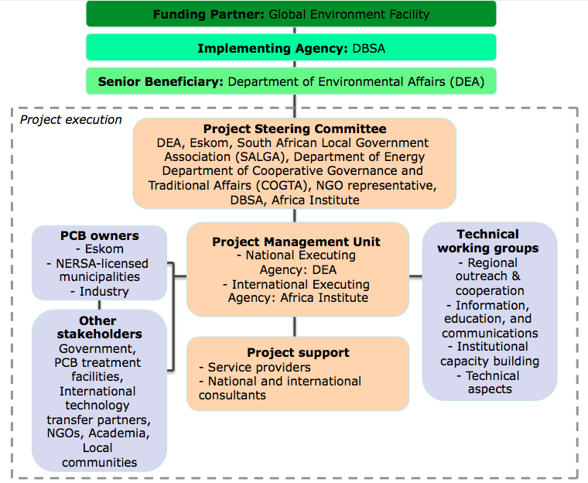

The Project Steering Committee (PSC) is responsible for making management decisions, by consensus, when guidance is required by the Project Manager, including recommendations for the Executing Partners’ approval of project plans and revisions. The PSC’s decisions should be made in accordance with standards that shall ensure management for development results, best value for money, fairness, integrity, transparency, and effective international competition. The PSC comprises the following individuals:
- DEA
- Eskom
- South African Local Government Association (SALGA)
- Department of Energy
- Department of Cooperative Governance and Traditional Affairs (COGTA)
- NGO representative
- DBSA
- AI
The Project Manager will run the project on a day-to-day basis within the constraints laid down by the PSC. The Project Manager’s function will end when the final project terminal evaluation report and other documentation required by the GEF and DBSA have been completed and submitted to DBSA (including operational closure of the project). A Responsible Party will also be contracted to provide technical support to the project.
Both the PMU, which will be established at DEA, and the PSC will implement mechanisms to ensure ongoing stakeholder participation and effectiveness of the project by conducting regular stakeholder meetings, issuing a regular project electronic newsletter, conducting feedback surveys, implementing strong project management practices, and having close involvement with DBSA as the GEF implementing agency.
This project builds on the NIP that was formulated and submitted by the country in the 2012, with funding from the GEF, in which the baseline situation with regards to the 12 POPs including PCBs was analysed. It also builds on the current NIP updating project.
Where relevant, the project will also build on other POPs-related regional projects implemented in Africa, such as the UNIDO/UNEP project “Capacity Strengthening and Technical Assistance for the Implementation of Stockholm Convention National Implementation Plans (NIPs) in African Least Developed Countries (LDCs) of the COMESA, ECOWAS and SADC regions”, regarding sustainable enforcement and administrative capacity, contaminated site identification methodology, training on ESM of contaminated sites, and South- South cooperation.
The project will also build on existing experience gained and training undertaken in current and past PCB projects in the African region, including in Ghana, Ethiopia, and The Gambia (implemented with the technical support of UNITAR), among others.
In addition, synergies will be achieved, where applicable, with the project “Disposal of PCB oils contained in transformers and disposal of capacitors containing PCB in Southern Africa” which is currently running in 12 SADC countries. The objective of that project is to reduce environmental and human health risks from PCB releases through the demonstration of a regional approach to the introduction of cost-effective and socially acceptable ESM of PCB oils, equipment, and wastes held by electrical utilities and other PCB owners in participating countries. Where appropriate, PCBs and PCB-contaminated oil, equipment, and waste will be considered for treatment in South Africa, subject to the outcome of the detailed third-party assessment of the South African PCB treatment facilities and South African law. Some of the training workshops in the South Africa project may include participants from the SADC PCB project to expose them to PCB management and treatment processes, particularly for technicians, and to ensure regional collaboration that will benefit both South Africa and the region.
The project will also seeks synergies with the technically approve project “Leapfrogging South Africa’s markets to high-efficiency LED lighting and high efficiency distribution transformers”, to be implemented by DBSA and UNEP, regarding high-efficiency distribution transformers. Synergies will be explored regarding process-related matters such as developing a national strategy to advance energy efficiency; access to monitoring, surveillance, control and testing facilities for distribution transformers; procurement specifications for distribution transformers; and enhancing capacities for a national system to collect, recycle, and responsibly dispose of distribution transformers that contain both valuable and hazardous materials. This will be coordinated with similar process regarding PCB management and PCB-free equipment and oil.

Additional Information not well elaborated at PIF Stage:

PCB inventory data, technical specifications of PCB treatment and disposal facilities in South Africa, and possible PPP framework (as presented throughout this document).
A.7 Benefits. Describe the socioeconomic benefits to be delivered by the project at the national and local levels. How do these benefits translate in supporting the achievement of global environment benefits (GEF Trust Fund) or adaptation benefits (LDCF/SCCF)?

The project will bring direct and indirect socio-economic benefits. The direct and immediate benefits are those related to the implementation of the project itself, including employment of project staff and operators; strengthened technology for PCB treatment, if required; establishment of a PPP for the treatment of the PCBs and PCB-contaminated oil, equipment, and waste; and financial incentive for the PCB owners for the sampling, analysis, and treatment of their PCBs and PCB-contaminated oil, equipment, and waste.
The project will also bring obvious indirect benefits. The removal of PCB sources (oil, equipment, waste, contaminated soil) from the environment will prevent the contamination of the environment by these substances. This will translate into reduced mortality and morbidity of the population in the long term, with specific reference to the pathologies associated with exposure to PCBs, resulting in the reduction of social and economic costs. In addition, the technical capacity developed by the project partners (e.g. project staff, stakeholders, consultants) in the management of PCB waste will result in the creation of skills and capabilities for the management of hazardous substances and waste in general, which will result in the creation of specialized jobs in the country.

A.8 Knowledge Management. Elaborate on the knowledge management approach for the project, including, if any, plans for the project to learn from other relevant projects and initiatives (e.g. participate in trainings, conferences, stakeholder exchanges, virtual networks, project twinning) and plans for the project to assess and document in a user-friendly form (e.g. lessons learned briefs, engaging websites, guidebooks based on experience) and share these experiences and expertise (e.g. participate in community of practices, organize seminars, trainings and conferences) with relevant stakeholders.
Knowledge management will be an integral part of the project. The project will generate a significant account of knowledge, which will be carefully managed during project implementation. Project results will be properly communicated and disseminated during the whole project lifecycle with all relevant stakeholders, and lessons learned and success stories will also be shared among other countries and UN agencies.
The work of the project will build on existing experience gained in similar programmes from the African region, for example, PCB projects with UNITAR (and UNDP) involvement, such as Ghana, Ethiopia, and The Gambia, as well as projects implemented by other GEF agencies. Coordination with other UN agencies working on chemicals and capacity building will be ensured so that the best quality of services can be provided to South Africa and that experiences gained through this project are fully disseminated in Africa and beyond. DBSA and the Africa Institute will also ensure that the activities, achievements, and lessons learned from the project will be shared with all of their relevant partners and in appropriate regional and global forums. Knowledge sharing platforms will include the project website and mechanism within the GEF for sharing knowledge and information. The Stockholm Convention’s mechanisms like the PCB Elimination Network (PEN) and participation in collective information events such as webinars organized by the Basel/Stockholm Conventions Secretariat will be utilised as knowledge management tools.
At the national level, during project implementation, a website for sharing relevant project information will be designed and launched. Public access will be granted to all resources which are of public relevance, such as project performance and guidance on PCB material management for easy retrieval by all potential users including industry, NGOs, academia, and other project partners. User-friendly summaries and multimedia materials based on the project activities will be uploaded on the website periodically, and proposed for partners’ websites. Electronic newsletters will be regularly issued and feedback surveys will be conducted. All major types of media will be used to disseminate information about project objectives and activities. Success stories, manuals, flyers, and presentations will be made available on the website for possible knowledge roll-outs. Among the information to be included are the health impact of POPs (specifically PCBs), updates on regulations, targets and goals in the NIP and PCB project, and the status of compliance of South Africa in the Stockholm Convention. A feedback mechanism on the usefulness of the data and information will be included for the enhancement of the website.

B. Description of the consistency of the project with:
B.1 Consistency with National Priorities. Describe the consistency of the project with national strategies and plans or reports and assessements under relevant conventions such as NAPAs, NAPs, ASGM NAPs, MIAs, NBSAPs, NCs, TNAs, NCSAs, NIPs, PRSPs, NPFE, BURs, etc.:

The Constitution of South Africa enshrines the Bill of Rights with specific emphasis on environmental rights. The Bill of Rights states, among other things, that: “Everyone has the right—
(a) to an environment that is not harmful to their health or wellbeing;
(b) to have the environment protected, for the benefit of present and future generations, through reasonable legislative and other measures that—
(i) prevent pollution and ecological degradation;
(ii) promote conservation; and
(iii) secure ecologically sustainable development and use of natural resources while promoting justifiable economic and social development.”
South Africa has a duty to give effect to these rights by implementing measures to protect the environment for present and future generations. Examples of such measures include the ratification of MEAs and instituting regulations on the management of POPs in South Africa. The Constitution also sets out the rights and obligations of the legislative and executive arms of government in adopting international agreements: essentially the executive is responsible for negotiating and signing international agreements and such agreements only become binding on the State after Parliament has approved the adoption of the international agreement.
South Africa has also specifically prioritised the effective management of POPs chemicals (and PCBs) to reduce, and ultimately eliminate, the use and release of POPs in accordance with the requirements of the Stockholm Convention and national sustainable development objectives and strategies such as the Government of South Africa-United Nations Strategic Cooperation Framework 2013-2017 and South African National Development Plan (NDP) 2030, which provides a broad strategic framework to guide key choices and actions for South African development for the coming years. Environmental sustainability through pollution control and cleaner/green processes with climate change mitigation take the top position. This project is aligned with South Africa’s commitments at the international level, such as the Stockholm Convention, and builds on the country’s national efforts to comply with such obligations. This includes consistency of the project with the NIP on POPs, submitted in May 2006, as well as the draft updated NIP; the 2014 South Africa PCB Regulations; and South African National Standard on “Mineral insulating oils – Management of polychlorinated biphenyls (PCBs)” (SANS 290).
In accordance with the above documents, regulations, and standards, under the project PCBs and PCB-contaminated oil, equipment, and waste will be identified and labelled, and management measures to mitigate/eliminate the risk associated with these materials will be put in place. These activities will also enable the formulation of the national PCB management plan and phase-out plans by PCB owners that will feed into the NIP, thus enabling South Africa to update a realistic and verifiable NIP that will be submitted in line with the Stockholm Convention.
The project also builds capacity for sound management of PCBs at both the national and regional level. The project not only enables regional cooperation, but also assists South Africa in terms of managing cross-border movement of PCBs (and other toxic substances), and ensuring compliance with the Stockholm Convention and the country’s own Customs Tariff Code.

C. Describe the budgeted m &e plan:
The project results as outlined in the project results framework will be monitored annually and evaluated periodically during project implementation to ensure the project effectively achieves these results.
The project will comply with DBSA and GEF standard monitoring, reporting, and evaluation procedures. Reporting requirements and templates are an integral part of the legal instrument to be signed by the Executing Agencies and Implementing Agency. DBSA will work with the relevant project stakeholders to ensure that DBSA M&E requirements are met in a timely fashion and to high quality standards. Additional mandatory GEF-specific M&E requirements (as outlined below) will be undertaken in accordance with the GEF M&E policy and other relevant GEF policies.
In addition to these mandatory DBSA and GEF M&E requirements, other M&E activities deemed necessary to support project-level adaptive management will be agreed during the Project Inception Workshop and will be detailed in the Inception Report. This will include the exact role of project target groups and other stakeholders in project M&E activities including the GEF Operational Focal Point and national/regional institutions assigned to undertake project monitoring. The GEF Operational Focal Point will strive to ensure consistency in the approach taken to the GEF-specific M&E requirements (notably the GEF Tracking Tools) across all GEF-financed projects in the country. This could be achieved for example by using one national institute to complete the GEF Tracking Tools for all GEF-financed projects in the country, including projects supported by other GEF Agencies.

M&E oversight and monitoring responsibilities:
Project Manager: The Project Manager is responsible for day-to-day project management and regular monitoring of project results and risks, including social and environmental risks. The Project Manager will ensure that all project staff maintain a high level of transparency, responsibility, and accountability in M&E and reporting of project results. The Project Manager will inform the PSC of any delays or difficulties as they arise during implementation so that appropriate support and corrective measures can be adopted.
The Project Manager will develop annual work plans based on the multi-year work plan included in Annex J, including annual output targets to support the efficient implementation of the project (see Annex K for TOR). The Project Manager will ensure that the standard DBSA and GEF M&E requirements are fulfilled to the highest quality. This includes, but is not limited to, ensuring the results framework indicators are monitored annually in time for evidence-based reporting in the GEF PIR, and that the monitoring of risks and the various plans/strategies developed to support project implementation (e.g. Gender Action Plan, IEC strategy) occur on a regular basis.
Project Steering Committee (PSC): The PSC will take corrective action as needed to ensure the project achieves the desired results. The PSC will hold project reviews to assess the performance of the project and appraise the Annual Work Plan for the following year. In the project’s final year, the PSC will hold an end-of-project review to capture lessons learned and discuss opportunities for scaling up and to highlight project results and lessons learned with relevant audiences. This final review meeting will also discuss the findings outlined in the project terminal evaluation report and the management response.
Project Executing Partners: The Project Executing Partners (DEA and AI) are responsible for providing any and all required information and data necessary for timely, comprehensive, and evidence-based project reporting, including results and financial data, as necessary and appropriate. The Project Executing Partners will strive to ensure project-level M&E is undertaken by national institutes, and is aligned with national systems so that the data used by and generated by the project supports national systems.
Audit: The project will be audited in accordance with DBSA Financial Regulations and Rules and applicable audit policies.

Additional GEF monitoring and reporting requirements:
Inception Workshop and Report: A project inception workshop will be held within two months after the project document has been signed by all relevant parties to:
- Re-orient project stakeholders to the project strategy and discuss any changes in the overall context that influence project implementation
- Discuss the roles and responsibilities of the project team, including reporting and communication lines and conflict resolution mechanisms
- Review the results framework and finalize the indicators, means of verification, and monitoring plan
- Discuss reporting and monitoring and evaluation roles and responsibilities, and finalize the M&E budget; identify national/regional institutes to be involved in project-level M&E; and discuss the role of the GEF OFP in M&E
- Update and review responsibilities for monitoring the various project plans and strategies, including the Gender Action Plan; IEC Strategy; and other relevant strategies
- Review financial reporting procedures and mandatory requirements, and agree on the arrangements for the annual audit
- Plan and schedule PSC meetings and finalize the first-year annual work plan
The Project Manager will prepare the inception report no later than one month after the inception workshop. The inception report will be cleared by AI and DBSA, and will be approved by the PSC.
GEF Project Implementation Report (PIR): The Project Manager, AI, and DBSA will provide objective input to the annual GEF PIR covering the reporting period July (previous year) to June (current year) for each year of project implementation. The Project Manager will ensure that the indicators included in the project results framework are monitored annually in advance of the PIR submission deadline so that progress can be reported in the PIR. Any environmental and social risks and related management plans will be monitored regularly, and progress will be reported in the PIR.
The PIR submitted to the GEF will be shared with the PSC. AI and DBSA will coordinate the input of the GEF Operational Focal Point and other stakeholders to the PIR as appropriate. The quality rating of the previous year’s PIR will be used to inform the preparation of the subsequent PIR.
Lessons learned and knowledge generation: Results from the project will be disseminated within and beyond the project intervention area through existing information sharing networks and forums. The project will identify and participate, as relevant and appropriate, in scientific, policy-based, and/or any other networks, which may be of benefit to the project. The project will identify, analyse, and share lessons learned that might be beneficial to the design and implementation of similar projects and disseminate these lessons widely. There will be continuous information exchange between this project and other projects of similar focus in South Africa, the Africa region, and globally.
GEF Focal Area Tracking Tools: The following GEF Tracking Tool(s) will be used to monitor global environmental benefit results:
The baseline/CEO Endorsement GEF Focal Area Tracking Tool – submitted as an annex to this project document – will be updated by the Project Manager/PMU and shared with the mid-term review consultants and terminal evaluation consultants before the required review/evaluation missions take place. The updated GEF Tracking Tool(s) will be submitted to the GEF along with the completed Mid-term Review report and Terminal Evaluation report.
Independent Mid-term Review: An independent mid-term review process (MTR) will begin after the second PIR has been submitted to the GEF, and the MTR report will be submitted to the GEF in the same year as the third PIR. The MTR will include all parameters recommended by the GEF for such evaluations and will verify information gathered through the GEF tracking tools, as relevant. The MTR findings and responses outlined in the management response will be incorporated as recommendations for enhanced implementation during the final half of the project’s duration. The consultants that will be hired to undertake the assignment will be independent from organizations that were involved in designing, executing, or advising on the project to be evaluated. The GEF Operational Focal Point and other stakeholders will be involved and consulted during the terminal evaluation process. Additional quality assurance support is available from AI and DBSA. The final MTR report will be available in English and will be cleared by AI and DBSA and approved by the PSC.
Terminal Evaluation: An independent terminal evaluation (TE) will take place upon completion of all major project outputs and activities. The TE process will begin three months before operational closure of the project allowing the evaluation mission to proceed while the project team is still in place, yet ensuring the project is close enough to completion for the evaluation team to reach conclusions on key aspects such as project sustainability. The Project Manager will remain on contract until the TE report and management response have been finalized. The TE will provide an independent assessment of project performance (in terms of relevance, effectiveness and efficiency), and determine the likelihood of impact and sustainability. The terms of reference, evaluation process, and final TE report will follow the standard templates and guidance prepared by DBSA, based on the GEF guidance. The consultants that will be hired to undertake the assignment will be independent from organizations that were involved in designing, executing, or advising on the project to be evaluated. The GEF Operational Focal Point and other stakeholders will be involved and consulted during the TE process. Formal comments on the report will be shared in an open and transparent manner. Additional quality assurance support is available from AI and DBSA. The final TE report will be reviewed and cleared by AI and DBSA, and will be approved by the PSC. A review of the quality of the evaluation report will be submitted along with the TE report to the GEF Evaluation Office not later than six months after the completion of the evaluation. The TE report will be publically disclosed.
Final Report: The project’s terminal PIR along with the TE report and corresponding management response will serve as the final project report package. The final project report package shall be discussed with the PSC during an end-of-project review meeting to discuss lessons learned and opportunities for scaling up.

M&E Budget and Workplan:
M&E activity | Primary responsibility | Indicative costs to be charged to the Project Budget (US$) |  | Time frame
M&E activity | Primary responsibility | GEF grant | Co-financing | Time frame
Inception Workshop and Report | Africa Institute and Project Manager | USD 7,100 | USD 5,000 | Within two months of project document signature
Standard monitoring and reporting requirements | Africa Institute, Project Manager | None (Covered by Africa Institute and PMU staff’s time) | USD 100,000 | Quarterly, annually
Monitoring of indicators in project results framework | Project Manager | Per year: USD 1,000 (USD 5,000 for five years) | USD 100,000 | Annually
GEF Project Implementation Report (PIR) | Project Manager, Africa Institute, and DBSA | None (Covered by PMU and Africa Institute staff’s time) | USD 15,000 | Annually
Lessons learned, knowledge generation, and knowledge management | Project Manager | 17,500 USD | USD 520,000 | On-going
Monitoring of environmental and social risks, and corresponding management plans as relevant | Project Manager, Africa Institute | None (Covered by PMU and Africa Institute staff’s time) | USD 100,000 | On-going
Addressing environmental and social grievances | Project Manager, Africa Institute | None (Covered by PMU and Africa Institute staff’s time) | USD 10,000
Supervision missions | Africa Institute | None (Covered by Africa Institute staff’s time) | USD 100,000 | Annually
Oversight missions | DBSA | None (Covered by DBSA’s time) | USD 100,000 | Troubleshooting as needed
GEF Secretariat learning missions/site visits | Africa Institute, DBSA | None | None | To be determined.
Mid-term GEF Tracking Tool to be updated | Project Manager | None (Covered by PMU staff’s time) | USD 10,000 | Before mid-term review mission takes place.
Independent Midterm Evaluation (ME), and management response | Project Manager, Africa Institute, and DBSA | USD 18,882.50 | USD 80,000 | At least three months before operational closure
Terminal GEF Tracking Tool to be updated | Project Manager | None (Covered by PMU staff’s time) | USD 15,000 | Before terminal evaluation mission takes place
Independent Terminal Evaluation (TE), and management response | Project Manager, Africa Institute, and DBSA | USD 31,167.50 | USD 80,000 | At least three months before operational closure
TOTAL indicative COST  Excluding project team staff time, and AI/DBSA staff and travel expenses |  | USD 80,153 | USD 1,235,000

Monitoring Plan:
The Project Manager will collect results data according to the following monitoring plan.

Monitoring | Indicators | Description | Data source/ Collection methods | Frequency | Responsible for data collection | Means of verification | Assumptions and Risks
Project objective from the results framework:  To reduce and eliminate the use and releases of PCBs to the environment through development and implementation of the ESM and disposal of PCBs and PCB-contaminated oil, equipment, and wastes in South Africa | Indicator 1:  National ESM system of PCB chemicals and waste drafted and implemented | Verifies that ESM guidance materials have been drafted  Comprehensive national PCB inventory has been completed | - National PCB tracking and record keeping system  - Laboratory reports  - Project progress reports | - Annually/MTR/TE reports  - Reported in the GEF PIR | - PMU  - Project consultants | - Reports from DEA  - Laboratory reports  - PCB tracking and record keeping system  - Project progress reports | Identified PCBs and PCB-contaminated oil, equipment, and wastes is under control and secured for disposal until technologies or service delivered by the project are available  Handling of PCB equipment and disposal activities are carried out in an environmentally safe way without any harm to human health and the environment
 | Indicator 2:  Amount of PCB equipment identified and listed in the national PCB tracking and record keeping system and included in the national PCB management plan | Measures the number of pieces of equipment tested to verify their PCB content  Confirms that PCBs and PCB-contaminated oil, equipment, and wastes are identified and labelled for future treatment or disposal | - Reports from treatment facility  - Laboratory reports  - National PCB tracking and record keeping system  - Project progress report | - Annually | - PMU  - Project consultants | - PCB tracking and record keeping system  - Project progress reports  - National PCB management plan | Potential PCB owners are willing to facilitate sampling and analysis of their equipment  The capacity of to carry out sampling and analysis of dielectric oil and waste for PCB quantification is sufficient and reliable
Project Outcome 1:  Key institutions are enabled to manage PCBs in an environmentally sound manner, and awareness raised on the adverse effects of PCBs | Indicator 3:  Extent to which institutional capacity is developed for the ESM of PCBs  Number of employees from key institutions confirming having increased knowledge/skills to manage PCBs in an environmentally sound manner | A comprehensive assessment of the national institutional framework for PCB management has been completed  Technical assistance to the environmental authorities on the enforcement of the South Africa PCB Regulations and to project staff, NERSA-licensed municipalities, industry, and others related to the ESM of PCBs has been delivered through specialized trainings and joint participation of project staff and government representatives | - PMU  - Workshops | - Quarterly | - PMU  - DBSA/AI | - National institutional framework for PCB management assessment report  - List of workshop participants  - Workshop and training reports | A fruitful cooperation among project staff, government, and key stakeholders on technical, legal, institutional, and administrative is ensured so that South Africa PCB Regulations is implementable, enforceable, and sustainable
 | Indicator 4:  One consolidated country-wide PCB inventory updated, completed, and entered in the national PCB tracking and record keeping system, with appropriate data including sampling dates and analysis results of phased-out and in-use equipment | Number of samples that have been taken and analysed for quantifying PCB concentration, if applicable  PCB tracking and record keeping system inventory database has been upgraded and made available to authorities and PCB holders through a dedicated website with access policies  Number of PCB-containing equipment labelled and entered in the national PCB tracking and record keeping system  Periodic technical visits to the PCB holders have been undertaken and technical support and advice provided to purchase PCB-free transformers, capacitors, and related equipment | - PMU  - Reports | - Annually | - PMU  - DBSA/AI | - PCB tracking and record keeping system  - Laboratory reports  - Project progress reports  - National PCB management plan | Owners of PCBs and PCB-contaminated oil, equipment, and wastes will facilitate the access to their facilities, records, and the sampling operations  Proper chain of custody and quality control procedures is established to ensure the reliability of sampling and analysis operations
 | Indicator 5:  Number of PCB owner phase-out plans and National PCB management plan that are drafted and approved | Number of PCB owner phase-out plans reviewed and adopted  A National PCB management plan has been reviewed and adopted  The update of the National PCB management plan is based on updated inventory data | - National PCB management plan | - Annually | - PMU  - DBSA/AI | - PCB phase-out plans  - PCB tracking and record keeping system  - National PCB management plan | Information, Education, and Communication (IEC) Strategy on national PCB-related effort (South Africa PCB Regulations, SANS:290, PCB equipment inventory and phase-out/ disposal/decontamination) is in place and implemented to ensure better support from PCB equipment/waste owners and other stakeholders  A fruitful cooperation among project staff, government, and key stakeholders on technical, legal, and financial matters is ensured so that the National PCB management plan is implementable and sustainable
 | Indicator 6:  Number of operators/ technical staff in the electric sector, DEA, and other stakeholders trained on and confident in practically applying the ESM system for PCBs | Using the guidance material, at least 25 training sessions held covering 800 operators/technical staff of the electric sector implemented | - Workshop and training reports | - Quarterly | - PMU  - DBSA/AI | - List of workshop participants  - Workshop and training reports  - Project website  - Project progress reports | Prospects for adoption of technical guidance are high, and related consultations initiated and ongoing  Equipment operators willing to attend training and apply knowledge practically in joint work with the project  Trainers have extensive experience in the field of PCB management
 | Indicator 7:  Number of technical and procedural guidance documents compliant with Stockholm Convention and national regulations completed and endorsed | The following are to be adopted: Guidance for sampling of electrical equipment; use of screening and analytical tools and devices for PCBs; PCB labelling criteria and standards; collection, safe packaging, transportation, storage procedures and technical specifications for storage facilities; international shipment procedures Procedural and guidance documents for environmental authorities on Stockholm and Basel Conventions, and BAT/ BEP for PCB treatment and disposal operations adopted | - Project progress reports | - Quarterly | - PMU  - DBSA/AI | - List of workshop participants  - Workshop and training reports  - Project website  - Project progress reports | Prospects for adoption of technical guidance are high, and related consultations initiated and ongoing  Equipment operators willing to attend training and apply knowledge practically in joint work with the project  Trainers have extensive experience in the field of PCB management
 | Indicator 8:  IEC Strategy developed and implemented, which targets government, public and private sector, civil society, and local communities | Verifies that an IEC strategy has been developed, and awareness materials such as multimedia educational tools, posters, and brochures, for different target groups, were developed and disseminated  Awareness materials have been disseminated at different levels: communities, technicians, and policy-makers  Media briefing events for mid-level managers (facility managers), high-level (ministers, members of parliament and chief executives), and media were planned and executed  Local communities have access to awareness raising materials in their own local languages and training at the community level is organised | - IEC materials | - Quarterly | - PMU  - DBSA/AI | - Pre- and post-IEC strategy implement-tation questionnaires  - IEC event reports  - IEC materials | Trainings and dissemination of awareness raising materials considered as key to strengthen the ESM of PCBs at national level
Project Outcome 2:  PCBs and PCB-contaminated oil, equipment, and wastes are collected, treated, and disposed | Indicator 9:  Environmentally sound technologies or services for PCBs treatment/ disposal have been identified, assessed, and procured | Documentary and direct evidence on the identification and technical-economic feasibility assessment of disposal options | - Project progress reports | - Annually | - PMU  - DBSA/AI | - Third-party detailed assessment  - Hazardous waste manifests/ certificate of storage, transportation, and disposal of the amount of PCB waste treated in compliance with South Africa PCB Regulations and SC /BC Obligations  - Analytical certificates  - PCB tracking and record keeping system  - Project progress reports | International experts and national stakeholders establish cooperation so that the technical specification and identification of proper technologies are appropriately suited to the national situation and needs  Technologies for the safe disposal of PCBs and PCBs and PCB-contaminated oil, equipment, and wastes are commercially available in the country
 | Indicator 10:  Technology transfer for PCB treatment and destruction has been undertaken through open international tender process, local authorizations and permits, and PPP model | Documentary and direct evidence on the drafting of TORs for the procurement of PCBs treatment/disposal service and equipment  Documentary and direct evidence on the drafting of TORs for the PPP to provide a clear, predictable, and legitimate institutional framework supported by structured and predictable resources | - TORs  - Procurement reports | - Annually | - PMU  - DBSA/AI | - Hazardous waste manifests/ certificate of storage, transportation, and disposal of the amount of PCB waste treated in compliance with South Africa PCB Regulations and SC /BC Obligations  - Analytical certificates  - PCB tracking and record keeping system  - Project progress reports | International experts and national stakeholders establish cooperation so that the technical specification and identification of proper technologies are appropriately suited to the national situation and needs  Technologies for the safe disposal of PCBs and PCBs and PCB-contaminated oil, equipment, and wastes are commercially available in the country
 | Indicator 11:  Interim storage facilities are established/ upgraded, where required, and monitored under the project for the safe storage of PCBs and PCB-contaminated oil, equipment, and wastes pending final disposal or decontamination procedures | At least 2 storage facilities have been upgraded, where required, to ensure safe storage of PCBs and PCB-contaminated oil, equipment, and wastes in accordance with national and international rules on PCBs | - Service providers | - Annually | - PMU  - DBSA/AI | - TOR for upgrading of storage facilities | Storage facilities need only limited intervention to ensure the increase of their safety up to the required standards  Storage facilities can be upgraded and permitted within planned budget and timeframe
 | Indicator 12:  Number of PCBs and PCB-contaminated oil, equipment, and wastes disposed in an environmentally sound manner | Destruction/treatment of at least 2,640 tons of PCB and PCB-contaminated oil, equipment, and waste in an environmentally sound manner in South Africa with disposal certificates obtained | - Reports from treatment facility  - Laboratory reports | - Annually | - PMU  Project consultants | - Hazardous waste manifests/certificate of storage, transportation, and disposal of the amount of PCB waste treated in compliance with South Africa PCB Regulations and SC/BC obligations  - Site visit reports to treatment/ disposal facilities during operations  - Analytical certificates | DBSA and AI use experience from other projects to ensure the effectiveness and reliability of the choice of technology for both pure/high-concentrated and low-concentrated wastes  Selected vendors already familiar with the requirements and activities related to testing of their technologies  PCBs and PCB-contaminated oil, equipment, and wastes are identified, safely stored, and secured for their disposal under the project  No PCB waste transportation limitations are in place that block waste treatment operations  The technology or service for the treatment/disposal of PCBs and PCB-contaminated oil, equipment, and wastes will be procured in a cost-effective manner to stay within the project’s budget and timing constraints
 | Indicator 13:  Occupational safety and health issues are incorporated into PCB management | Documentary and direct evidence that occupational safety rules are set out in the national PCB management plan and endorsed nationally  All necessary equipment and procedures to control worker exposures to PCBs are deployed | - Project progress reports | - Annually | - PMU  - DBSA/AI | - Project progress reports | All the relevant stakeholders are aware of the risks and hazards related to PCB management and comply with occupational safety and health requirements
Project Outcome 3:  Project results sustained and replicated. Lessons learned and best practices captured, published and disseminated | Indicator 14:  Knowledge management system established and sustained | Verified that inception activities were carried out, project management structure implemented, knowledge management system including project website established | - Project progress reports | - To be completed in the first year of project implementation  - Annually | - PMU  - DBSA/AI | - Project progress reports  - PMU meeting reports  - Project website | All the relevant stakeholders well aware of GEF/DBSA rules as well as national obligations under the Stockholm Convention, and willing to cooperate in the timely establishment of project management structures
 | Indicator 15:  Number of progress reports | Documentary evidence that the project’s results sustained and replicated through proper M&E and knowledge management actions | - Project progress reports | - Annually | - PMU  - DBSA/AI | - Project progress reports  - PMU meeting reports  - Project website | Project reporting and planning mechanisms and templates communicated in a timely manner and agreed with project management staff at all levels
 | Indicator 16:  Monitoring activities have been carried out  Number of minutes  Number of project management reports  Number of interviews | Measures whether monitoring activities have been properly carried out | - Collection of minutes and reports  - Collection of project management reports  - Direct interviews with persons in charge | - Quarterly | - PMU  - DBSA/AI | - Inception report  - Meeting minutes | Key project management and monitoring steps carried out in a timely manner; project started within expected deadline; PSC and PMU established in a timely manner and working effectively
 | Indicator 17:  Midterm evaluation and auditing activities carried out | Documentary evidence that the project’s results sustained and replicated through proper M&E and knowledge management actions | - Development of TOR  - Development of Draft report  - Writing and editing of Final report | - Mid-term evaluation | - PMU  - DBSA/AI | - Mid-term evaluation Report  - Project audit reports | Project stakeholders actively cooperating in all evaluation and auditing activities  Evaluation and auditing are carried out in an independent and professional way, with the purpose to enhance project activities and generate recommendations for project success and sustainability after project closure
 | Indicator 18:  Terminal evaluation activities have been carried out | Terminal and auditing activities carried out; terminal reporting completed and submitted to Government of South Africa, DBSA, and GEF | - M&E reports  - Audit reports | - Terminal evaluation | - PMU  - DBSA/AI | - Terminal evaluation report  - Audit reports | Evaluation and auditing are carried out in an independent and professional way, with the purpose to enhance project activities and generate recommendations for project success and sustainability after project closure
 | Indicator 19:  Gender Action Plan in the context of PCB issues in South Africa implemented for better gender mainstreaming in POPs-related activities identified | Dissemination of project objectives and midterm results through establishment of a website, broadcasting, and workshops, and enhancement of gender related issues | - Project progress reports | - Quarterly | - PMU  - DBSA/AI | - Gender Action Plan review

PART iII: certification by gef partner agency(ies)
- GEF Agency(ies) certification
This request has been prepared in accordance with GEF policies and procedures and meets the GEF criteria for CEO endorsement under GEF-6.

Agency Coordinator, Agency Name | Signature | Date  (MM/dd/yyyy) | Project Contact Person | Telephone | Email Address
Nomsa Tilly Zondi |  | 11/19/2019 | Nomsa Zondi | +27 11 313 3491 | Nomsaz2@dbsa.org

List of Annexes

Annex A: Project Results Framework
Annex B: Responses to Project Reviews
Annex C: Status of Implementation of Project Preparation Activities and the Use of Funds
Annex D: Calendar of Expected Reflows
Annex E: GEF 7 Core Indicator Worksheet
Annex F: GEF Project Taxonomy Worksheet
Annex G: Co-financing Letters
Annex H: Mainstreaming Gender: Gender Analysis and Gender Action Plan
Annex I: Environmental and Social Safeguards Scoping Report
Annex J: Multi-year work plan
Annex K: Terms of Reference for Project Personnel
Annex L: Preliminary Technical Assessment of Internationally Acceptable PCB Treatment Technologies
in South Africa, European Union, and United Kingdom
Annex M: Tracking Tool

Annex N: Total Budget

ANNEX A: PROJECT RESULTS FRAMEWORK

 | Objective and Outcome Indicators | Baseline | Mid-term Target | End of Project Target | Source of information | Assumptions
Project Objective:  To reduce and eliminate the use and releases of PCBs to the environment through development and implementation of the ESM and disposal of PCBs and PCB-contaminated oil, equipment, and wastes in South Africa | National ESM system of PCB chemicals and waste drafted and implemented by 2023 | People and workers are currently exposed to the risks posed by PCBs and PCB-contaminated oil, equipment, and wastes stored or in-use  Required capacity and cooperation from PCB equipment/waste owners to implement the South Africa PCB Regulations and comply with SANS:290 is not available  No national PCB management plan prepared and comprehensively implemented  No comprehensive ESM system is in place to address the national PCB situation, and power equipment is potentially exposed to cross-contamination | Comprehensive national PCB inventory is completed  ESM guidance materials drafted and an initial training of PCB holders undertaken  The risk for the population surrounding transformers and storage facilities containing PCBs is minimized as a result of safety measures preventing PCB release in the environment | Existing interim storage facilities for PCBs and PCB-contaminated oil, equipment, and wastes are assessed and upgraded, where required, in accordance with international standards  The risk for the populations surrounding transformers and storage facilities containing PCBs is minimized through the sound disposal of at least 2,640 tons of PCBs and PCB-contaminated oil, equipment, and wastes | Reports from DEA  Laboratory reports  PCB tracking and record keeping system  Project progress reports | Identified PCBs and PCB-contaminated oil, equipment, and wastes is under control and secured for disposal until technologies or service delivered by the project are available  Handling of PCB equipment and disposal activities are carried out in an environmentally safe way without any harm to human health and the environment
 | Amount of PCB equipment identified and listed in the national PCB tracking and record keeping system and included in the national PCB management plan | A systematic PCB inventory, including PCB identification and labelling is missing | 40,000 pieces of equipment tested to verify their PCB content, and PCBs and PCB-contaminated oil, equipment, and wastes is identified and labelled for future treatment or disposal  National PCB inventory and national PCB tracking and record keeping system established and maintained to help with priority decision-making | 50,000 pieces of equipment tested to verify their PCB content, and PCBs and PCB-contaminated oil, equipment, and wastes is identified and labelled  Measures to prevent release of PCBs in the environment are in place | PCB tracking and record keeping system  Project progress reports  National PCB management plan | Potential PCB owners are willing to facilitate sampling and analysis of their equipment  The capacity of to carry out sampling and analysis of dielectric oil and waste for PCB quantification is sufficient and reliable
 | At least 2,640 tons (1,516 tons of PCBs or PCB-contaminated oil, 753 tons of equipment contaminated with pure PCBs, and 371 tons of PCB-contaminated materials) are safely managed and disposed of/ decontaminated by the end of the project, thus reducing global and local environment from exposure to these hazardous wastes | 1,516 tons of PCB-contaminated oil, 753 tons of equipment contaminated with pure PCBs, and 371 tons of oil and articles with PCB concentration > 500 ppm have been estimated and an additional 8,900 tons have been disposed of domestically or abroad.  The NERSA-licensed facilities have not prepared PCB inventories nor disposed of PCB wastes, but approximately 584 tons of PCB-contaminated oil, 290 tons of equipment contaminated with pure PCBs, and approximately 143 tons of oil and articles with PCB concentration > 500 ppm are estimated based on trends in Eskom and other industries in South Africa.  Two PCB treatment facilities in South Africa, but require independent third-party assessment and potentially technology transfer | Based on final inventory amounts, interim storage locations identified and upgraded, where required, to meet international standards  The required technology transfer and PPP for the EMS of PCBs and PCB-contaminated oil, equipment, and wastes in South Africa is finalised | At least 2,640 tons of PCB and PCB-contaminated oil, equipment, and waste are treated or disposed of in compliance with Stockholm Convention and Basel Convention requirements  Disposal/treatment certificates obtained | Reports from DEA  Laboratory reports  PCB tracking and record keeping system  Project progress reports | Identified PCBs and PCB-contaminated oil, equipment, and wastes amount to at least 2,640 tons and are properly stored/ transported for treatment or disposal under the project  The technology or service for the treatment/disposal of PCBs and PCB-contaminated oil, equipment, and wastes will be procured in a cost-effective manner to stay within the project’s budget and timing constraints  Disposal of 2,640 tons of PCBs and PCB-contaminated oil, equipment, and wastes can be completed within project and budget constraints
Outcome 1  Key institutions are enabled to manage PCBs in an environmentally sound manner, and awareness raised on the adverse effects of PCBs | Institutional capacity and arrangements for the ESM of PCBs reviewed, and gaps and overlaps identified and addressed through consultation and coordination processes | Insufficient capacity and awareness regarding implementation of the South Africa PCB Regulations  Lack of coordination regarding PCB management | Comprehensive assessment of the national institutional framework for PCB management completed  Technical assistance to the environmental authorities on the enforcement of the South Africa PCB Regulations and to project staff, NERSA-licensed municipalities, industry, and others related to the ESM of PCBs delivered through specialized trainings and joint participation of project staff and government representatives  Project management unit and PSC established and meeting regularly | Advisory support and required technical assistance in the implementation of the South Africa PCB Regulations and guidance on PCBs delivered through continuous project support  Technical assistance to the environmental authorities on the enforcement of the South Africa PCB Regulations delivered through joint participation of project staff and government representatives  Institutions effectively coordinating implementation of the project | National institutional framework for PCB management assessment report  List of workshop participants  Workshop and training reports | A fruitful cooperation among project staff, government, and key stakeholders on technical, legal, institutional, and administrative is ensured so that South Africa PCB Regulations is implementable, enforceable, and sustainable
 | One consolidated country-wide PCB inventory updated, completed, and entered in the national PCB tracking and record keeping system, with appropriate data including sampling dates and analysis results of phased-out and in-use equipment | An incomplete inventory (particularly from the NERSA-licensed municipalities) without analytical data  Central consolidated PCB tracking and record keeping system to track inventory and PCB disposal process is not available | Inventory sampling activity plan for 234,000 pieces of equipment is well underway at mid-term point. Services for the sampling and analysis of this equipment and strengthening of PCB inventory procured, if applicable  Sampling and analysis of 40,000 pieces of PCB-suspected equipment carried out, if applicable  PCB-containing equipment labelled and entered in the national PCB tracking and record keeping system | 50,000 oil samples have been taken and analysed for quantifying PCB concentration, if applicable  PCB tracking and record keeping system inventory database upgraded and made available to authorities and PCB holders through a dedicated website with access policies  Periodic technical visits to the PCB holders undertaken and technical support and advice provided to purchase PCB-free transformers, capacitors, and related equipment | PCB tracking and record keeping system  Laboratory reports  Project progress reports  National PCB management plan | Owners of PCBs and PCB-contaminated oil, equipment, and wastes will facilitate the access to their facilities, records, and the sampling operations  Proper chain of custody and quality control procedures is established to ensure the reliability of sampling and analysis operations
 | Number of PCB owner phase-out plans and National PCB management plan are drafted and approved | PCB owner phase-out plans are not available (from all of the NERSA-licensed municipalities) and no National PCB management plan available to guide action on addressing PCB matters in the country | PCB owner phase-out plans drafted  National PCB management plan drafted  First update of the National PCB management plan at midterm based on inventory data  At least three contaminated sites management plans developed | PCB owner phase-out plans reviewed and adopted  National PCB management plan reviewed and adopted  Second update of the National PCB management plan based on updated inventory data | PCB phase-out plans  PCB tracking and record keeping system  National PCB management plan | Information, Education, and Communication (IEC) Strategy on national PCB-related effort (South Africa PCB Regulations, SANS:290, PCB equipment inventory and phase-out/ disposal/decontamination) is in place and implemented to ensure better support from PCB equipment/waste owners and other stakeholders  A fruitful cooperation among project staff, government, and key stakeholders on technical, legal, and financial matters is ensured so that the National PCB management plan is implementable and sustainable
 | Number of operators/ technical staff in the electric sector, DEA, and other stakeholders trained on and confident in practically applying the ESM system for PCBs  Number of technical and procedural guidance documents compliant with Stockholm Convention and national regulations completed and endorsed | Insufficient technical level guidance materials exist on ESM for PCB management  Insufficient training on ESM of PCBs delivered to operators/technical staff in the electric sector countrywide  Lack of awareness and technical knowledge about POPs in general and PCB issues in particular | Guidance drafted for sampling of electrical equipment; use of screening and analytical tools and devices for PCBs; PCB labelling criteria and standards; collection; safe packaging; transportation; storage procedures and technical specifications for storage facilities; international shipment procedures, where applicable and discussed in 4 dedicated workshops  Using the guidance material, at least 20 training sessions held covering 600 operators/technical staff of the electric sector implemented  20 demonstration and field work activities undertaken covering the various steps of PCB management  10 training sessions for DEA staff to monitor the PCB phase-out plans, through spot sampling and analysis undertaken  5 training sessions undertaken for Customs officials and other relevant stakeholders on national and international regulations concerning PCBs and related safe inspection practices to ensure appropriate action is taking at the borders  Training on chemical (PCB) response procedures and mechanisms undertaken | Guidance for sampling of electrical equipment; use of screening and analytical tools and devices for PCBs; PCB labelling criteria and standards; collection; safe packaging; transportation; storage procedures and technical specifications for storage facilities; international shipment procedures, where applicable adopted  Using the guidance material, at least 25 training sessions held covering 800 operators/technical staff of the electric sector implemented  Procedural and guidance documents for environmental authorities on Stockholm and Basel Conventions, and BAT/ BEP for PCB treatment and disposal operations adopted | List of workshop participants  Workshop and training reports  Project website  Project progress reports | Prospects for adoption of technical guidance are high, and related consultations initiated and ongoing  Equipment operators willing to attend training and apply knowledge practically in joint work with the project  Trainers have extensive experience in the field of PCB management
 | IEC Strategy developed and implemented, which targets government, public and private sector, civil society, and local communities | Low levels of awareness on the adverse effects of POPs, especially PCBs, leading to possible mismanagement of PCB-containing equipment | An IEC strategy developed, and awareness materials such as multimedia educational tools, posters, and brochures, for different target groups, developed and disseminated | Awareness materials disseminated at different levels: communities, technicians, and policy-makers  Media briefing events for mid-level managers (facility managers), high-level (ministers, members of parliament and chief executives), and media planned and executed  Local communities have access to awareness raising materials in their own local languages and training at the community level is organised | Pre- and post-IEC Strategy implementation questionnaires  IEC event reports  IEC materials | Trainings and dissemination of awareness raising materials considered as key to strengthen the ESM of PCBs at national level
Outcome 2  Collection and final treatment and disposal of PCBs and PCB-contaminated oil, equipment, and wastes | Documentary and direct evidence that environmentally sound technologies or services for PCBs disposal/ dechlorination have been identified, assessed, and procured  Documentary and direct evidence that technology transfer for PCB treatment and destruction has been undertaken through open international tender process, local authorizations and permits, and PPP model | PCB treatment and disposal technology available in the country but needs third-party assessment and potentially technology transfer | Identification and technical-economic feasibility assessment of disposal options  Drafting of TORs for the procurement of PCBs disposal/ decontamination service and equipment  Drafting of TORs for the PPP to provide a clear, predictable, and legitimate institutional framework supported by structured and predictable resources | PCB treatment facility upgraded based on the outcome of the detailed assessment  PPP established to treat PCBs and PCB-contaminated oil, equipment, and wastes | Hazardous waste manifests/certificate of storage, transportation, and disposal of the amount of PCB waste treated in compliance with South Africa PCB Regulations and SC/BC obligations  Analytical certificates  PCB tracking and record keeping system  Project progress reports | International experts and national stakeholders establish cooperation so that the technical specification and identification of proper technologies are appropriately suited to the national situation and needs  Technologies for the safe disposal of PCBs and PCBs and PCB-contaminated oil, equipment, and wastes are commercially available in the country
 | Interim storage facilities are established/upgraded, where required, and monitored under the project for the safe storage of PCBs and PCB-contaminated oil, equipment, and wastes pending final disposal or decontamination procedures | Storage facilities available need checking and possibly upgrading and, in some cases, may be contaminated by PCBs | Interim storage facilities for PCBs and PCB-contaminated oil, equipment, and wastes are identified, where required  Upgrading of safety and emergency response in selected interim storage facilities  PPE equipment for personnel is available to ensure safe operations  Monitoring of quality of storage over time is ensured by enforcement authorities | At least 2 storage facilities have been upgraded, where required, to ensure safe storage of PCBs and PCB-contaminated oil, equipment, and wastes in accordance with national and international rules on PCBs | TOR for upgrading of storage facilities  Site visit reports (before, during, and after storage upgrading) | Storage facilities need only limited intervention to ensure the increase of their safety up to the required standards  Storage facilities can be upgraded and permitted within planned budget and timeframe
 | Amount of PCBs and PCB-contaminated oil, equipment, and wastes disposed in an environmentally sound manner | Limited PCBs and PCB-contaminated oil, equipment, and wastes disposed, particularly regarding the NERSA-licensed municipalities | Existing qualified service providers informed and invited and tender for hazardous waste handling, in coordination with PPP and technology transfer, where required  The selected PCB treatment/disposal technologies are assessed for their reliability, environmental performance, and compliance with national regulation, Stockholm and Basel Conventions’ requirements | Destruction/treatment of at least 2,640 tons of PCB and PCB-contaminated oil, equipment, and waste in an environmentally sound manner in South Africa with disposal certificates obtained | Hazardous waste manifests/certificate of storage, transportation, and disposal of the amount of PCB waste treated in compliance with South Africa PCB Regulations and SC/BC obligations  Site visit reports to treatment/disposal facilities during operations  Analytical certificates | DBSA and AI use experience from other projects to ensure the effectiveness and reliability of the choice of technology for both pure/high-concentrated and low-concentrated wastes  Selected vendors already familiar with the requirements and activities related to testing of their technologies  PCBs and PCB-contaminated oil, equipment, and wastes are identified, safely stored, and secured for their disposal under the project  No PCB waste transportation limitations are in place that block waste treatment operations
 | Documentary and direct evidence that occupational safety and health issues are incorporated into PCB management | The South Africa PCB Regulations and SANS:290 address basic principals regarding occupational safety and health related to PCB management | Occupational safety rules are set out in the national PCB management plan and endorsed nationally | All necessary equipment and procedures to control worker exposures to PCBs are deployed | Project progress reports | All the relevant stakeholders are aware of the risks and hazards related to PCB management and comply with occupational safety and health requirements
Outcome 3  Monitoring and evaluation and replication ensured | Documentary evidence that the project’s results sustained and replicated through proper M&E and knowledge management actions | N/A | Inception activities carried out, project management structure implemented, knowledge management system including project website established (to be completed in the first year of project implementation) |  | Project progress reports  PMU meeting reports  Project website | All the relevant stakeholders well aware of GEF/DBSA rules as well as national obligations under the Stockholm Convention, and willing to cooperate in the timely establishment of project management structures
Outcome 3  Monitoring and evaluation and replication ensured |  | N/A | Project reporting and planning established and implemented | Project reporting and planning continued until project end | Project progress reports  PMU meeting reports  Project website | Project reporting and planning mechanisms and templates communicated in a timely manner and agreed with project management staff at all levels
Outcome 3  Monitoring and evaluation and replication ensured |  | N/A | Midterm evaluation and auditing activities carried out | Terminal and auditing activities carried out; terminal reporting completed and submitted to Government of South Africa, DBSA, and GEF | M&E reports  Audit reports | Project stakeholders actively cooperating in all evaluation and auditing activities  Evaluation and auditing are carried out in an independent and professional way, with the purpose to enhance project activities and generate recommendations for project success and sustainability after project closure
Outcome 3  Monitoring and evaluation and replication ensured | Gender Action Plan in the context of PCB issues in South Africa implemented for better gender mainstreaming in POPs-related activities identified | No Gender Action Plan on POPs implemented in South Africa | Implementation and monitoring of Gender Action Plan completed  Dissemination of project objectives and midterm results through establishment of a website, broadcasting, and workshops, and enhancement of gender related issues | Dissemination of project objectives and midterm results through establishment of a website, broadcasting, and workshops, and enhancement of gender related issues | Gender Action Plan and review

ANNEX B: RESPONSES TO PROJECT REVIEWS (from GEF Secretariat and GEF Agencies, and Responses to Comments from Council at work program inclusion and the Convention Secretariat and STAP at PIF).

Project ID 9576 – Comments on the PIF

STAP Advisory Response on the PIF, 3 November 2017 | DBSA response
Based on this PIF screening, STAP’s advisory response to the GEF Secretariat and GEF Agency(ies): Concur | N/A
Further guidance from STAP | DBSA response
1. The objective of this project is to reduce and eventually eliminate the use and releases of PCBs to the environment in South Africa. This will be achieved through the development and implementation of pilot projects on Environmentally Sound Management (ESM), and the disposal of PCB-contaminated equipment and PCB-containing oils and wastes in South Africa. | Since the PIF was written, the thermal desorption technology available in South Africa (at A-Thermal) has improved significantly and as a result the project will treat/dispose of 2,640 tons of PCBs and PCB-contaminated oil, equipment, and wastes rather than focus on pilot projects.  However, the project will include demonstration and field work activities, in coordination with project partners, covering the various steps of PCB management. For example, pilot studies will be undertaken in NERSA-licensed municipalities, and documentation, including lessons learned and best practices, will be made available to all stakeholders for adoption.
2. South Africa currently has several PCB containing oils and waste especially in electrical equipment that pose a significant risk to human health as well as the environment. While some efforts have been made to clean up some of these wastes, the country is still faced with challenges that make it difficult to meet international clean up objectives. This barrier includes the lack of technical capacity, poor level of awareness, inadequate national inventory, lack of systematic investment mechanisms to support PCB management, and inadequate and disparity in PCB administrative and governing mechanisms. | This project will systematically address these key barriers and will enable South Africa to meet the 2025 Stockholm Convention deadline. This will serve as one of the key responses to the Stockholm Convention National Implementation Plan (NIP) by the Government of South Africa. The project will support South Africa to implement best management practices for PCBs including their disposal. As part of this project, South Africa will undertake the following activities, among others: strengthen institutional capacity for the ESM of PCBs and PCB-contaminated oil, equipment, and wastes; conduct a national PCB inventory and upgrade the national PCB tracking and record keeping system; develop PCB owner phase-out plans and national PCB management plan; develop and implement an Information, Education, and Communication (IEC) Strategy; undertake technology transfer and establish a public-private-partnership (PPP); and safely manage and dispose PCBs and PCB-contaminated oil, equipment, and wastes.  Addressing the disparity in PCB administrative and governing mechanisms, The capacity building under the project will include a particular focus on the 174 NERSA-licensed municipalities, which face significant financial and technical challenges with undertaking comprehensive PCB inventories and disposing of PCBs and PCB-contaminated oil, equipment, and waste.  Regarding a lack of systematic investment mechanisms to support PCB management, please see response to question 9 below.
3. This project aims to overcome these barriers by capacity building and awareness raising initiatives, improvement of the current inventory, and eventual demonstration treatment and disposal of PCB wastes.
4. There is limited information in the baseline information on the tonnage of PCB oils and waste in South Africa. It only provides information on concentrations. This information needs to be provided even if preliminary. | At least 1,516 tons of PCB-contaminated oil, 753 tons of equipment contaminated with pure PCBs, and 371 tons of oil and articles with PCB concentration > 500 ppm are estimated for treatment and disposal.
5. Depending on the concentration, some PCB contaminated waste will be sent for incineration outside South Africa while others will be treated within the country. However, the specific technology to be deployed for the treatment within the country is not stated in the project proposal. This is a valuable information needed to verify the scientific and technical feasibility of the project and should be provided.  6. Furthermore, PCB incineration requires specific parameters for destruction efficiency (see, for example, Rahuman et al., 2000: https://clu-in.org/download/remed/destruct_tech.pdf; USEPA: https://clu- in.org/download/contaminantfocus/pcb/PCB-EPA-600-S-13-079.pdf). It is important that the incineration facilities that will be employed for this project meet these parameters, to prevent unintended consequences for human and environment health. | There are currently two potential PCB treatment facilities in South Africa: A-Thermal and Enviroil. A-Thermal uses thermal desorption technology, with a capacity to treat approximately 1,000 tons/month of PCB waste. This includes transformer oil and transformer carcasses, capacitors, PCB-contaminated soil, and PCB-contaminated materials such as personal protective equipment (PPE) and metal barrels. According to A-Thermal, it uses USEPA 761 PCB destruction air quality standards and has reported PCB destruction efficiency of 99.9999%. In addition to annual audits and periodic air quality monitoring conducted by the national responsible authorities, A-Thermal undertakes continuous monitoring of CO, CO2, HCL, PM, Hg, TOCs, Benzene, HF, NOx, SOx, and NH3 emissions using uses infrared and UV sensor technology, and residues are analysed by ISO 17025 accredited labs. Its rotating kiln operates at 650oC, with thermal oxidation at 11,000oC for a minimum residence time of 2 seconds followed by a quenching process from 1,100 to 80oC in <0.5 seconds to reduce the chances of breaking down into dioxins and furans. Destruction and removal efficiency (DRE) tests are also undertaken including stack emissions and solid outputs, and external risk assessments are conducted. It has a number of certifications including ISO 9001 (Feb 2016); ISO 14001 (Nov 2009); and OSHAS 18001 (Feb 2016). Finally, briquettes can be produced from carbon residue, which serve as an alternative fuel resource to industrial boilers and kilns.  A-Thermal has the capacity to collect waste directly from its source of origin or receive waste at its premises delivered by other waste management companies/transporters. The A-Thermal campus appears to have ample security including more than 100 CCTV cameras on site; thermal imaging; security stands at feeding platforms; high schedule pharmaceuticals stored in locked cages; and barcoded waste. It also appears to have considerable measures in place regarding health and safety issues including segregation of stored waste; advanced firefighting capacity; hazchem training; and specialized vacuum facilities and PPEs. Internal training is provided, and medical tests are performed for its staff every six months. The cost of PCB destruction is 14 ZAR/kg (1 USD) for <500 ppm and 23 ZAR/kg (1.60 USD) for >500 ppm. A-Thermal is willing to participate in assessment and accreditation processes to ensure that its technology and practices adhere to the required international standards for PCB treatment. A-Thermal may also contribute to job creation, e.g. through labour required to prepare transformers and PCB waste for treatment, as a result of the project. (The unemployment rate in South Africa is currently 26.6%.) The participation of A-Thermal in the project would be subject to a transparent national selection process in accordance with South African law and DBSA policy.  According to Enviroil, it is a leading supplier of new and regenerated transformer oil in Southern Africa and also provides transformer oil related services. It undertakes PCB decontamination using a proprietary reagent that operates at controlled temperatures starting from 60˚C. This process is unique to Enviroil and is capable of detoxifying and dehalogenating PCBs present in transformer oil with an efficiency of 99.9%. The PCB level of transformer oil received for decontamination is verified by gas chromatograph (GC) prior to decontamination. After decontamination the PCB level is again verified by GC. A certificate is provided as evidence that the transformer oil has been decontaminated by Enviroil and contains unique information to identify the volume, date, etc. of the transformer oil decontaminated. All of the work indicated above is performed in-house. In 2011, Enviroil obtained ISO 9001:2008 management system certification in 2011 and was also certified according to SANS 290:2011 for the handling of PCBs. Enviroil was the first company to be certified to this PCB management standard.  A detailed third-party assessment of these facilities will be conducted in the early part of this project to ensure that they can treat PCBs in an environmentally sound manner in accordance with national laws and regulations, Stockholm and Basel Convention provisions, and related guidance. Where needed, this project will support international technology transfer to South Africa through a PPP model to ensure that the country is technically capable to manage PCBs in an environmentally sound manner. It is only through this proposed project and GEF funding that this can be achieved.  It is expected that all PCB waste will be treated or disposed of in South Africa.
7. One of the identified challenges is the fact that municipalities across the country do not, for the most part, have specific schemes or administrative mechanisms governing PCB oils, which means some still procure PCB-contaminated transformers. It is not clear from whom these purchases are being made (within or outside the country). Capacity building and awareness raising is needed not only for municipalities but also for customs officials, especially if the purchase is from outside South Africa. Mechanisms (policies and regulations) need to be put in place to prevent sales of contaminated equipment within the country. This should be considered by the project. | The South Africa PCB Regulations address the prevention of sales of contaminated equipment within the country. Chapter 2 of the Regulations, under “General prohibitions” states that “…no person may – (a) use, process, or produce PCB materials or PCB contaminated materials; (b) import PCB materials or PCB contaminated materials into the Republic of South Africa, or export PCB materials or PCB contaminated materials from South Africa; or (c) sell PCB materials or PCB contaminated materials in South Africa.  SANS:290 also addresses the purchasing of contaminated equipment. Chapter 12 (“Reclassification of transformers”) states, “Redundant transformers classified as PCB or PCB-contaminated shall be dismantled by a licensed contractor, before packaging and transporting them to a licensed incineration facility. Chapter 16 (“Purchasing”) states, “Sale of fluids and electrical equipment classified as PCB level 4 [>50 ppm] and higher to unlicensed facilities is prohibited” and “Where de-chlorinated oil is sold, this status and the PCB level of oil shall be declared in writing to the purchaser”.  Based on information gathered during the PPG phase, all transformers and capacitors procured in recent years are new equipment.  Mechanisms to prevent sales of contaminated equipment within the country will also be addressed under Component 1 of the project, through the development of reference documents for project staff, NERSA-licensed municipalities, industry, and others; related training; site inspections; development of PCB-phase out plans and strengthening of the national PCB equipment tracking and record keeping system, and IEC Strategy. DEA will also be capacitated to monitor the PCB phase-out plans, through spot sampling and analysis.  Customs officials and other relevant stakeholders will also be trained on national and international regulations concerning PCBs and related safe inspection practices to ensure appropriate action is taking at the borders. This will also address procurement issues to ensure that PCB-contaminated transformers are not purchased and that mechanisms are in place to prevent sales of contaminated equipment within the country.
8. The project intends to destroy 2500 tons of "PCB oils and contaminated equipment." This expected Global Environment Benefit is however not clear. Is the project intending to destroy 2500 tons of PCB contained in contaminated equipment or is the weight of the equipment included in the projected 2500 tons? It is essential to provide the tons of "PCB" expected to be destroyed. This is important to the GEF in accounting for Global Environment Benefits. | At least 1,516 tons of PCB-contaminated oil, 753 tons of equipment contaminated with pure PCBs, and 371 tons of oil and articles with PCB concentration > 500 ppm are estimated for treatment and disposal.
9. One of the identified challenges is the lack of systematic investment mechanisms to support environmentally sound management of PCB wastes in South Africa. However, no solution for this was provided in the project document. This is particularly important for the sustainability of the project. It would be useful if this project could help create a mechanism that provides investment for the disposal of the remaining PCBs and other hazardous chemicals in South Africa. | The PPP, to be confirmed during project implementation, would be a long-term agreement between the Government of South Africa and a treatment and disposal facility that facilitates the delivery of PCB treatment services using its capital assets and sharing the associated risks. The private sector counterpart would be required to guarantee the price of treatment services and meet the national and international standards. DEA, as the public sector counterpart, would provide an enabling framework and facilitate the upgrading of the treatment facility based on the outcome of the detailed third-party assessment, and guarantee the amount of PCB waste that will be treated under the PPP. The technology transfer required under the project will depend on the outcome of the detailed assessment and the available resources under the project. The precise requirements will be identified in the early stages of project implementation and the PPP’s scope and related details will be defined, followed by formal establishment of the PPP.  The PPP will establish a clear, predictable, and legitimate institutional framework supported by structured and predictable resources. The agreed modalities will utilise available resources in a transparent manner in order to minimise fiscal risks and ensure the integrity of the procurement process. It will leverage resources and expertise and provide a win-win situation for both the public and private sector in South Africa.

Comments from Germany to the Work Program for GEF 53 | DBSA response
General Suggestions:  Systematic investment mechanisms to ensure long-term support on the environmentally sound management of PCB should be taken in to consideration in the project proposal. | The PPP, to be confirmed during project implementation, would be a long-term agreement between the Government of South Africa and a treatment and disposal facility that facilitates the delivery of PCB treatment services using its capital assets and sharing the associated risks. The private sector counterpart would be required to guarantee the price of treatment services and meet the national and international standards. DEA, as the public sector counterpart, would provide an enabling framework and facilitate the upgrading of the treatment facility based on the outcome of the detailed assessment, and guarantee the amount of PCB waste that will be treated under the PPP. The technology transfer required under the project will depend on the outcome of the detailed assessment and the available resources under the project. The precise requirements will be identified in the early stages of project implementation and the PPP’s scope and related details will be defined followed by formal establishment of the PPP.  The PPP will establish a clear, predictable, and legitimate institutional framework supported by structured and predictable resources. The agreed modalities will utilise available resources in a transparent manner in order to minimise fiscal risks and ensure the integrity of the procurement process. It will leverage resources and expertise and provide a win-win situation for both the public and private sector in South Africa.
Component 1: Institutional Capacity Building and Awareness Raising  Mechanisms to prevent sales of contaminated equipment within the country should be put into place and incorporated into institutional capacity building and awareness raising. | The South Africa PCB Regulations address the prevention of sales of contaminated equipment within the country. Chapter 2 of the Regulations, under “General prohibitions” states that “…no person may – (a) use, process, or produce PCB materials or PCB contaminated materials; (b) import PCB materials or PCB contaminated materials into the Republic of South Africa, or export PCB materials or PCB contaminated materials from South Africa; or (c) sell PCB materials or PCB contaminated materials in South Africa.  SANS:290 also addresses the purchasing of contaminated equipment. Chapter 12 (“Reclassification of transformers”) states, “Redundant transformers classified as PCB or PCB-contaminated shall be dismantled by a licensed contractor, before packaging and transporting them to a licensed incineration facility. Chapter 16 (“Purchasing”) states, “Sale of fluids and electrical equipment classified as PCB level 4 [>50 ppm] and higher to unlicensed facilities is prohibited” and “Where de-chlorinated oil is sold, this status and the PCB level of oil shall be declared in writing to the purchaser”.  Mechanisms to prevent sales of contaminated equipment within the country will also be addressed under Component 1 of the project, through the development of reference documents for project staff, NERSA-licensed municipalities, industry, and others; related training; site inspections; development of PCB-phase out plans and strengthening of the national PCB equipment tracking and record keeping system, and IEC Strategy. DEA will also be capacitated to monitor the PCB phase-out plans, through spot sampling and analysis.  Customs officials and other relevant stakeholders will also be trained on national and international regulations concerning PCBs and related safe inspection practices to ensure appropriate action is taking at the borders. This will also address procurement issues to ensure that PCB-contaminated transformers are not purchased and that mechanisms are in place to prevent sales of contaminated equipment within the country.
Component 2: Final Treatment and disposal of PCB contaminated oils and waters  Germany suggests specifying the parameters for the destruction efficiency of technologies used for final treatment and disposal. Upgrade of existing technology should make sure that environmental standards are met (incineration at very high temperatures to limit emissions to a minimum etc.; see STAP p.2, paragraph 6). Furthermore, the treatment/disposal of 2,500 tons of PCB contaminated oils and equipment should be further defined, weight measures between oils and equipment might be quite different which leads to a varying degree of environmental benefits. | There are currently two potential PCB treatment facilities in South Africa: A-Thermal and Enviroil. A-Thermal uses thermal desorption technology, with a capacity to treat approximately 1,000 tons/month of PCB waste. This includes transformer oil and transformer carcasses, capacitors, PCB-contaminated soil, and PCB-contaminated materials such as personal protective equipment (PPE) and metal barrels. According to A-Thermal, it uses USEPA 761 PCB destruction air quality standards and has reported PCB destruction efficiency of 99.9999%. In addition to annual audits and periodic air quality monitoring conducted by the national responsible authorities, A-Thermal undertakes continuous monitoring of CO, CO2, HCL, PM, Hg, TOCs, Benzene, HF, NOx, SOx, and NH3 emissions using uses infrared and UV sensor technology, and residues are analysed by ISO 17025 accredited labs. Its rotating kiln operates at 650oC, with thermal oxidation at 11,000oC for a minimum residence time of 2 seconds followed by a quenching process from 1,100 to 80oC in <0.5 seconds to reduce the chances of breaking down into dioxins and furans. Destruction and removal efficiency (DRE) tests are also undertaken including stack emissions and solid outputs, and external risk assessments are conducted. It has a number of certifications including ISO 9001 (Feb 2016); ISO 14001 (Nov 2009); and OSHAS 18001 (Feb 2016). Finally, briquettes can be produced from carbon residue, which serve as an alternative fuel resource to industrial boilers and kilns.  A-Thermal has the capacity to collect waste directly from its source of origin or receive waste at its premises delivered by other waste management companies/transporters. The A-Thermal campus appears to have ample security including more than 100 CCTV cameras on site; thermal imaging; security stands at feeding platforms; high schedule pharmaceuticals stored in locked cages; and barcoded waste. It also appears to have considerable measures in place regarding health and safety issues including segregation of stored waste; advanced firefighting capacity; hazchem training; and specialized vacuum facilities and PPEs. Internal training is provided, and medical tests are performed for its staff every six months. The cost of PCB destruction is 14 ZAR/kg (1 USD) for <500 ppm and 23 ZAR/kg (1.60 USD) for >500 ppm. A-Thermal is willing to participate in assessment and accreditation processes to ensure that its technology and practices adhere to the required international standards for PCB treatment. A-Thermal may also contribute to job creation, e.g. through labour required to prepare transformers and PCB waste for treatment, as a result of the project. (The unemployment rate in South Africa is currently 26.6%.) The participation of A-Thermal in the project would be subject to a transparent national selection process in accordance with South African law and DBSA policy.  According to Enviroil, it is a leading supplier of new and regenerated transformer oil in Southern Africa and also provides transformer oil related services. It undertakes PCB decontamination using a proprietary reagent that operates at controlled temperatures starting from 60˚C. This process is unique to Enviroil and is capable of detoxifying and dehalogenating PCBs present in transformer oil with an efficiency of 99.9%. The PCB level of transformer oil received for decontamination is verified by gas chromatograph (GC) prior to decontamination. After decontamination the PCB level is again verified by GC. A certificate is provided as evidence that the transformer oil has been decontaminated by Enviroil and contains unique information to identify the volume, date, etc. of the transformer oil decontaminated. All of the work indicated above is performed in-house. In 2011, Enviroil obtained ISO 9001:2008 management system certification in 2011 and was also certified according to SANS 290:2011 for the handling of PCBs. Enviroil was the first company to be certified to this PCB management standard.  A detailed third-party assessment of these facilities will be conducted in the early part of this project to ensure that they can treat PCBs in an environmentally sound manner in accordance with national laws and regulations, Stockholm and Basel Convention provisions, and related guidance. Where needed, this project will support international technology transfer to South Africa through a PPP model to ensure that the country is technically capable to manage PCBs in an environmentally sound manner. It is only through this proposed project and GEF funding that this can be achieved.  At least 1,516 tons of PCB-contaminated oil, 753 tons of equipment contaminated with pure PCBs, and 371 tons of oil and articles with PCB concentration > 500 ppm are estimated for treatment and disposal.

Comments from Norway to the Work Program for GEF 53 | DBSA response
The project addresses an important issue, namely remaining stockpiles of substances basically regulated under the Stockholm Convention years ago. During the last governing body meeting this issue figured strongly in the debate, it was not common knowledge that the problem was that serious. We very much welcome this pilot program. | South Africa has specifically prioritised the effective management of POPs chemicals (and PCBs) to reduce, and ultimately eliminate, the use and release of POPs in accordance with the requirements of the Stockholm Convention and national sustainable development objectives and strategies such as the Government of South Africa-United Nations Strategic Cooperation Framework 2013-2017 and South African National Development Plan (NDP) 2030, which provides a broad strategic framework to guide key choices and actions for South African development for the coming years.  Environmental sustainability through pollution control and cleaner/green processes with climate change mitigation take the top position.  The strengthening of waste management facilities under this project will also support the ESM of other stockpiles of hazardous substances including other POPs.

Annex C: status of implementation of project preparation activities and the use of funds

A. Provide detailed funding amount of the PPG activities financing status in the table below:
PPG Grant Approved at PIF: 200,000
Project Preparation Activities Implemented | GEF/LDCF/SCCF Amount ($)
Project Preparation Activities Implemented | Budgeted Amount | Amount Spent To date | Amount Committed
Project design and technical review | 192,000 | 115,638.29 | 76,361.71
Validation workshop | 8,000 | 4,000 | 4,000
Total | 200,000 | 119,638.29 | 80,361.71

annex D: calendar of expected reflows (if non-grant instrument is used)

Provide a calendar of expected reflows to the GEF/LDCF/SCCF Trust Funds or to your Agency (and/or revolving fund that will be set up)

N/A

Annex E: GEF 7 Core Indicator Worksheet

Use this Worksheet to compute those indicator values as required in Part I, Table E to the extent applicable to your proposed project. Progress in programming against these targets for the program will be aggregated and reported at any time during the replenishment period. There is no need to complete this table for climate adaptation projects financed solely through LDCF and SCCF.

Core Indicator 9 | Reduction, disposal/destruction, phase out, elimination and avoidance of chemicals of global concern and their waste in the environment and in processes, materials and products |  |  |  |  | (Metric Tons)
 |  |  | Metric Tons (9.1+9.2+9.3)
 |  |  | Expected |  | Achieved
 |  |  | PIF stage | PIF stage | MTR | TE
 |  |  | 2,500 | 2,640
Indicator 9.1 | Solid and liquid Persistent Organic Pollutants (POPs) removed or disposed (POPs type)
POPs type |  |  | Metric Tons
 |  |  | Expected |  | Achieved
 |  |  | PIF stage | Endorsement | MTR | TE
 |  |  | 2,500 | 2,640
Indicator 9.2 | Quantity of mercury reduced
 |  |  | Metric Tons
 |  |  | Expected |  | Achieved
 |  |  | PIF stage | Endorsement | MTR | TE
Indicator 9.3 | Hydrochloroflurocarbons (HCFC) Reduced/Phased out
 |  |  | Metric Tons
 |  |  | Expected |  | Achieved
 |  |  | PIF stage | Endorsement | MTR | TE
Indicator 9.4 | Number of countries with legislation and policy implemented to control chemicals and waste
 |  |  | Number of Countries
 |  |  | Expected |  | Achieved
 |  |  | PIF stage | Endorsement | MTR | TE
Indicator 9.5 | Number of low-chemical/non-chemical systems implemented particularly in food production, manufacturing and cities
 |  | Technology | Number
 |  | Technology | Expected |  | Achieved
 |  | Technology | PIF stage | Endorsement | MTR | TE
Indicator 9.6 | Quantity of POPs/Mercury containing materials and products directly avoided
 |  |  | Metric Tons
 |  |  | Expected |  | Achieved
 |  |  | PIF stage | Endorsement | PIF stage | Endorsement
Core Indicator 10 | Reduction, avoidance of emissions of POPs to air from point and non-point sources |  |  |  |  | (grams of toxic equivalent gTEQ)
Indicator 10.1 | Number of countries with legislation and policy implemented to control emissions of POPs to air
 |  |  | Number of Countries
 |  |  | Expected |  | Achieved
 |  |  | PIF stage | Endorsement | MTR | TE
Indicator 10.2 | Number of emission control technologies/practices implemented
 |  |  | Number
 |  |  | Expected |  | Achieved
 |  |  | PIF stage | Endorsement | MTR | TE
Core Indicator 11 | Number of direct beneficiaries disaggregated by gender as co-benefit of GEF investment |  |  |  |  | (Number)
 |  |  | Number
 |  |  | Expected |  | Achieved
 |  |  | PIF stage | Endorsement | MTR | TE
 |  | Female
 |  | Male
 |  | Total

Annex F: GEF Project Taxonomy Worksheet
Use this Worksheet to list down the taxonomic information required under Part I, item F by ticking the most relevant keywords/ topics/themes that best describe this project.

Level 1 | Level 2 | Level 3 | Level 4
Influencing models
 | Transform policy and regulatory environments
 | Strengthen institutional capacity and decision-making
 | Convene multi-stakeholder alliances
 | Demonstrate innovative approaches
 | Deploy innovative financial instruments
Stakeholders
 | Indigenous Peoples
 | Private Sector
 |  | Capital providers
 |  | Financial intermediaries and market facilitators
 |  | Large corporations
 |  | SMEs
 |  | Individuals/Entrepreneurs
 |  | Non-Grant Pilot
 |  | Project Reflow
 | Beneficiaries
 | Local Communities
 | Civil Society
 |  | Community Based Organization
 |  | Non-Governmental Organization
 |  | Academia
 |  | Trade Unions and Workers Unions
 | Type of Engagement
 |  | Information Dissemination
 |  | Partnership
 |  | Consultation
 |  | Participation
 | Communications
 |  | Awareness Raising
 |  | Education
 |  | Public Campaigns
 |  | Behavior Change
Capacity, Knowledge and Research
 | Enabling Activities
 | Capacity Development
 | Knowledge Generation and Exchange
 | Targeted Research
 | Learning
 |  | Theory of Change
 |  | Adaptive Management
 |  | Indicators to Measure Change
 | Innovation
 | Knowledge and Learning
 |  | Knowledge Management
 |  | Innovation
 |  | Capacity Development
 |  | Learning
 | Stakeholder Engagement Plan
Gender Equality
 | Gender Mainstreaming
 |  | Beneficiaries
 |  | Women groups
 |  | Sex-disaggregated indicators
 |  | Gender-sensitive indicators
 | Gender results areas
 |  | Access and control over natural resources
 |  | Participation and leadership
 |  | Access to benefits and services
 |  | Capacity development
 |  | Awareness raising
 |  | Knowledge generation
Focal Areas/Theme
 | Integrated Programs
 |  | Commodity Supply Chains (Good Growth Partnership)
 |  |  | Sustainable Commodities Production
 |  |  | Deforestation-free Sourcing
 |  |  | Financial Screening Tools
 |  |  | High Conservation Value Forests
 |  |  | High Carbon Stocks Forests
 |  |  | Soybean Supply Chain
 |  |  | Oil Palm Supply Chain
 |  |  | Beef Supply Chain
 |  |  | Smallholder Farmers
 |  |  | Adaptive Management
 |  | Food Security in Sub-Sahara Africa
 |  |  | Resilience (climate and shocks)
 |  |  | Sustainable Production Systems
 |  |  | Agroecosystems
 |  |  | Land and Soil Health
 |  |  | Diversified Farming
 |  |  | Integrated Land and Water Management
 |  |  | Smallholder Farming
 |  |  | Small and Medium Enterprises
 |  |  | Crop Genetic Diversity
 |  |  | Food Value Chains
 |  |  | Gender Dimensions
 |  |  | Multi-stakeholder Platforms
 |  | Food Systems, Land Use and Restoration
 |  |  | Sustainable Food Systems
 |  |  | Landscape Restoration
 |  |  | Sustainable Commodity Production
 |  |  | Comprehensive Land Use Planning
 |  |  | Integrated Landscapes
 |  |  | Food Value Chains
 |  |  | Deforestation-free Sourcing
 |  |  | Smallholder Farmers
 |  | Sustainable Cities
 |  |  | Integrated urban planning
 |  |  | Urban sustainability framework
 |  |  | Transport and Mobility
 |  |  | Buildings
 |  |  | Municipal waste management
 |  |  | Green space
 |  |  | Urban Biodiversity
 |  |  | Urban Food Systems
 |  |  | Energy efficiency
 |  |  | Municipal Financing
 |  |  | Global Platform for Sustainable Cities
 |  |  | Urban Resilience
 | Biodiversity
 |  | Protected Areas and Landscapes
 |  |  | Terrestrial Protected Areas
 |  |  | Coastal and Marine Protected Areas
 |  |  | Productive Landscapes
 |  |  | Productive Seascapes
 |  |  | Community Based Natural Resource Management
 |  | Mainstreaming
 |  |  | Extractive Industries (oil, gas, mining)
 |  |  | Forestry (Including HCVF and REDD+)
 |  |  | Tourism
 |  |  | Agriculture & agrobiodiversity
 |  |  | Fisheries
 |  |  | Infrastructure
 |  |  | Certification (National Standards)
 |  |  | Certification (International Standards)
 |  | Species
 |  |  | Illegal Wildlife Trade
 |  |  | Threatened Species
 |  |  | Wildlife for Sustainable Development
 |  |  | Crop Wild Relatives
 |  |  | Plant Genetic Resources
 |  |  | Animal Genetic Resources
 |  |  | Livestock Wild Relatives
 |  |  | Invasive Alien Species (IAS)
 |  | Biomes
 |  |  | Mangroves
 |  |  | Coral Reefs
 |  |  | Sea Grasses
 |  |  | Wetlands
 |  |  | Rivers
 |  |  | Lakes
 |  |  | Tropical Rain Forests
 |  |  | Tropical Dry Forests
 |  |  | Temperate Forests
 |  |  | Grasslands
 |  |  | Paramo
 |  |  | Desert
 |  | Financial and Accounting
 |  |  | Payment for Ecosystem Services
 |  |  | Natural Capital Assessment and Accounting
 |  |  | Conservation Trust Funds
 |  |  | Conservation Finance
 |  | Supplementary Protocol to the CBD
 |  |  | Biosafety
 |  |  | Access to Genetic Resources Benefit Sharing
 | Forests
 |  | Forest and Landscape Restoration
 |  |  | REDD/REDD+
 |  | Forest
 |  |  | Amazon
 |  |  | Congo
 |  |  | Drylands
 | Land Degradation
 |  | Sustainable Land Management
 |  |  | Restoration and Rehabilitation of Degraded Lands
 |  |  | Ecosystem Approach
 |  |  | Integrated and Cross-sectoral approach
 |  |  | Community-Based NRM
 |  |  | Sustainable Livelihoods
 |  |  | Income Generating Activities
 |  |  | Sustainable Agriculture
 |  |  | Sustainable Pasture Management
 |  |  | Sustainable Forest/Woodland Management
 |  |  | Improved Soil and Water Management Techniques
 |  |  | Sustainable Fire Management
 |  |  | Drought Mitigation/Early Warning
 |  | Land Degradation Neutrality
 |  |  | Land Productivity
 |  |  | Land Cover and Land cover change
 |  |  | Carbon stocks above or below ground
 |  | Food Security
 | International Waters
 |  | Ship
 |  | Coastal
 |  | Freshwater
 |  |  | Aquifer
 |  |  | River Basin
 |  |  | Lake Basin
 |  | Learning
 |  | Fisheries
 |  | Persistent toxic substances
 |  | SIDS : Small Island Dev States
 |  | Targeted Research
 |  | Pollution
 |  |  | Persistent toxic substances
 |  |  | Plastics
 |  |  | Nutrient pollution from all sectors except wastewater
 |  |  | Nutrient pollution from Wastewater
 |  | Transboundary Diagnostic Analysis and Strategic Action Plan preparation
 |  | Strategic Action Plan Implementation
 |  | Areas Beyond National Jurisdiction
 |  | Large Marine Ecosystems
 |  | Private Sector
 |  | Aquaculture
 |  | Marine Protected Area
 |  | Biomes
 |  |  | Mangrove
 |  |  | Coral Reefs
 |  |  | Seagrasses
 |  |  | Polar Ecosystems
 |  |  | Constructed Wetlands
 | Chemicals and Waste
 |  | Mercury
 |  | Artisanal and Scale Gold Mining
 |  | Coal Fired Power Plants
 |  | Coal Fired Industrial Boilers
 |  | Cement
 |  | Non-Ferrous Metals Production
 |  | Ozone
 |  | Persistent Organic Pollutants
 |  | Unintentional Persistent Organic Pollutants
 |  | Sound Management of chemicals and Waste
 |  | Waste Management
 |  |  | Hazardous Waste Management
 |  |  | Industrial Waste
 |  |  | e-Waste
 |  | Emissions
 |  | Disposal
 |  | New Persistent Organic Pollutants
 |  | Polychlorinated Biphenyls
 |  | Plastics
 |  | Eco-Efficiency
 |  | Pesticides
 |  | DDT - Vector Management
 |  | DDT - Other
 |  | Industrial Emissions
 |  | Open Burning
 |  | Best Available Technology / Best Environmental Practices
 |  | Green Chemistry
 | Climate Change
 |  | Climate Change Adaptation
 |  |  | Climate Finance
 |  |  | Least Developed Countries
 |  |  | Small Island Developing States
 |  |  | Disaster Risk Management
 |  |  | Sea-level rise
 |  |  | Climate Resilience
 |  |  | Climate information
 |  |  | Ecosystem-based Adaptation
 |  |  | Adaptation Tech Transfer
 |  |  | National Adaptation Programme of Action
 |  |  | National Adaptation Plan
 |  |  | Mainstreaming Adaptation
 |  |  | Private Sector
 |  |  | Innovation
 |  |  | Complementarity
 |  |  | Community-based Adaptation
 |  |  | Livelihoods
 |  | Climate Change Mitigation
 |  |  | Agriculture, Forestry, and other Land Use
 |  |  | Energy Efficiency
 |  |  | Sustainable Urban Systems and Transport
 |  |  | Technology Transfer
 |  |  | Renewable Energy
 |  |  | Financing
 |  |  | Enabling Activities
 |  | Technology Transfer
 |  |  | Poznan Strategic Programme on Technology Transfer
 |  |  | Climate Technology Centre & Network (CTCN)
 |  |  | Endogenous technology
 |  |  | Technology Needs Assessment
 |  |  | Adaptation Tech Transfer
 |  | United Nations Framework on Climate Change
 |  |  | Nationally Determined Contribution

Annex G: Co-financing Letters
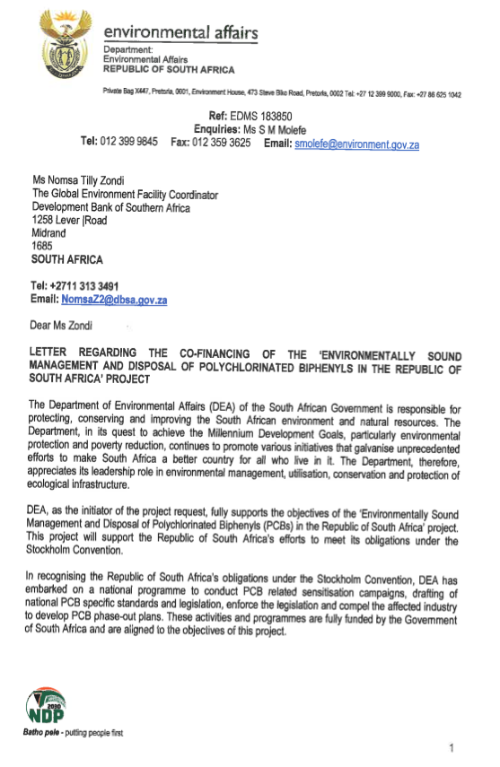
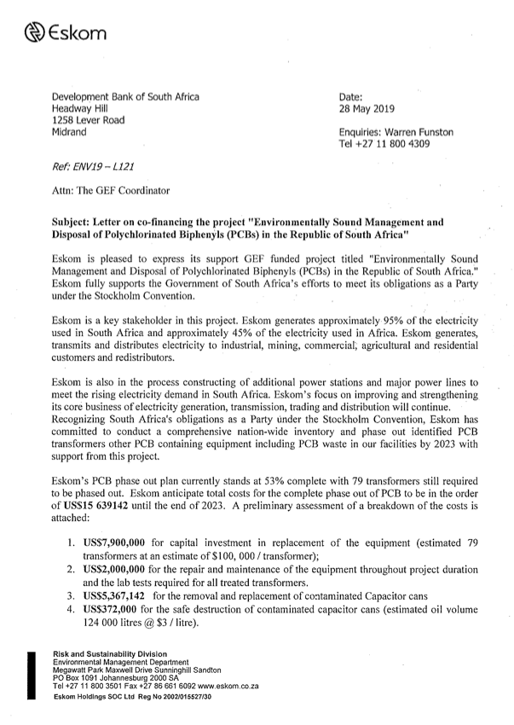
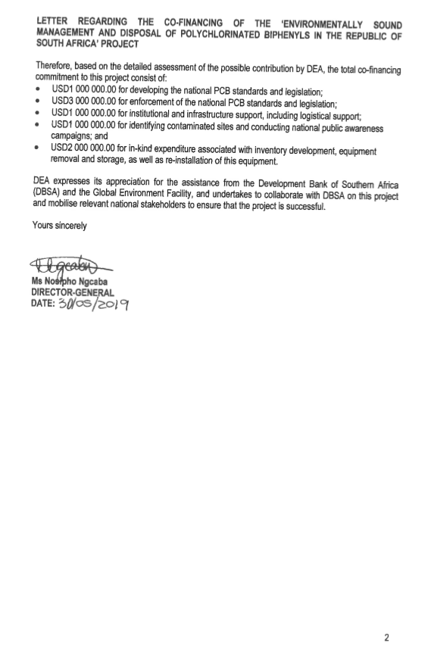
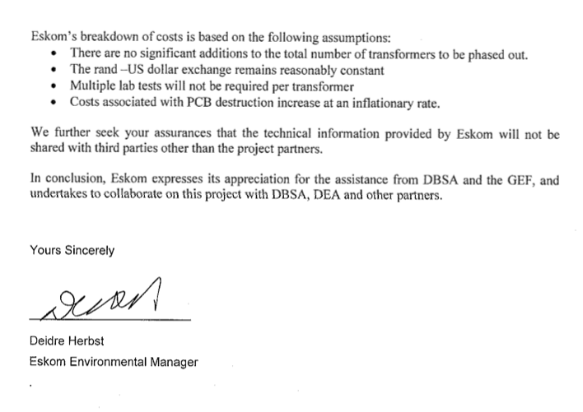
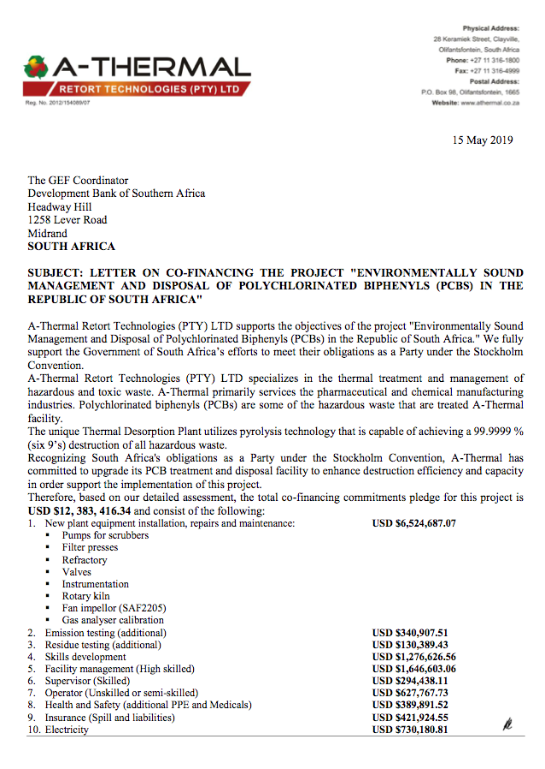

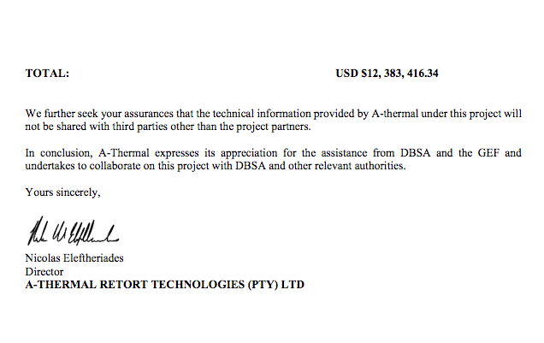
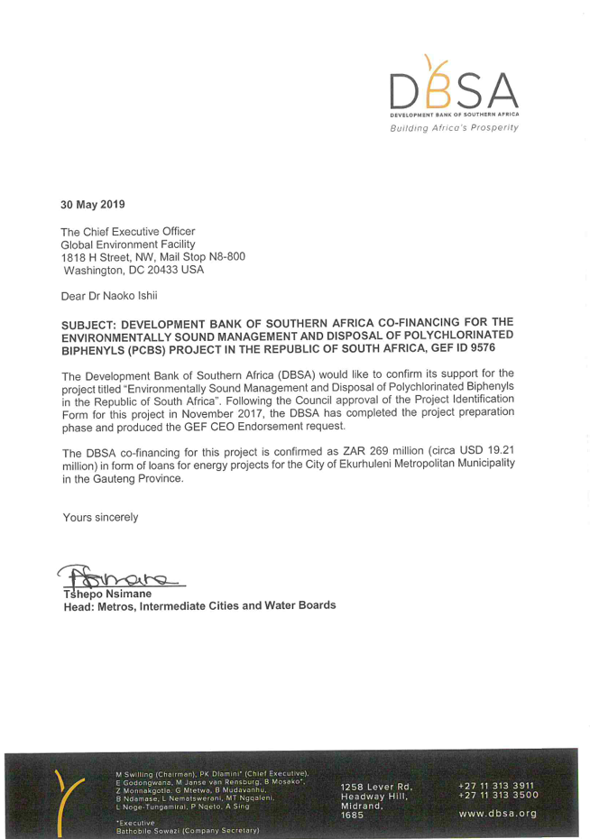

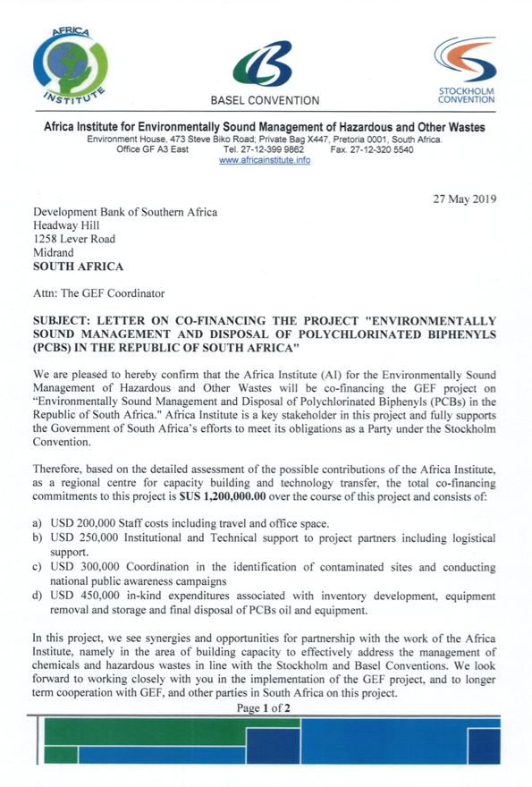

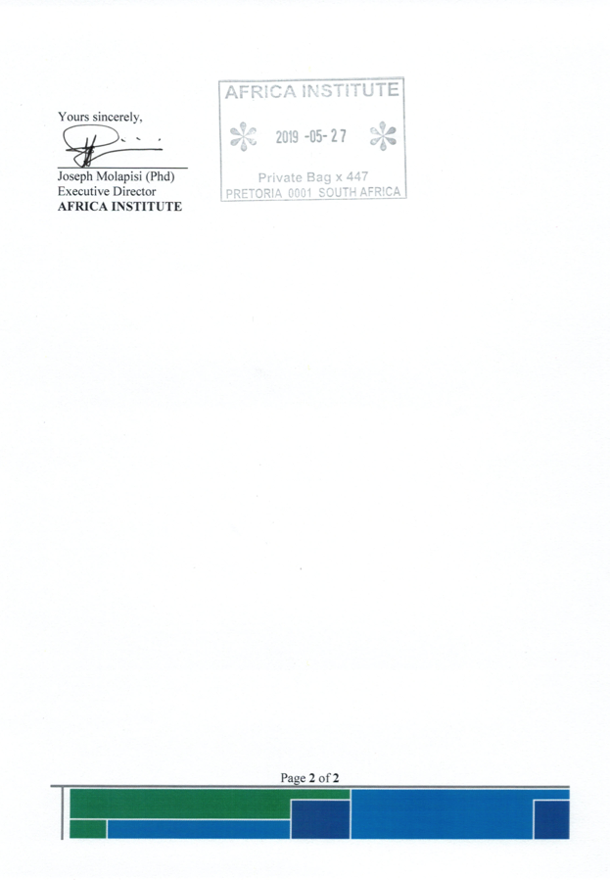

Annex H: Mainstreaming Gender: Gender Analysis and Gender Action Plan
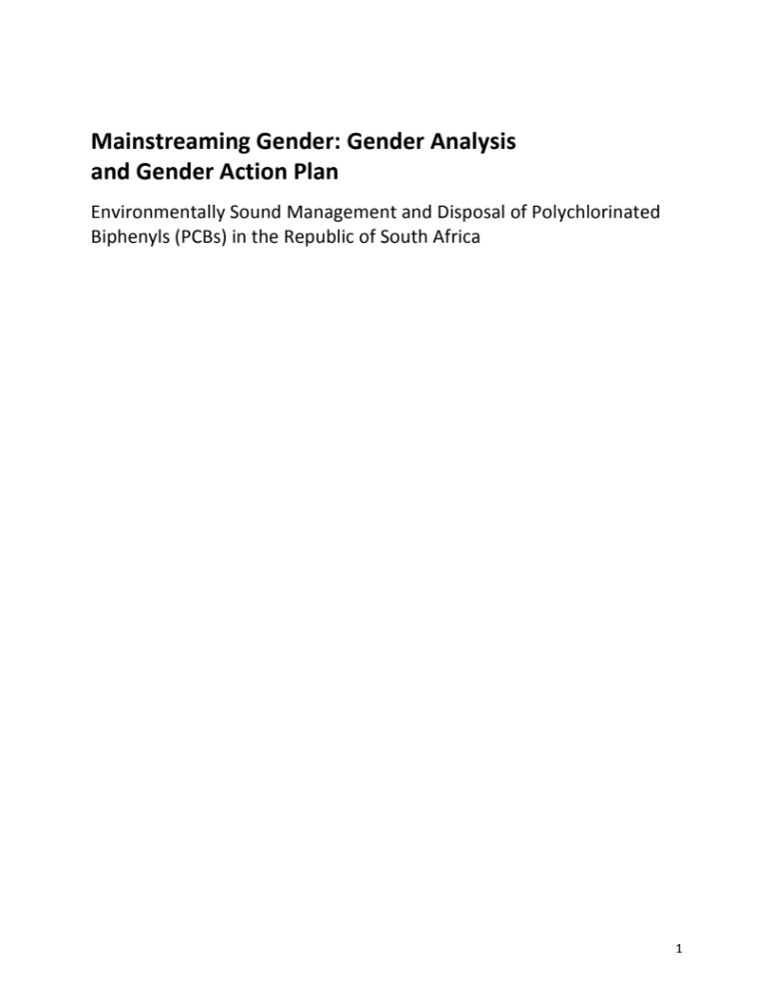
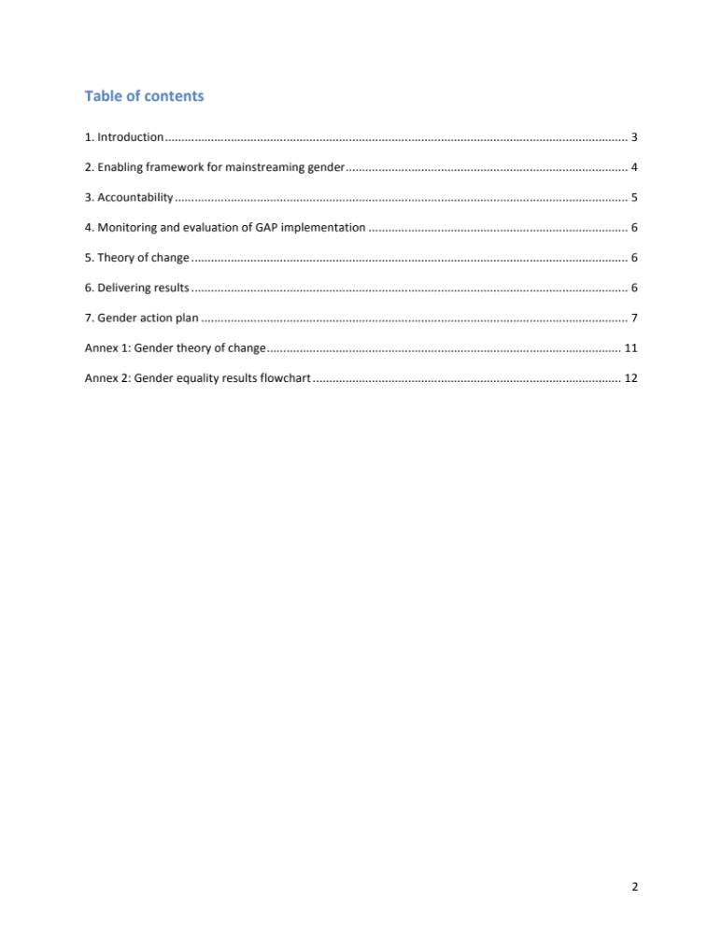

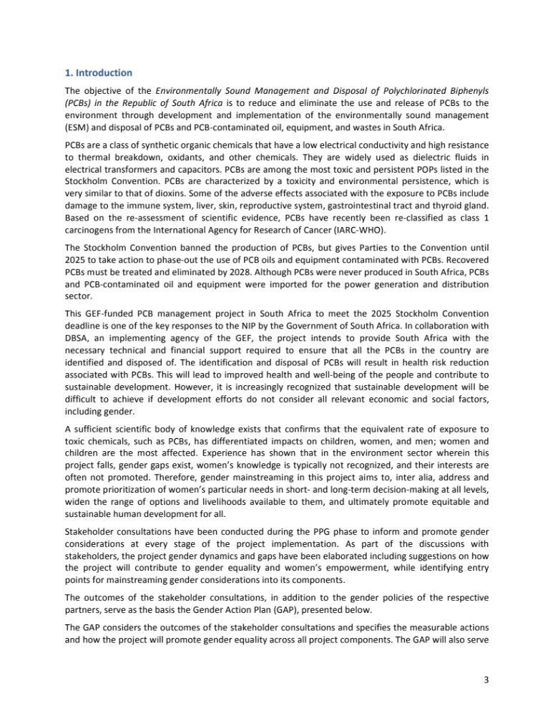

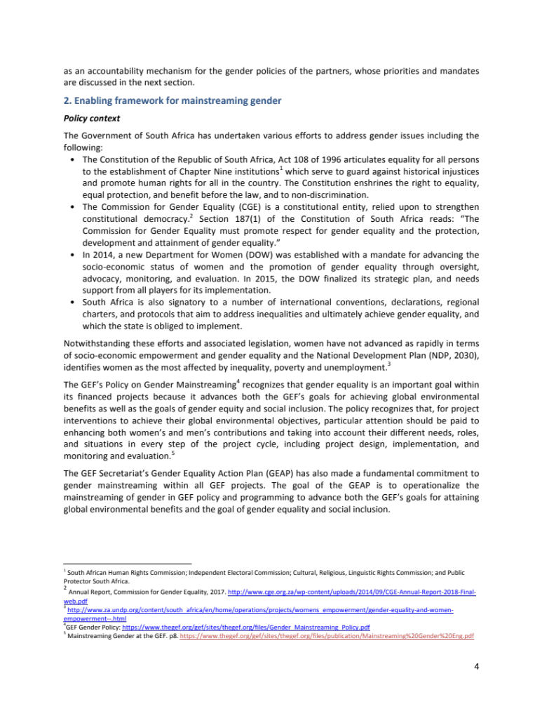

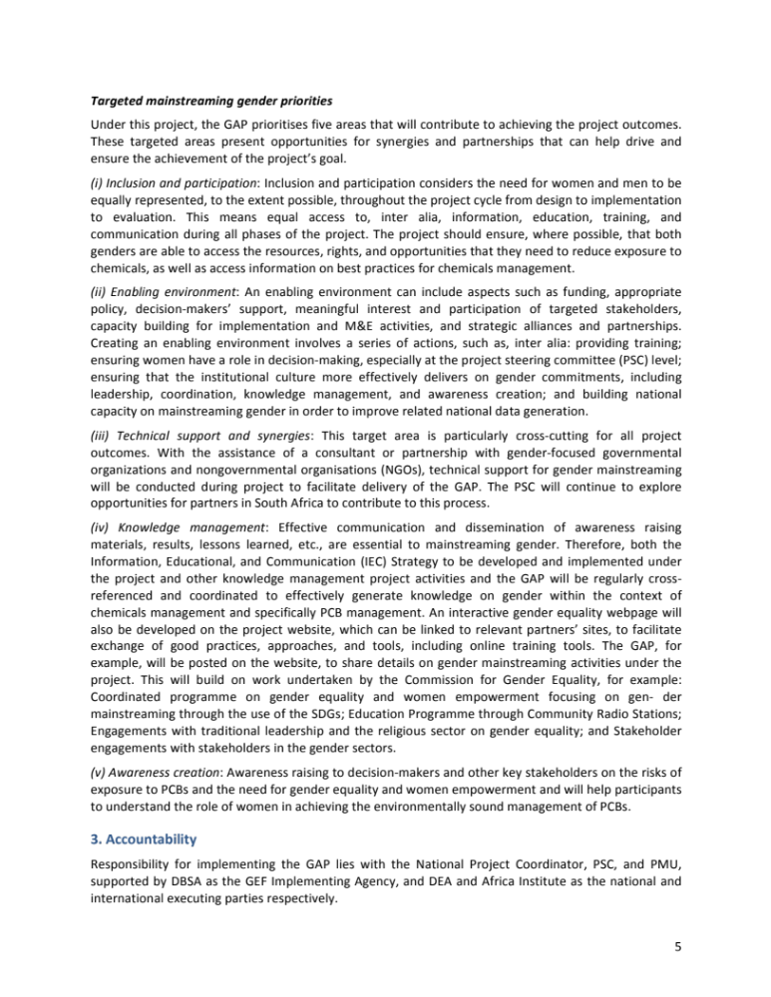

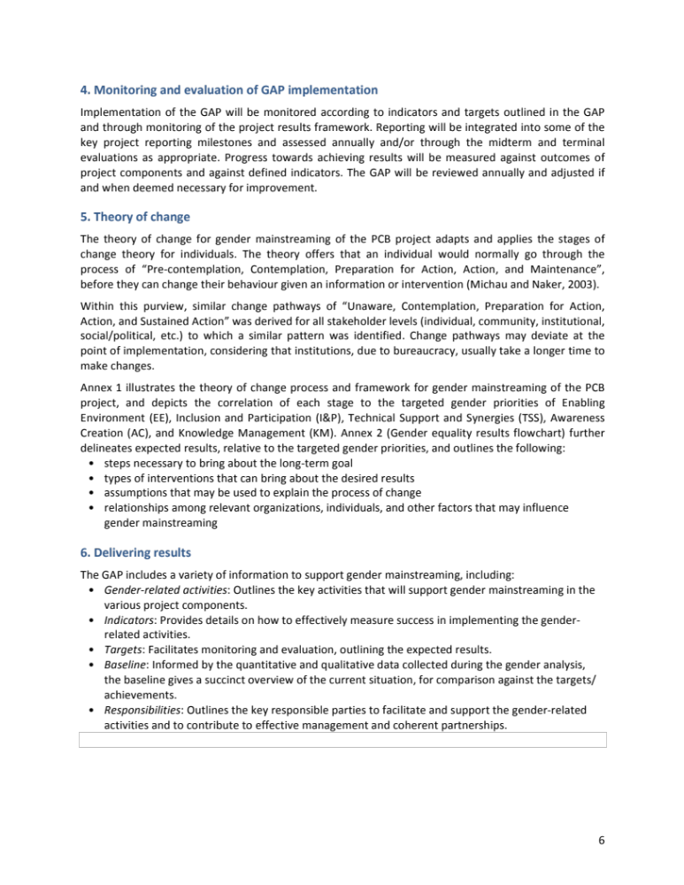

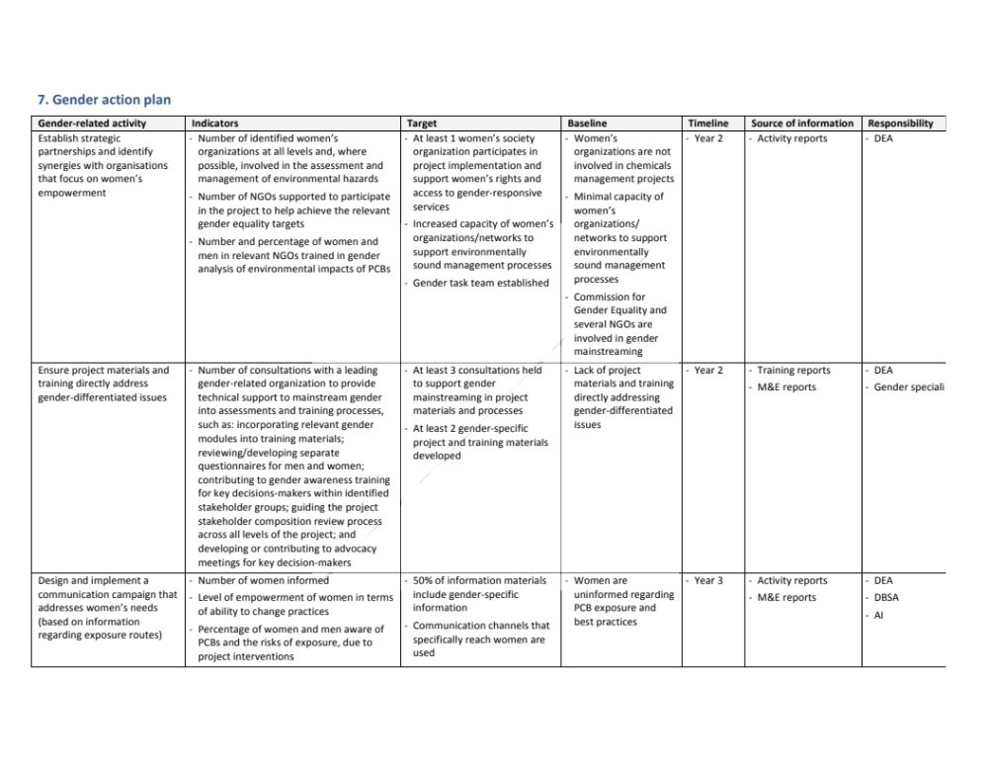
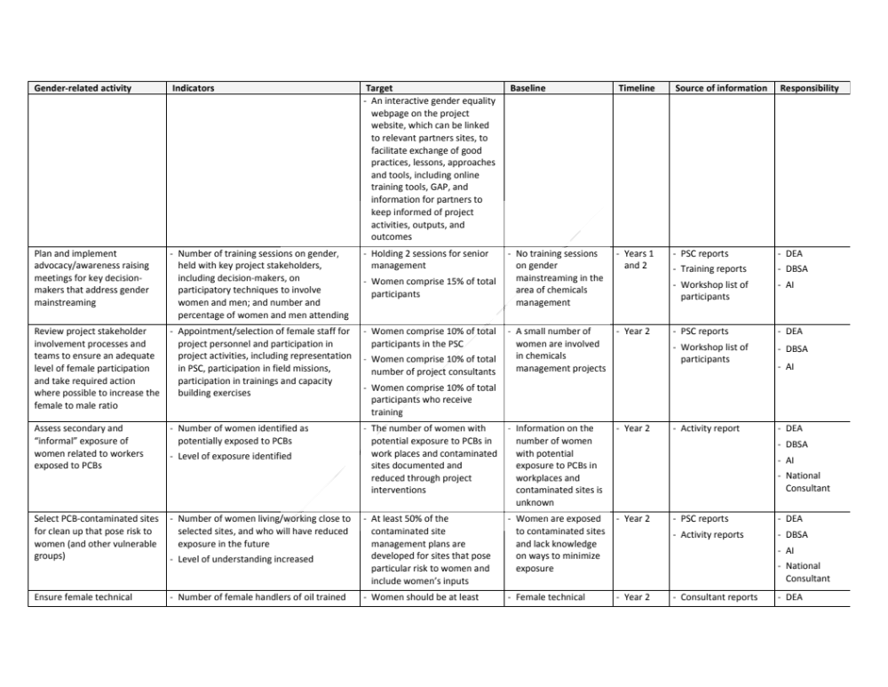
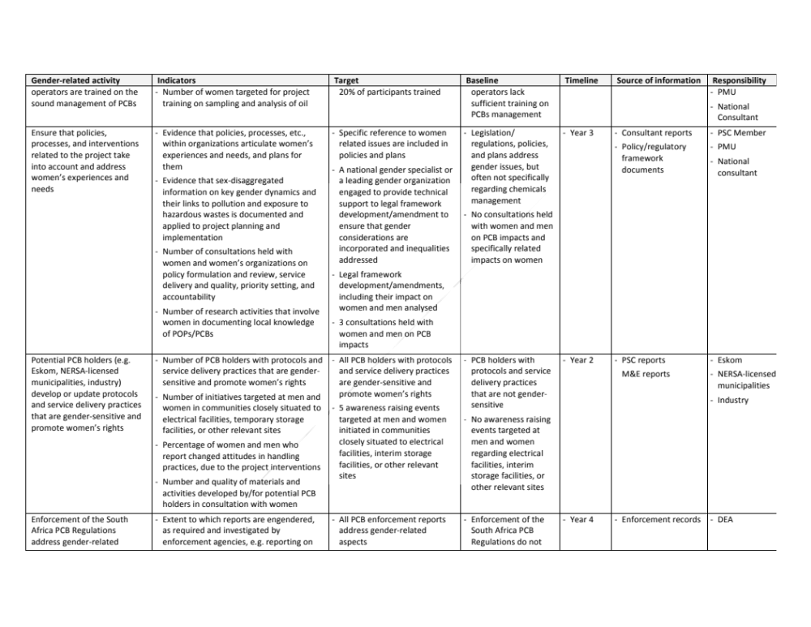
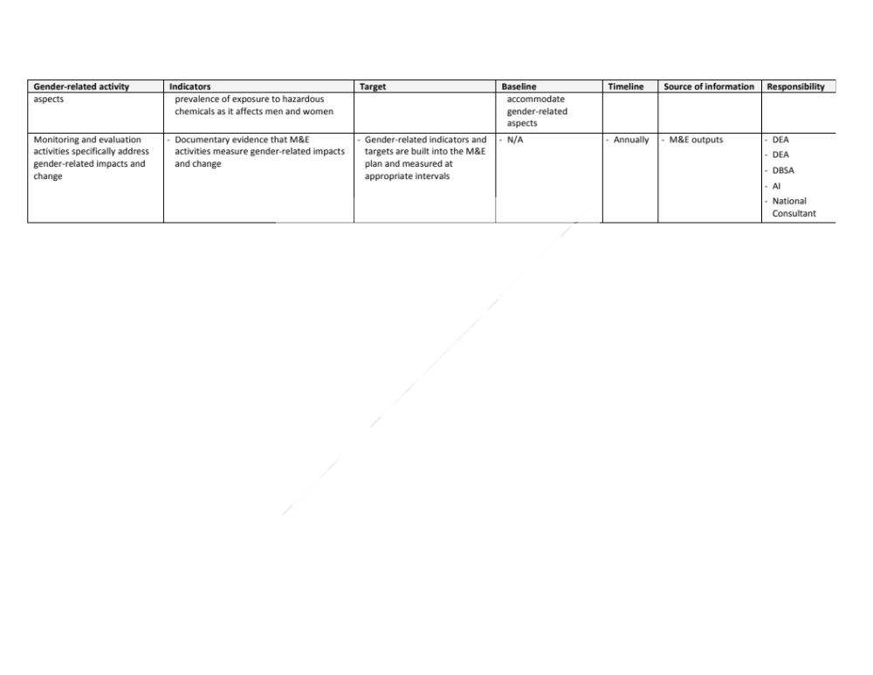
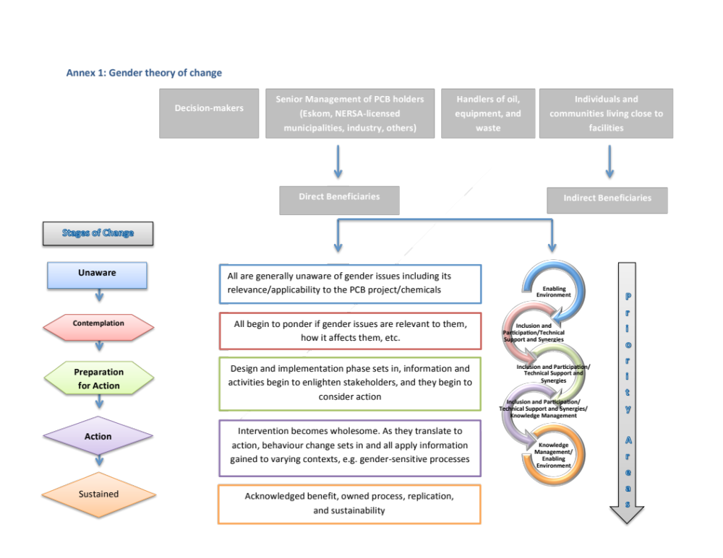

Annex I: Environmental and Social Safeguards Scoping Report

Environmentally Sound Management and Disposal of Polychlorinated Biphenyls (PCBs) in the Republic of South Africa

Project number: 9576

Table of contents

Executive summary 100

1. Environmental and Social Assessment Practitioner(s) details 101

2. Proposed activity description 101

3. Alternatives identified 101

4. Property on which the project will be undertaken 102

5. Legislation and guidelines considered to prepare the scoping report 102

6. Need for the project 102

7. Environment (physical and social) that may be affected by the project 103

8. ESIA plan 103

9. Environmental and human health risks, potential and cumulative impacts 104

10. Social and Gender risks, including potential and cumulative impacts 106

11. Public participation process and steps to notify interested and affected parties 107

12. Environmental and Social Management Plan 108

Executive summary

It is well known that the exposure to Persistent Organic Pollutants (POPs) can lead to serious health effects including certain cancers, birth defects, dysfunctional immune and reproductive systems, greater susceptibility to disease, and damages to the central and peripheral nervous systems. The Stockholm Convention on POPs has been established based on the consideration that, and given the long-range transportation of POPs, no one government acting alone can protect its citizens or its environment from POPs.

Polychlorinated Biphenyls (PCBs) are among the most toxic and persistent POPs listed in the Stockholm Convention. The so-called dioxin-like PCBs are characterized by a toxicity and environmental persistence, which is very similar to that of dioxins. Based on the re-assessment of scientific evidence, PCBs have recently been re-classified as class 1 carcinogens from the International Agency for Research of Cancer (IARC-WHO). Although PCBs were mostly used in closed systems, like transformers and capacitors, very often such equipment is recycled at the end of their operational life and the PCB oil contained therein can be either directly wasted in the environment, recycled, or even sold as fuel oil.

The Stockholm Convention banned the production of PCBs, but gives Parties to the Convention until 2025 to take action to phase-out the use of PCB oils and equipment contaminated with PCBs. Recovered PCBs must be treated and eliminated by 2028. Although PCBs were never produced in South Africa, PCBs and possibly PCB-contaminated oil and equipment were imported for the power generation and distribution sector.

This project, which will enable South Africa to meet the 2025 and 2028 Stockholm Convention deadlines, is one of the key responses to the Stockholm Convention National Implementation Plan (NIP) by the Government of South Africa. The project will support South Africa to implement best management practices for PCBs including their disposal. As part of this project, South Africa will undertake the following activities, among others: strengthen institutional capacity for the ESM of PCBs and PCB-contaminated oil, equipment, and wastes; conduct a national PCB inventory and upgrade the national PCB tracking and record keeping system; develop PCB owner phase-out plans and national PCB management plan; develop and implement an Information, Educational, and Communication (IEC) Strategy; undertake technology transfer and establish a public-private-partnership (PPP); and safely manage and dispose PCBs and PCB-contaminated oil, equipment, and wastes.

The identification and proper management of PCBs and PCB-contaminated oil, equipment, and wastes, in addition to the increased awareness of health and environmental risks of these toxic compounds, improved occupational safety and health issues, and gender mainstreaming, will protect the health of employees, government officials, and the public in general, prevent the global spread of these chlorinated wastes to other locations, and contribute to sustainable development.

The Universal Declaration of Human Rights proclaimed by the General Assembly, contains a number of articles that are closely linked to the scope of the proposed project. These articles and the manner in which the project will ensure that the human-rights based approached is mainstreamed in the project are as follows:

Article 3. “Everyone has the right to life, liberty and security of person”.

The elimination of PCBs from South Africa and the establishment of an environmental management system for the use, handling, and disposal of these toxic materials will contribute to the protection of human health and the environment by reducing and/or eliminating the exposure to these toxic compounds. The identification and proper management of PCBs and PCB-contaminated oil and equipment will eliminate the release of PCBs from leaking equipment and out-of-service transformers and allow workers to wear proper personal protective equipment (PPE) when handling and/or maintaining these transformers and capacitors. By reducing the potential exposure of workers and public in general to these toxic materials, the project is protecting human health and life and providing a safe and secure environment.

Article 19. “Everyone has the right to freedom of opinion and expression; this right includes freedom to hold opinions without interference and to seek, receive and impart information and ideas through any media and regardless of frontiers”.

The upgrading of environmental regulations to ensure PCBs in South Africa are identified and properly managed, including their treatment and disposal, will be equally applied to all locations in the country. The project will ensure that stakeholders impacted by, involved in, and interested in the management of PCBs and PCB-contaminated oil and equipment will be engaged in the project’s development and implementation, through national consultation mechanisms, workshops, and awareness raising events to allow them to express their opinions on the project and its intended activities. Furthermore, project activities, objectives, and results will be widely disseminated through various media channels throughout the project’s implementation.

Article 23 (2) “Everyone has the right to work, to free choice of employment, to just and favorable conditions of work and to protection against unemployment”.

The project will help to disseminate the information on the risks associated with PCBs and promote environmentally sound management and disposal systems for PCBs and PCB-contaminated oil and equipment. Workers potentially exposed to PCBs will have the knowledge to better evaluate the environmental conditions of their jobs and better protect themselves with handling PCBs and avoid and/or reduce the potential exposure to these toxic materials.

The project is considered to be “Category 1 or High and Substantial Risk Category”, following DBSA’s Environmental and Social Safeguard Standards (ESSS) guidelines, as it involves the “Manufacture, transportation and use of hazardous and/or toxic materials” and “Domestic and hazardous waste disposal operations”.

1. Environmental and Social Assessment Practitioner(s) details

Expert environmental and social assessment practitioners will be contracted at the start of project implementation to undertake the Environmental and Social Impact Assessment (ESIA) and Environmental and Social Management Plan (ESMP), where required.

2. Proposed activity description

The objective of the Environmentally Sound Management and Disposal of Polychlorinated Biphenyls (PCBs) in the Republic of South Africa is to reduce and eliminate the use and release of PCBs to the environment through development and implementation of the environmentally sound management (ESM) and disposal of PCBs and PCB-contaminated oil, equipment, and wastes in South Africa.

The proposed project consists of the following three components:
- Component 1: Institutional capacity building and awareness raising
- Component 2: Final treatment and disposal of PCBs and PCB-contaminated oil, equipment, and wastes
- Component 3: Monitoring, evaluation, and replication
As part of project implementation, South Africa will strengthen its technical capacity to manage and dispose of PCBs and other hazardous POPs chemicals of similar nature in an environmentally sound manner. This will result in the reduction and elimination of the use and release of PCBs to the environment and will enhance the quality of life of South African citizens.

3. Alternatives identified

The alternative to the project is insufficient action on PCB management, resulting in exposure to PCBs and degradation of the environment.

4. Property on which the project will be undertaken

The project covers all of South Africa and targets the energy sector (including power generation, transmission, and distribution) and other potential PCB holders, such as mining, cement, steel, aluminium, chemical, petrochemical manufacturing, and municipalities. Activities are also planned to take place at interim storage facilities and one or more PCB treatment facilities in South Africa.

5. Legislation and guidelines considered to prepare the scoping report

This scoping report follows DBSA’s ESSS guidelines and takes into account various South African regulations and standards including:
- EIA regulations promulgated in December 2014 in GNR 982, 983, 984, 985 in Government Gazette 38282, in terms of Section 24 of the National Environmental Management Act, Act 107 of 1998.
- Regulations to phase-out the use of PCB materials and PCB contaminated materials under section 44(1) (aA) and (aB) of the National Environmental Management Act, 1998 (Act No. 107 of 1998)
- South Africa PCB Regulations and the South African National Standard on “Mineral insulating oils – Management of polychlorinated biphenyls (PCBs)” (SANS 290)
- National Environmental Management: Waste Act, No. 59 of 2008
- National Water Act, No 36 of 1998 (NWA)
- Environmental Conservation Act (ECA), Act No. 73 of 1989
- Municipal Systems Act, No 32 of 2000 (MSA)

6. Need for the project

The project will enhance South Africa’s institutional capacities to control and manage PCBs and PCB-contaminated oil and equipment in an environmentally sound manner. This will also help South Africa to comply with its obligations under the Stockholm Convention. The skills and knowledge to be acquired by government officials, workers, and public in general along with the hazardous waste management technology acquired/strengthened in South Africa will enable South Africa to manage the risks and challenges of PCB management and other environmental and health issues related to toxic chemicals and wastes.

The following are the barriers that need to be addressed by this project to ensure the environmentally sound management (ESM) of PCBs and PCB-contaminated oil, equipment, and wastes and to avoid PCBs being released into the environment as a consequence of improper disposal:
- Most of the NERSA-licensed municipalities across the country do not have specific schemes or administrative mechanisms governing PCBs and PCB-contaminated oil, equipment, and wastes
- Many of the potential owners of PCBs and PCB-contaminated oil, equipment, and wastes, particularly the NERSA-licensed municipalities, currently lack the means to identify such oil, equipment, and wastes or apply ESM practices to PCBs or PCB-contaminated equipment in service, in storage, or out-of-service
- The preliminary national PCB inventory that is available as a result of the 2012 (updating the NIP is underway) is not sufficiently detailed for the purposes of phase-out and disposal planning; a comprehensive, detailed inventory and assessment of the PCB situation in South Africa will be need to be undertaken at the early stages of the project, with a particular focus on the NERSA-licensed municipalities
- Despite awareness raising efforts undertaken regarding implementation of the South Africa PCB Regulations, many owners of PCBs and PCB-contaminated oil, equipment, and wastes are unaware of the threats that PCBs pose to human health and the environment, and hence electrical equipment is often not managed in an environmentally sound manner
- There are no systematic investment mechanisms to support the ESM of PCBs and PCB-contaminated oil, equipment, and wastes within the country
- There are at least four PCB-contaminated sites that have been identified, but environmental and social risk assessments or contaminated sites management plans have not been developed
- PCB treatment facilities in South Africa are relatively new and require detailed assessments and related accreditation processes to ensure that they can treat PCBs in an environmentally sound manner in accordance with national laws and regulations, Stockholm and Basel Convention provisions, and related guidance

7. Environment (physical and social) that may be affected by the project
The project is intended to address activities that could lead to PCB exposure to human health and the environment. This will include minimizing and/or eliminating exposure at key sites and taking into account the physical and social aspects of a specific areas (such as contaminated sites and transformer maintenance and storage sites, and related livelihoods) and applying adequate planning or mitigation measures to limit the impacts on human health and the environment.
During the implementation of the project, certain activities such as inventory development will require the recruitment of extra personnel to undertake these activities in all nine provinces of South Africa. The recruitment of such personnel will contribute to employment creation and the local economy.

8. ESIA plan
The Environmental and Social Impact Assessment (ESIA) provides a framework to assess project life-cycle environmental and social risks and impacts, support project structuring to ensure project outcomes are environmentally and socially sound and sustainable, and inform decision making. The ESIA describes the measures to identify, avoid, minimise, reduce, or mitigate project environmental and social impacts and risks.
The ESIA will into account all relevant project considerations, including applicable environment and social policy frameworks, national laws and regulations, institutional capabilities, country conditions and project context, country environmental or social studies, national environmental or social action plans, and country obligations directly applicable to the project.
An indicative outline of the ESIA is as follows.
- Project description
  - Description of the proposed project
  - Outline of the project geographic area and its, environmental, social, and temporal context, outlining any relevant physical, biological, and socioeconomic conditions, including any changes anticipated before the project commences
  - Any current and proposed development activities within the project area not directly connected to the project
  - Any offsite investments that may be required to implement the project, and the project’s primary suppliers
  - A map-detailing the project site and geographically indicate the project’s direct, indirect, and cumulative impacts
  - Timeframes to identify, plan and implement the project
- Stakeholder engagement
  - Description of the stakeholder engagement plan
  - Project related socio-economic and gender considerations
  - Identify mitigation measures to ensure disadvantaged or vulnerable groups do not unduly face adverse project impacts
  - Identify and assesses: positive and negative effects; the adequacy and outcome of public consultation; mitigation measures and residual negative impacts
- Legal and institutional framework
  - The legal and institutional framework including the country’s applicable policy framework, national laws and regulations, country conditions and project context; country environmental or social studies and action plans
  - Relevant international treaties and agreements and country obligations directly applicable to the project
  - Clients institutional capability to implement environment and social considerations
  - Identify and assess environmental and social obligations of any co-financiers
- Baseline data
  - Outline baseline data relevant to project location, design, operation, or mitigation decisions
  - Identify accuracy, reliability, and quality of available data, and extent of key data gaps
- Environmental and social risks, impacts and mitigation measures
  - Outline all relevant project environmental and social risks and impacts, including project nature, location, context and environmental risks and impacts identified
  - Outline applicable ESSS requirements as relevant to the project, compare against the environmental and social framework and identify any gaps to be addressed
  - Identify project environmental and social mitigation measures, assess the feasibility of implementing these, identify significant residual negative impacts that cannot be mitigated, and assess their acceptability
  - Outline institutional arrangements, training, and monitoring actions to implement proposed mitigation measures
  - Outline capital and recurrent costs of proposed mitigation measures
- Alternatives analysis
  - Compare the potential environmental and social impacts of feasible project alternatives to the proposed project site, technology, design, and operation-including the “without project” situation
  - Assesses feasibility of alternatives proposed, the environmental and social impacts; mitigations required and capital and recurrent costs for implementing these, their suitability; and any institutional and monitoring requirements
  - For each alternative, quantify the environmental and social impacts, and attach economic values where feasible
- Design
  - Set out the basis for selecting the proposed project design
  - If the ESHGs are determined to be inapplicable, justifies recommended emission levels and pollution prevention and abatement approaches that are consistent with GIIP
- Key measures and actions for the Environmental and Social Management Plan (ESMP)
  - Outline the key project measures, actions and timeframe to meet the ESSSs and to develop the ESMP
- Monitoring and Supervision Plan
- Conclusion and Recommendations
- Appendices
  - List individuals or organisations that prepared or contributed to the environmental and social assessment
  - References
  - Record of meetings, consultations and surveys with affected stakeholders and interested parties
  - Tables presenting relevant data

9. Environmental and human health risks, potential and cumulative impacts

9.1 PCB spills and exposure risks from operations

Potential risks

Accidental environmental releases of PCBs from operations can result in potential exposure to workers and the general public. In addition, environmental releases could take place during transboundary movement of PCB wastes caused by improper handling and packaging.

The removal, packaging, transportation, treatment, and disposal of PCBs and PCB-contaminated oil, equipment, and wastes will require people to directly handle these toxic materials. The handling is subject to human error and can affect workers and to a lesser extent communities close to the sites where PCBs and PCB-contaminated oil, equipment, and wastes are handled (e.g. transformer substations, interim storage facilities, hazardous waste treatment facilities).

Significance of potential risk

PCBs and PCB-contaminated oil, equipment, and wastes from various locations will be collected, packaged, and where appropriate may be temporarily stored prior to treatment or disposal. Transferring oil from the transformers to drums poses potential risk of spillage. The above activities will not be located in sensitive areas. Furthermore, the probability of significant PCB spills and related impacts is low due to the mitigation measures that will be put in place under the project.

Assessment and management measures

This assessment is based on the specific situation in South Africa and experience from implementation of similar PCB projects in other countries. Based on this, a national PCB management plan will be developed that addresses all aspects associated with this risk. In addition, the following management measures will be undertaken:
- Only trained personnel will participate in technical project activities, such as the sampling of transformers during the inventory stage of the project; handling of PCBs and PCB-contaminated oil, equipment, and wastes; transportation; and storage. All people involved in these activities will be required to have complete personal protective equipment (PPE). The sampling of transformer oil will be preceded by proper planning and coordination and will be supervised by experienced and well-trained personnel to minimize worker exposure to PCBs and to reduce or eliminate the risk of potential PCB-contaminated transformer oil into the environment. These activities will be carried out under a controlled environment.
- The transportation of PCBs and PCB-contaminated oil, equipment, and wastes from place of origin to interim storage facilities or the treatment/disposal facilities will be carried out only by trained personnel using rigorous and well-established and documented hazardous waste and dangerous goods management practices, procedures, and standards, including those set out by the Basel and Stockholm Conventions, GEF STAP guidelines, and internationally referenced OSH procedures for on-site workers.
- Local transportation routes with the least likely risks will be determined and selected.
- All treatment/disposal of PCBs and PCB-contaminated oil, equipment, and wastes will be undertaken by a professional company that has undergone an independent third-party detailed assessment of their technology to ensure that they can treat PCBs in an environmentally sound manner in accordance with national laws and regulations, Stockholm and Basel Convention provisions, and related guidance. Such companies will provide proof of insurance and the necessary bank guarantees to support remediation of potential accidents.

For all components, capacity building and training programmes will be conducted by international experts and advisory support will be provided. Specifically, local personnel involved in direct work on project sites will be trained and supported throughout the project duration.

9.2 PCB leakage from interim storage facilities

Potential risks

Improperly stored electrical equipment and oil drums at interim storage facilities can lead to the release of PCBs into the environment.

Moreover, PCBs are quite resistant to biodegradation, therefore, any leaks occurring in any jurisdiction has the potential to travel into the environment, having a negative global environmental impact.

Significance of potential risk

If interim storage facilities are determined to be required under the project, they will not be located in sensitive areas or in community areas, and will be secured. The probability of leakage will be low due to the use of proper equipment, procedures, and monitoring. Communities close to the facilities will be regularly consulted regarding project implementation, complemented by awareness raising activities.

Assessment and management measures

This assessment is based on the specific situation in South Africa and the implementation of similar PCB projects in other countries. Based on this, a national PCB management plan will be developed that addresses all aspects associated with this risk. In addition, the following management measures will be undertaken:
- If interim PCB storage are upgraded/constructed under the project, these facilities will be situated at existing transformer storage and repair facilities and will be designed, upgraded/constructed, and operated following strict environmental regulations. This will be complemented by best practices to ensure that workers, public, and the environment are properly protected. Secondary containment will be built around any liquid storage area. Where applicable, the facilities will also be upgraded/ constructed with an overall containment retention wall able to hold at least 200% volume capacity of the largest storage container in the building. The management of these facilities will be carried out by properly trained operators adhering to strict environmental and health and safety guidelines. PCB-containing oil will be stored in UN-approved drums to minimize the potential for release of PCBs into the environment.
- A routine monitoring programme of the interim storage facilitates and the surrounding areas will be implemented with baseline PCB contamination levels of the sites properly determined.
- The continuous checking of equipment and operations to minimize accidental releases of PCBs will be part of the facilities’ operating procedures. Any leaks discovered or activity determined to be the source of unwanted releases of PCBs will be promptly corrected.
- Towards the end of the project, all equipment and materials used in project operations that have the potential for PCB contamination will be secured and disposed of in an environmentally sound manner.

All operations conducted at the interim storage facilities will be subject to strict national and international requirements on PCB management, and will be carried out by trained operators.

10. Social and Gender risks, including potential and cumulative impacts

Lactating mothers’ milk is one of the best-known pathways for transfer of PCBs into their children. The low mass of their babies results in a significant exposure of these children to these toxic compounds that may lead to development of serious diseases and health conditions. This potential impact makes the environmentally sound management and disposal of PCBs in South Africa a unique opportunity to improve gender equality and women’s empowerment.

The PPG phase of the project assessed the gender aspects related to the management of PCBs and PCB-contaminated oil and equipment in industrial settings and ensure the participation, representation, and buy-in of vulnerable workers and community populations in the project's formulation and will be further investigated and addressed during implementation. Key guidance documents, such as DBSA’s ESSS guidelines, will be used to support gender-mainstreaming efforts.

This GEF project will build awareness on the links between waste management and public health (including occupational exposures), with a special focus on the health implications of exposure to PCBs and PCB-contaminated oil and equipment for particularly vulnerable populations, such as female workers, pregnant women, and children who could live nearby these industrial areas.

Potential risks

In the past, women have not been given equal opportunities to participate in project implementation and, therefore, there is a potential risk of underrepresentation of women participating in the project.

Similarly, potentially affected stakeholders, in particular marginalized groups, may not fully participate in project-related decisions that may affect them.

Significance of potential risk

Notwithstanding the plethora of legislation in South Africa, women have not advanced as rapidly as men in terms of socio-economic empowerment and gender equality and the National Development Plan (NDP, 2030) identifies women as the most affected by inequality, poverty and unemployment.

The potential lack of women’s participation in the project could result in a failure to include their interests and needs in decision-making. This could have an impact on their understanding of PCB exposure and best practices. However, this risk is manageable through relatively uncomplicated measures including those outlined in the Gender Action Plan.

Regarding potentially affected stakeholders, in particular marginalized groups, there may be challenges to fully participating in the project and decision-making. This could result from a lack of awareness about the project or a lack of capacity to easily participate.

The impact on potentially affected stakeholders and marginalized groups is minimal as the project does not include activities in populated areas or local communities, and should not interfere with the economic, social, or cultural well-being of any groups. Furthermore, this risk can be managed with relatively uncomplicated, accepted measures to avoid or mitigate the potential impacts.

Assessment and management measures

A Gender Action Plan was developed during the PPG phase, based on an initial gender analysis, and will be implemented throughout the project. Aspects of that Plan include: establishing strategic partnerships and identifying synergies with organisations that focus on women’s empowerment; developing project materials and training that directly address gender-differentiated issues; and designing and implementing a communication campaign that addresses women’s needs.

Regarding potentially affected stakeholders, a stakeholder analysis was prepared during the PPG phase, which identified a broad range of stakeholders, and stakeholder outreach and communication was undertaken. During project implementation, a number of activities will be undertaken to ensure stakeholder involvement including, inter alia: establishing a multi-stakeholder project steering committee; providing numerous opportunities to submit comments and participate in project activities including participation of civil society, NGOs, and others in meetings, forums, seminars, etc. related to decision-making on the project’s implementation plans; participation of civil society, NGOs, and others in training workshops, where appropriate; developing and implementing an Information, Education, and Communications (IEC) Strategy; developing awareness raising materials, such as multimedia educational tools, posters, and brochures, for different target groups; providing local communities with access to awareness raising materials in their own local languages; and conducting training for community leaders. All of these efforts will be geared towards ensuring that there is better understanding of the problems and ensure protection of the population and the environment from adverse effects of PCBs.

11. Public participation process and steps to notify interested and affected parties

Effective, open and transparent stakeholder engagement is an essential element of any transaction, leading to improved environmental and social project sustainability, enhanced project acceptance, and contributing to successful project design and implementation.

In the South African context, the Constitution (Act No.108 of 1996) and other relevant legislation including the Local Government: Municipal Systems Act No. 32 of 2000 and Municipal Finance Management Act No. 58 of 2003 emphasise stakeholder engagement. The Constitution defines local government objectives and its development mandate on the principle of active community consultation and meaningful participation in development planning and implementation processes. Local government legislation gives emphasis to the rights of citizens to contribute and participate through participatory democratic processes and places a duty on municipalities to encourage and facilitate public participation in municipal decision-making processes.

Public consultation with stakeholders will be a key feature of the ESIA process, which will give stakeholders an opportunity to comment on the project as well as on the reports that are produced during each phase of the ESIA. This will enable the interested and affected communities to be a part of the solutions when it comes to mitigating impacts or implementing management measures.

The field studies will involve the use of Participatory Rural Appraisal (PRA) techniques that enhance participation through focus group discussions and resource mapping. Local and traditional leaders, representatives of the communities, and potential vulnerable groups such as women and youth will be consulted to understand their specific issues and concerns. This will enable meaningful participation of the affected sub-sections of the communities in the studies.

The findings and recommendations will be discussed and disclosed in an open and transparent manner with interested and affected stakeholders in order to solicit their comments and suggestions in the studies. Deliverables that will be presented in public meetings shall include information and presentations in traditional languages with key project messages including:
- Expectations management around capacity building (employment, purchasing, contracting)
- Proposed activities
- Ongoing communication about project status and next steps

An initial list of stakeholders and related roles and responsibilities have been outlined in the project document. Consultations have also taken place during the PPG phase at bilateral, municipal, and national levels. This will feed into the public participation process during project implementation.

12. Environmental and Social Management Plan

The Environmental and Social Management Plan (ESMP) will present the environmental management, mitigation, monitoring and institutional measures to be taken during project implementation and operation, to reduce adverse environmental and social effects to acceptable levels and enhance positive effects. The ESMP will specifically define what actions will be taken and who will responsible to reduce adverse project impacts. It will address PCB management and disposal, emergency response, transportation, packaging, temporary storage, and public consultation, covering the different phases of the project.

The ESMP will highlight the issues and concerns presented in the ESIA and identify reasonable and practical responses. It will also establish the course that the project management will follow in complying with the national environmental laws and regulations as well as DBSA policies and guidelines.
The ESMP will be outlined as follows, in accordance with the DBSA guidance.
- Mitigation measures
  - Identify anticipated adverse environmental and social impacts and outline measures and actions aligned to the mitigation hierarchy to reduce potentially adverse environmental and social impacts to acceptable levels and implement any applicable compensatory measures
  - Specify each mitigation measure and action to be implemented providing relevant detail (designs, equipment descriptions, and operating procedures), and type of impact to which it relates and the conditions under which it is required
  - Estimates any potential environmental and social impacts of mitigation measures
- Opportunities for environmental and social positive impacts
  - Identify anticipated potential positive environmental and social impacts and outline measures and actions to address them
- Institutional arrangements
  - Identify project site
  - Detail parties responsible for implementing project environmental and social components and mitigation measures
  - Institutional arrangements for project operation, supervision, enforcement, implementation monitoring, remedial action, financing, reporting
  - Training and capacity development of the required human resources to address ESMP identified actions
  - Any measures necessary to implement identified environmental and social assessment recommendations
- Implementation schedule and cost estimates
  - Detail project implementation schedule including targets indicators and benchmarks aligned to overall project planning, design, and outcomes
  - Outline the capital and recurrent cost estimates and funding sources to implement the ESMP integrated into the total project cost tables
- Monitoring
  - Describes the monitoring measures and frequency, methods, sampling locations
  - Address mitigation measures and actions undertaken and how effective these were in addressing project environmental and social impacts, and identify any possible corrective action that may be needed
  - Outline how the project will be supervised

Annex J: Multi-year work plan
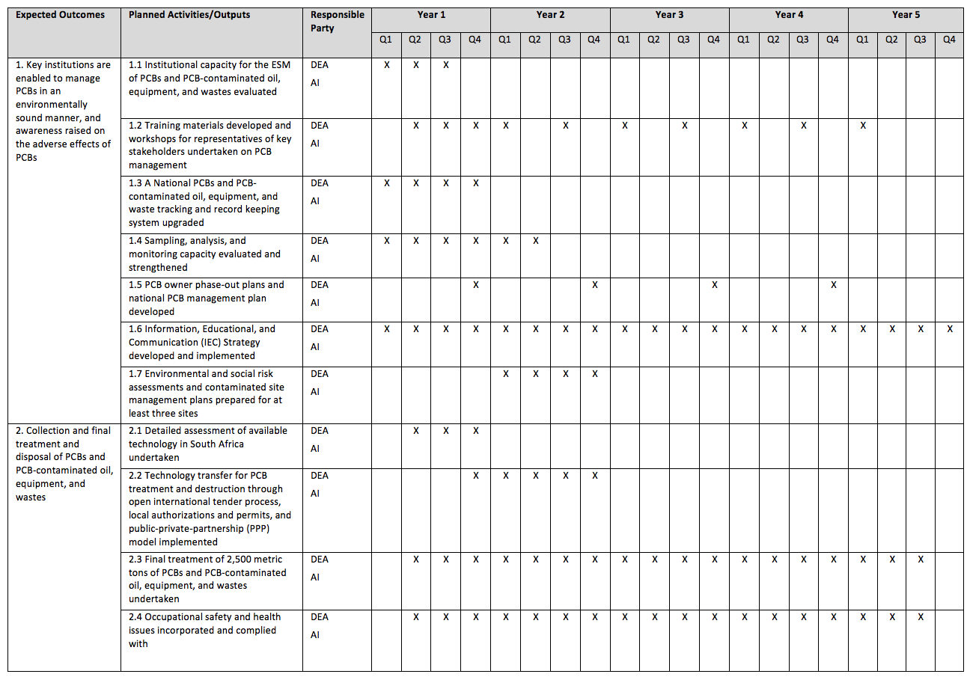
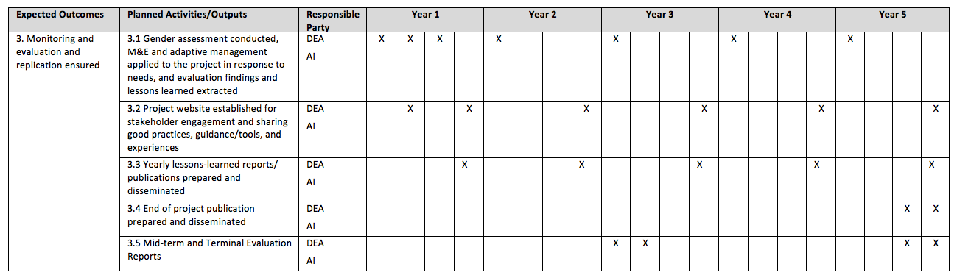

Annex K: Terms of Reference for Project Personnel
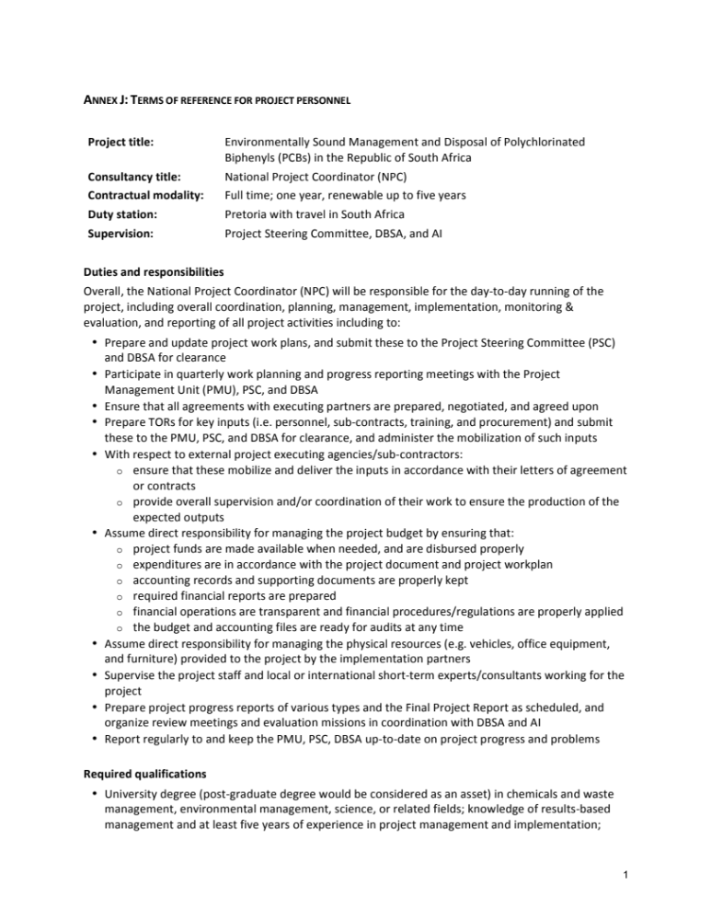

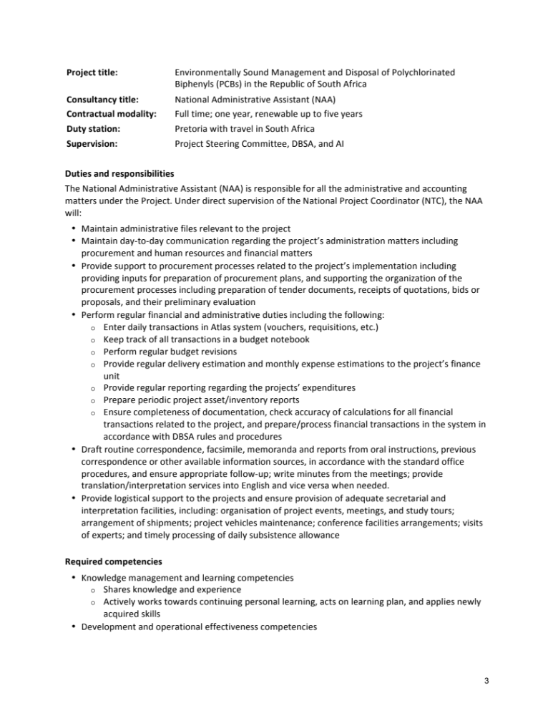
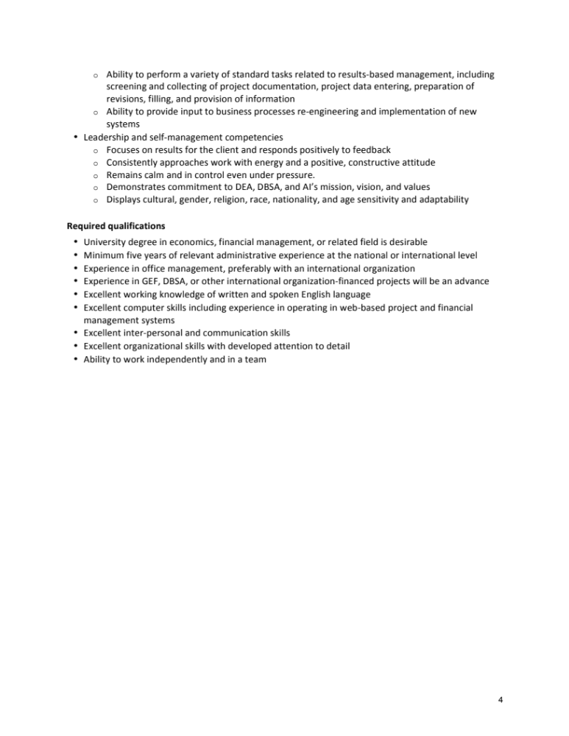
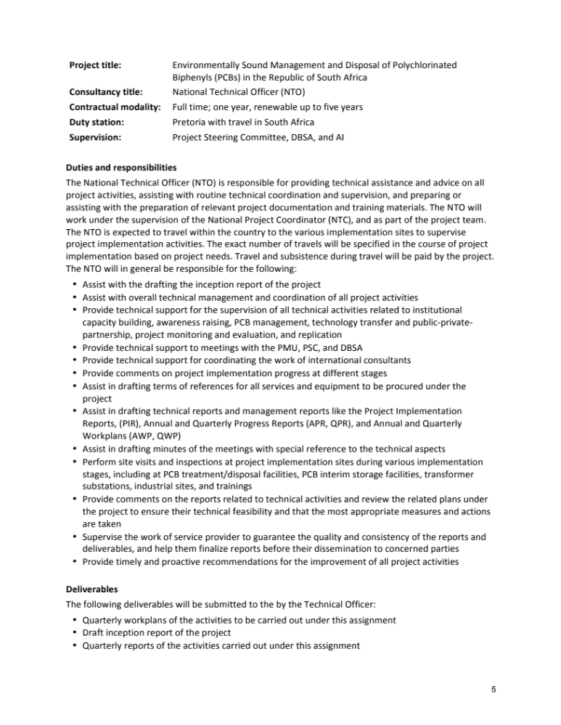
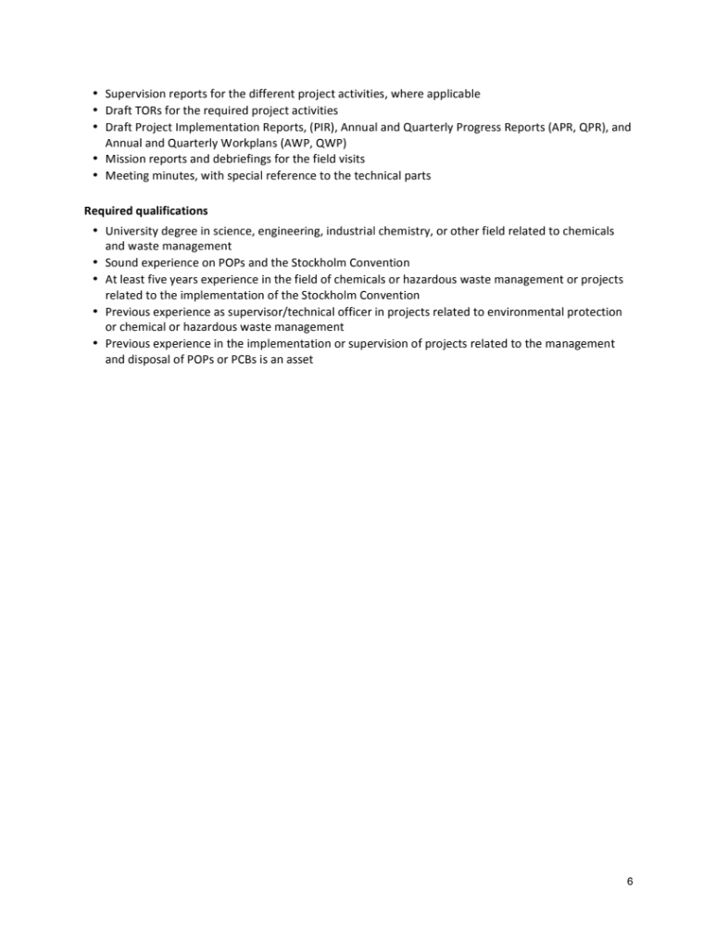

Annex L: Preliminary technical assessment of internationally acceptable PCB treatment technologies in South Africa, European Union, and United Kingdom
See Separate Attachment

Annex M: Tracking Tool
See Separate Attachment
Annex N: Total Budget
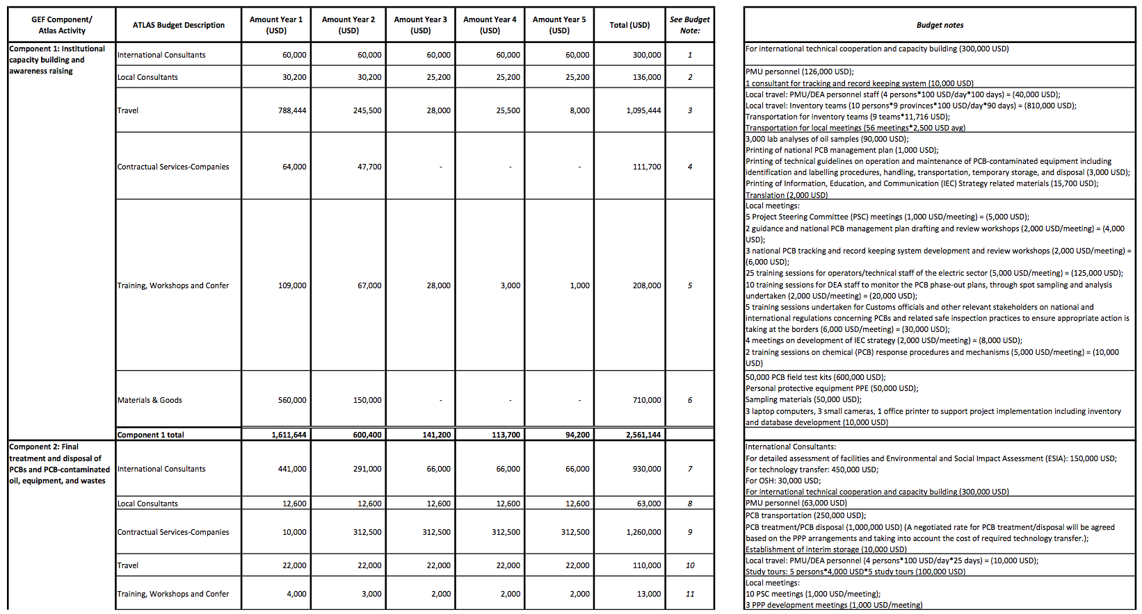

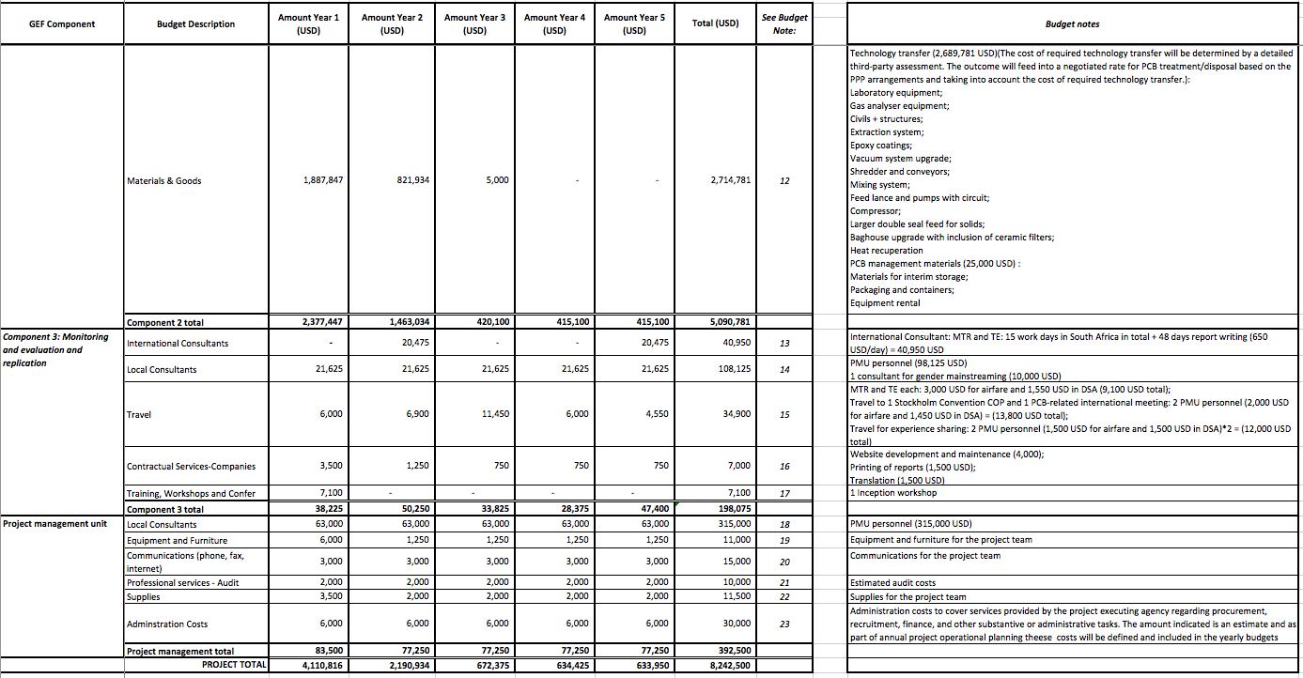

Project ID number remains the same as the assigned PIF number.
When completing Table A, refer to the excerpts on GEF 6 Results Frameworks for GETF, LDCF and SCCF.
Financing type can be either investment or technical assistance.
For GEF Project Financing up to $2 million, PMC could be up to10% of the subtotal; above $2 million, PMC could be up to 5% of the subtotal. PMC should be charged proportionately to focal areas based on focal area project financing amount in Table D below.
For questions A.1 –A.7 in Part II, if there are no changes since PIF , no need to respond, please enter “NA” after the respective question.
For the smaller pole transformers which are hermetically sealed, testing is done on failure of the equipment to determine appropriate disposal requirements. Eskom also uses this information to label other similar pole transformers from the same batch which further informs the inventory.
Enviroil 2019, accessed on 11 February 2019, http://www.enviroil.com/
Botswana, Lesotho, Madagascar, Malawi, Mauritius, Mozambique, Namibia, Seychelles, Swaziland, Tanzania, Zambia, and Zimbabwe.
http://www.basel.int/Implementation/Publications/LatestTechnicalGuidelines/tabid/5875/Default.aspx#
http://www.basel.int/Implementation/Publications/LatestTechnicalGuidelines/tabid/5875/Default.aspx#
http://www.basel.int/TheConvention/OpenendedWorkingGroup(OEWG)/Meetings/OEWG11/Overview/tabid/6258/Default.aspx
https://clu-in.org/download/remed/destruct_tech.pdf
https://clu-in.org/download/contaminantfocus/pcb/PCB-EPA-600-S-13-079.pdf
http://www.justice.gov.za/legislation/constitution/SAConstitution-web-eng-02.pdf
Excluding PMU staff time and travel expenses.
GEF policies encompass all managed trust funds, namely: GEFTF, LDCF, and SCCF
If at CEO Endorsement, the PPG activities have not been completed and there is a balance of unspent fund, Agencies can continue to undertake the activities up to one year of project start. No later than one year from start of project implementation, Agencies should report this table to the GEF Secretariat on the completion of PPG activities and the amount spent for the activities. Agencies should also report closing of PPG to Trustee in its Quarterly Report.
DBSA. 2018. Make Change Happen. Environmental and Social Safeguard Standards. URL: https://www.dbsa.org/EN/About-Us/Publications/Documents/DBSA%20Environmental%20and%20Social%20Safeguard%20Standards%202018.pdf
http://www.za.undp.org/content/south_africa/en/home/operations/projects/womens_empowerment/gender-equality-and-women-empowerment--.html

